REQUIREMENTS DOCUMENT
PROJECT NAME: |  |  | Type
CUSTOMIZER MENU RESKIN |  |  | New Feature
STAKEHOLDER |  | US UI/UX:
Dan Burns | Jon Fox |  | Devon Skidmore
BA AUTHOR:
Patricia Marzan
PROJECT MANAGER:
Ma. Jesa Patricia Viernes
DEVELOPMENT TEAM: (INCLUDING UI/UX)
Immanuel Mahusay
SQA TEAM:
Criselle David
OTHER TEAMS:
Jowin Cueta
PRIORITY: |  | BRAND:
Critical |  | All Brands

VERSIONS
VERSION NO. | BR/FR NO. | REVISION REMARKS | LAST UPDATED DATE
v1.0 | n/a | INITIAL RELEASE | March 5, 2026
v2.0 |  | - Added feature control functionality on ENV File  - Builder headers  - Back to <Sport> update  - Removed Help button  - Save and Share new UI and functionality implementation  - Add to Cart new UI and functionality implementation  - Details Tab - new items and modal on the list  - Options Tab - added fabric details and linking BRD_ABILITY TO ADD AN ITEM TO THE CART WITHOUT A FABRIC SELECTED  - Added Options tab for Reversible  - Brand Logo multiple logos mockup  - Added Application tab - reversible uniform  - Piping tab - added the hardcoded details  - Application tab - added soft limit functionality  - Floating tools mockup  - Team Name Application - added tailsweep missing mockup  - Player Name Application - added apply styling to all Player Numbers link and the link icon | May 29, 2026
v3.0 |  | Updates on Roster tab  Updates on Notification Notes  Added new requirement for Notification Notes Rework | June 23, 2026
v3.1 |  | Added new requirement for Updating of colors in Colors in Use - Customize Tab Regular Regular | June 26, 2026
v4.0 |  | Pricing Toggle Related Requirements | July 9, 2026
v5.0 | FR 24  FR 11  FR 12  FR 18 | Zoom Functionality  Additional Requirements of Application Soft and Hard Limit  Tailsweep Additional Requirements  Custom Number Additional requirement | July 17, 2026
v5.1.0 | FR 8  FR 11  FR 12, 13, 14 | -Removed Duplicate to Side A/B functionality  -Removed Duplicate to Side A/B functionality related to Hard Limit Rule  -Moved the Accent dropdown list from below the Layout to below the application name and field | July 30, 2026
v6.0.0 | FR 6  FR 6  FR 18 | -Added new requirements regarding Organization Dropdown items (with screenshot)  - Added Brand Logo Color Selection requirement  - Clear All functionality update  - Add Range functionality update | August 7, 2026
v7.0.0 | FR 3  FR 7  FR 8  FR 9  FR 10  FR 16  FR 20  FR 21  FR 29  FR 30 | - Added the Disclaimer message requirement  - Updated Reversible Colors In Used Requirements  - Added validation message on duplicating an application  - Added validation message when adding a pattern. Updated requirement on applying pattern to the uniform canvas. Updated requirement of the Configure Pattern panel Pattern thumbnail. Updated Remove button functionality. Updated Cancel and Done buttons functionality  - Updated Remove All button functionality  - Update on Text base pattern functionality  - Updated requirements of Main Body Color for Manual Order functionality  - Updated Logs requirement  - Carryover Of Team Name To The Picker Page – Sticky Filter Requirements  - Hide Add Pattern, Add Piping, Add Text And Add Logo If Not Applicable requirements | August 19, 2026
v8.0.0 | FR 22  FR 17 | -Restore Reworks Process flow  Added additional requirements based on the previous demo  - Add Change Logo requirement | September 9, 2026
V9.0.0 | FR 22  FR 26 | -Struck through Rework notes requirements as this will be part of different ticket  - Added Discount Code implementation | September 24, 2026
v9.0.1 | FR 2 | - Return to Saved Designs updated requirement | October 7, 2026

PROJECT INITIAL REQUIREMENTS FROM STAKEHOLDERS

QX7 CHECKLIST
SECTION | YES/NO | NOTES
QX7 PAGES
FE IMPLEMENTATION | YES | IF YES, proceed to Customizer Checklist
SYSTEM PERFORMANCE

CUSTOMIZER CHECKLIST
SECTION | YES/NO | NOTES
CUSTOMIZER LANDING PAGE | YES | Navigation header will not be displayed if the user is already in the Builder
PRODUCT PICKER | YES
BUILDER | YES | Reskin of the current builder
SHOPPING CART | YES | If Customizer Reskin is turned on → Shopping cart and approval page roster modal will also be reskinned  Quantity added Checking  Add-ons checking  Thumbnails checking
SHOPPING CART FLYOUT | YES | Quantity should be updating correctly
PDF | YES | Check Colors Used Section
PDF SERVICE | YES
CHECKOUT PAGE | YES | Should check if we can place an order since there are a lot of changes in the Roster
QSTRIKE SYSTEM | YES | Should check if order went through since there are a lot of changes in the Roster
SYSTEM PERFORMANCE | YES | System performance of Builder upon loading the styles
RELATED FUNCTIONALITIES: OLD/NEW/IN PROGRESS TICKETS | YES | Fabric Flow (Upgrade and Difference on Addons)  Manual Orders  Twill Product Functionality  Stocks Product Functionality  Reversible Product Functionality  Bags Product Functionality  No Default Fabric  Fabric Selection  Trims Enhancement  Trim Functionality  Locker tag and locker tag sublimated  3D trim  Brand Logo Color Rule  Brand Logo Intersecting Part  Reversible Color Combination Functionality  Body part and Application Hover  Color Combination Functionality  Color indexing  Pattern Functionality  Application Soft And Hard Limit  Vectorsoft Integration  Vectorsoft PDS  Cowl Functionality  Text Application Customization with PIXI Integration  Application Layer Dragable  Fabric for Style Parts (Tackle and Non tackle Twill)  Graduation Year (New)
IF PRICE RELATED TICKETS, CONSIDER PRICING TOGGLE | YES | See Pricing toggle requirements

PRODUCTS CHECKLIST
SECTION | YES/NO | NOTES
ALL | YES

PROJECT REQUIREMENTS

BUSINESS REQUIREMENTS (BR)
NO. | NAME | DESCRIPTION
1 | PROCESS FLOW | Customizer Landing Page → Sports Picker → Product Picker → Builder Page

FUNCTIONAL REQUIREMENTS (FR)
NO. | NAME | DESCRIPTION
1 | FEATURE CONTROL | ✅ ENV FILE
2 | BUILDER HEADER BUTTONS | 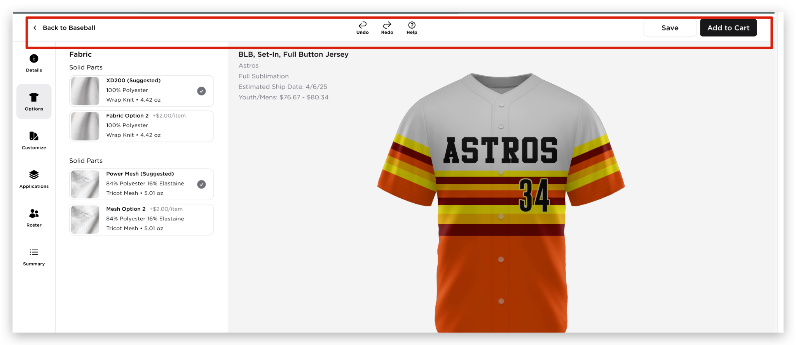  - Back to <Sport>  - For any action in the Picker page that opens the builder page,a “Back to <Sport>” link will be displayed and clicking this will return to the Picker page with the applied filters and team details if there’s any (Sticky Feature Requirement Consideration)  - Back to Cart  - For any action in the shopping cart that opens the builder page, a “Back to Cart” link will be displayed and clicking this will return to the Shopping Cart  - Back to Saved Designs  - For any action in the Saved Designs Page that opens the builder page, a “Back to Saved Designs” link will be displayed and clicking this will return to the user’s Saved Designs page  - Back to PDF File  - When the URL builder is accessed from the PDF file, “Back to PDF File” link will be displayed. Clicking it will return to the previously opened PDF file  - Back to Cart  - When the URL Builder is accessed from the Approval Page, a “Back to Cart” link will be displayed. Clicking it will return the user to the Shopping Cart  - Back to <Sport>  - When the URL Builder is accessed from anywhere outside the Customizer, a “Back to <Sport>” link will be displayed. Clicking this link will return the user to the Picker Page and filtered by sport to which the uniform belongs  - Undo  - Clicking this will revert the previous action  - After clicking Undo, the user will be redirected to the tab or section where the last action was undone  - Disabled when the builder first loads (including when a saved design is revisited)  - TBC – Limit for undo actions  - Redo  - Clicking this will restore the previous change  - After clicking Redo, the user will be redirected to the tab or section where the last action was reapplied  - Disabled when the builder first loads, (including when a saved design is revisited)  - TBC – Limit for redo actions  UNDO and REDO Scenarios  - Help  - TBD  - Save  - New UI will be implemented  - Clicking the Save button  - New Save and Share UI will be displayed  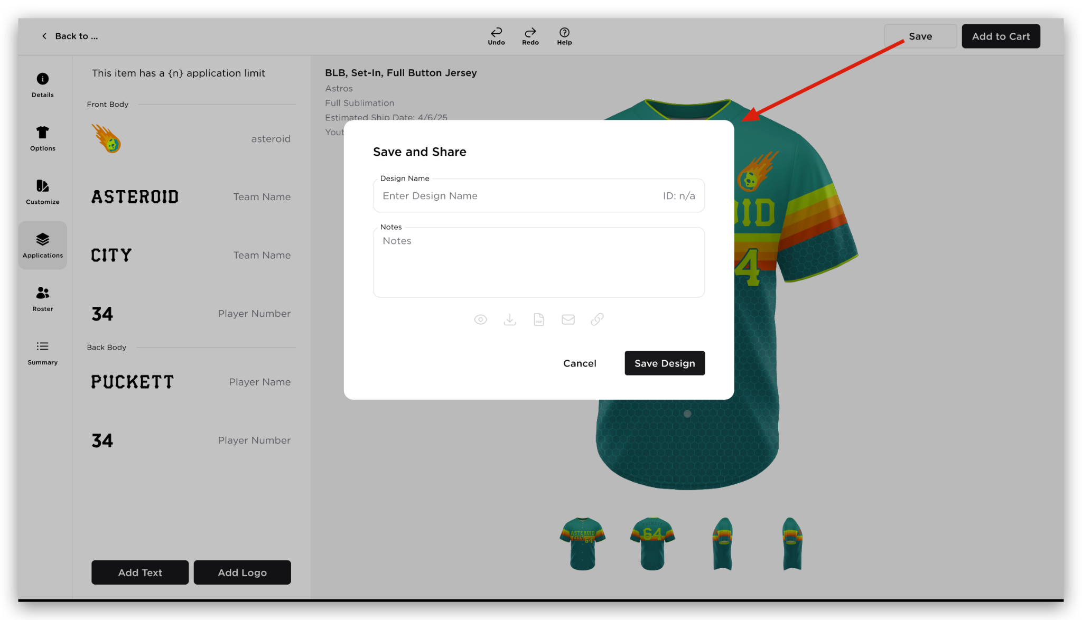  - The user will enter Design name and Notes  - Clicking Save Design will populate the ID number. All the ‘share’ functionalities below the ‘Notes’ will be enabled. ‘Save Design’ button will be changed to Done  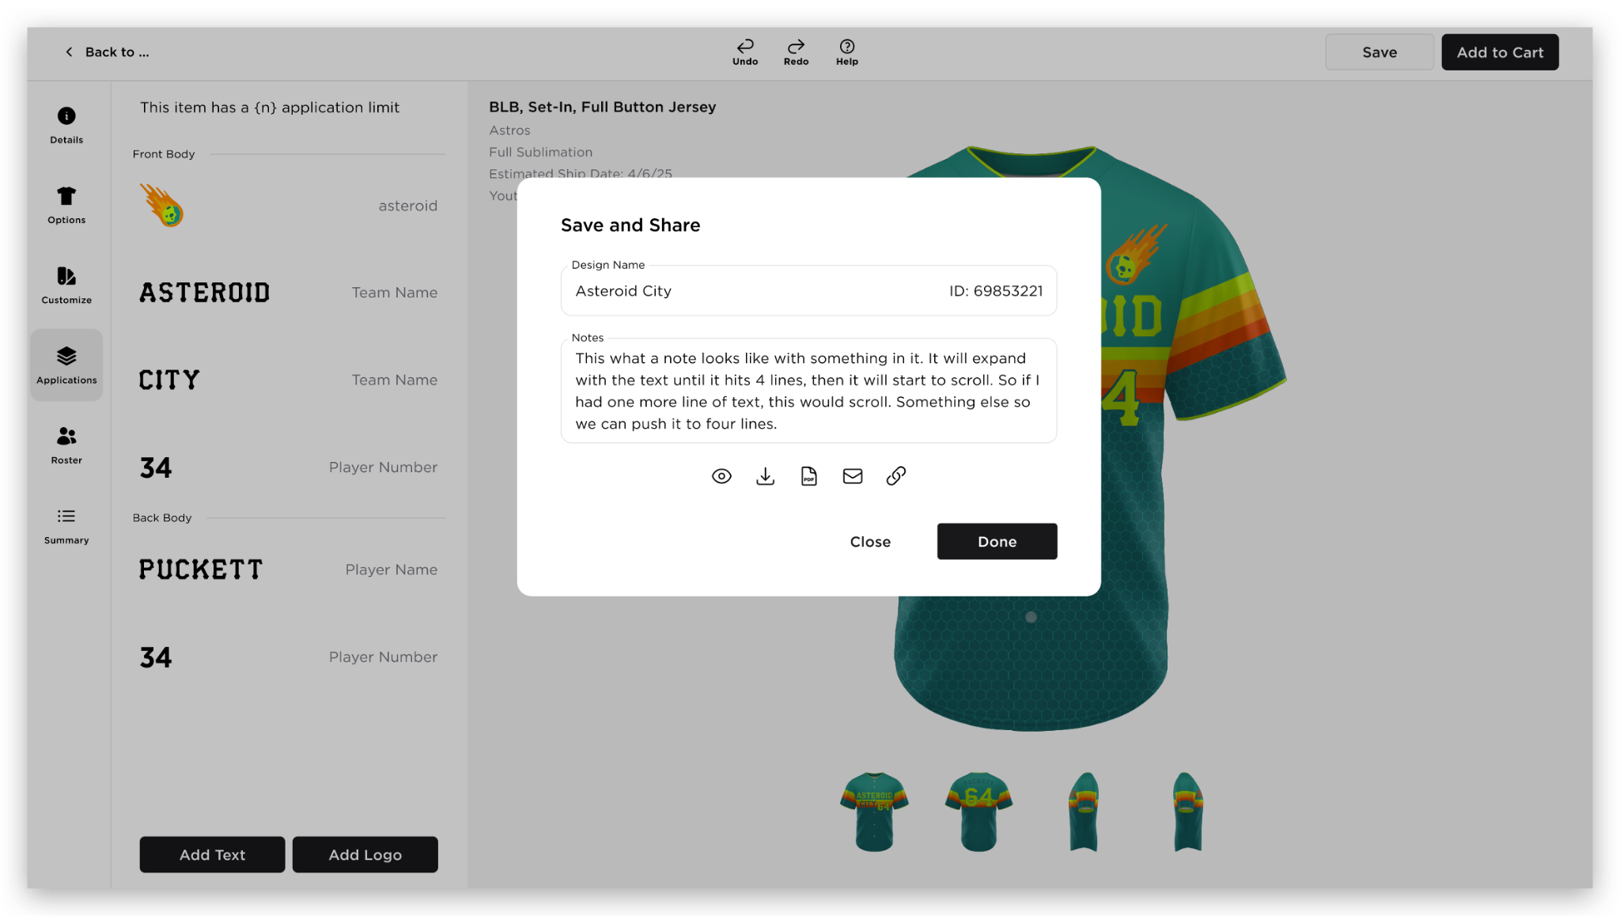  - Clicking Done will save the design. ‘Save‘ button in the header will be changed to ‘Update’  - When the user clicks ‘Update’, Save and Share modal will reopen  - When the user updates the Design Name, ‘Close‘ and ‘Done’ will automatically changed to ‘Close’, ‘Save as New’ and ‘Update’  - Save as New will create a new ID number and will display ‘Close’ and ‘Done’ button  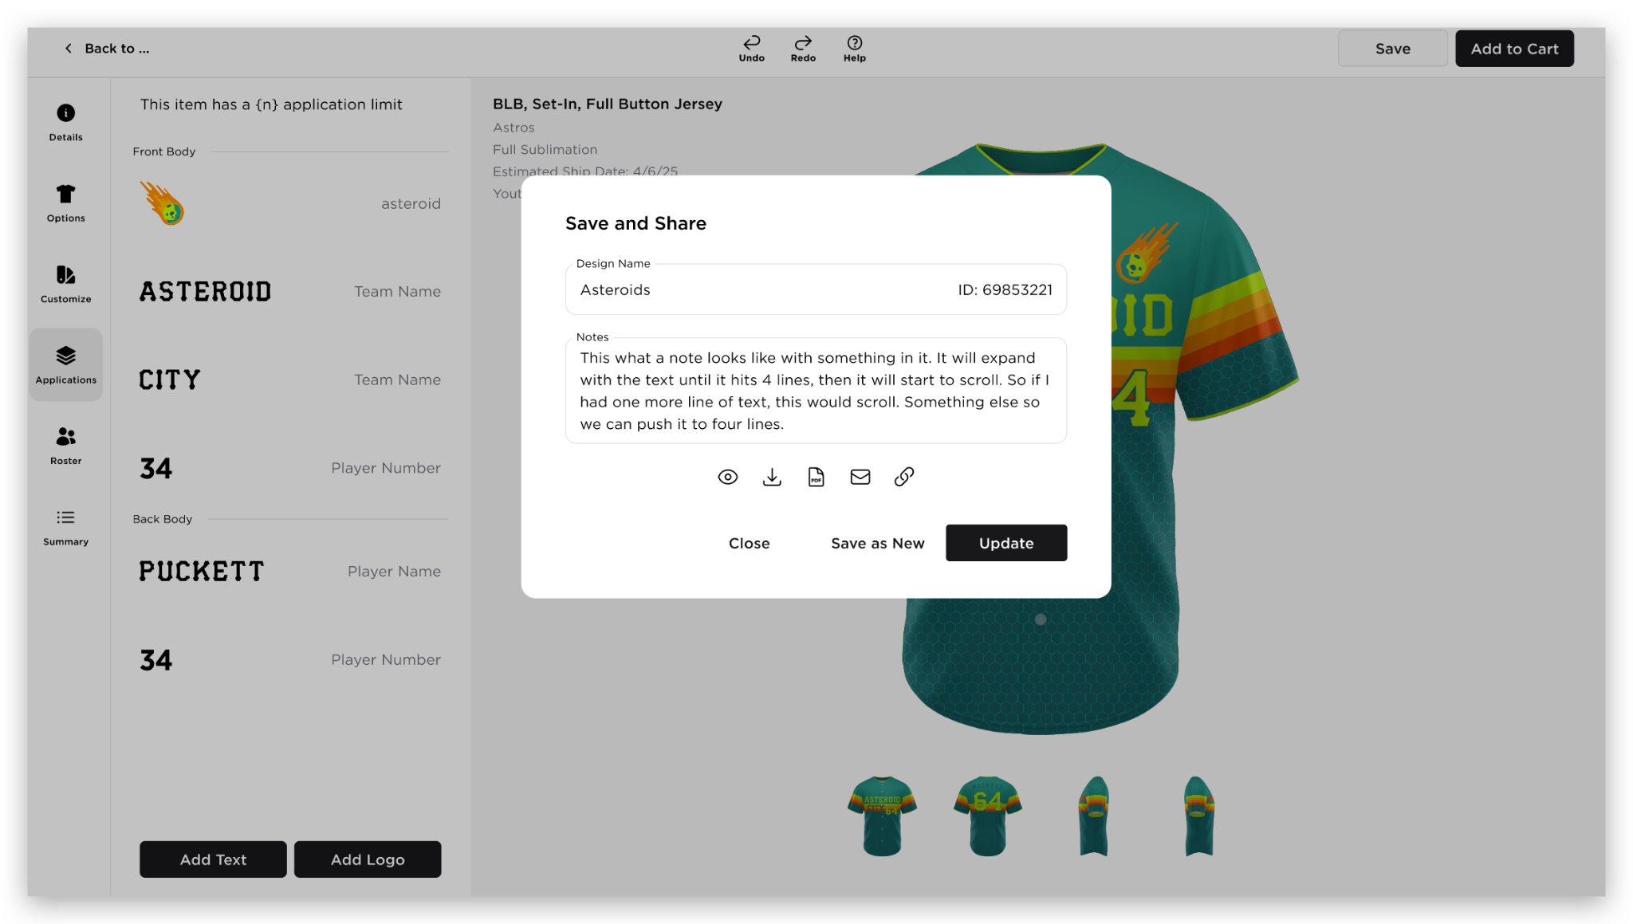  Share Functionalities  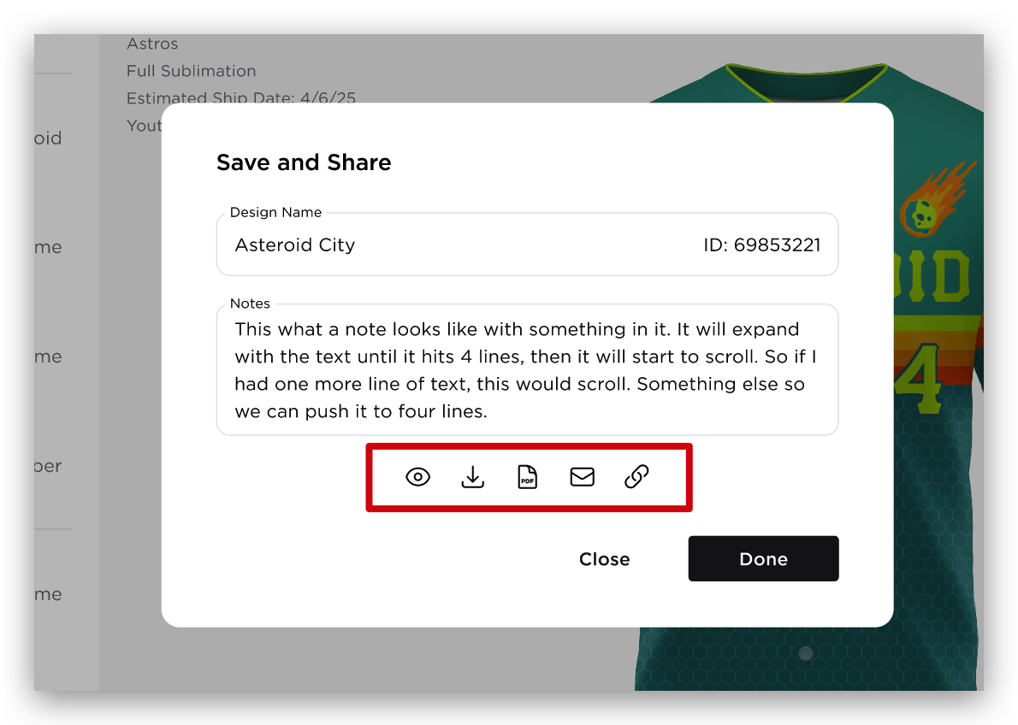  - View icon - redirection to Save Design Page  - Download icon  - Opens Download Images modal  - The user can select multiple items to be downloaded  - List of options  - All views as one image  - Front and back as one image  - Front View  - Back View  - Left View  - Right View  - List of Options for Reversible  - Side A: All views as one image  - Side A: Front and back as one image  - Side A: Front View  - Side A: Back View  - Side A: Left View  - Side A: Right View  - Side B: All views as one image  - Side B: Front and back as one image  - Side B: Front View  - Side B: Back View  - Side B: Left View  - Side B: Right View  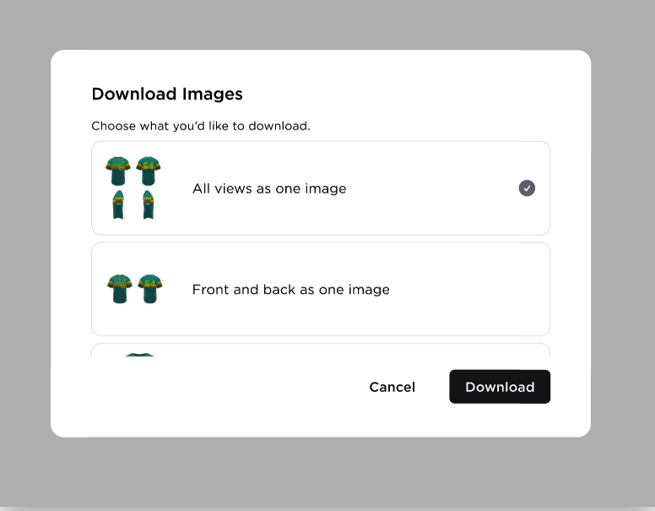  - When the user clicks “Download” button, it will open the local machine download functionality of the user  - File Type - .png  - File Name - Design Name_<Downloaded View>.png  - Example: Design Name_all-views.png  - If the user selected multiple images to be downloaded, it will be downloaded as a zip file  - Zip File Name: Design Name  - View PDF - opens the PDF of the style in a new tab  - Share via Email  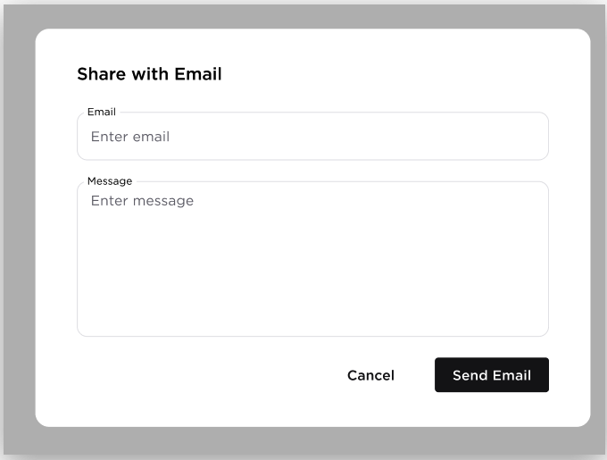  - Share Link - copies the URL builder  - Add to Cart  - Clicking Add to Cart button will open “Add Item to Cart” modal  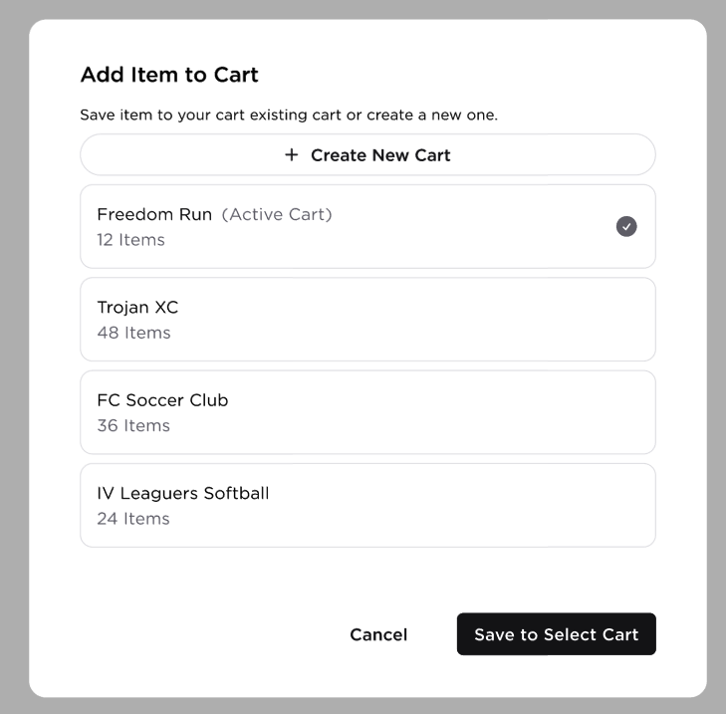  - Create New Cart  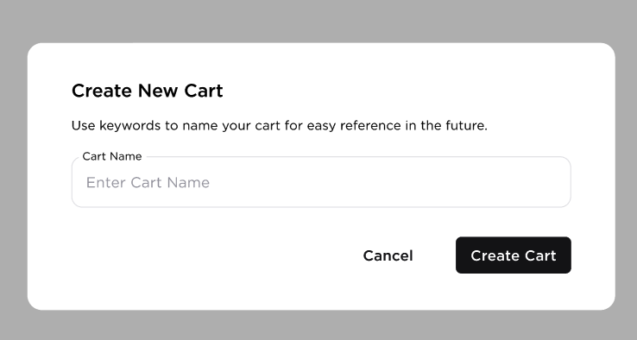  - Clicking the ‘Create Cart’ button will automatically added the item to the cart  - The 'Item Added to Cart' modal will then be displayed  - Once the cart is created, “Item Added to Cart” modal will display  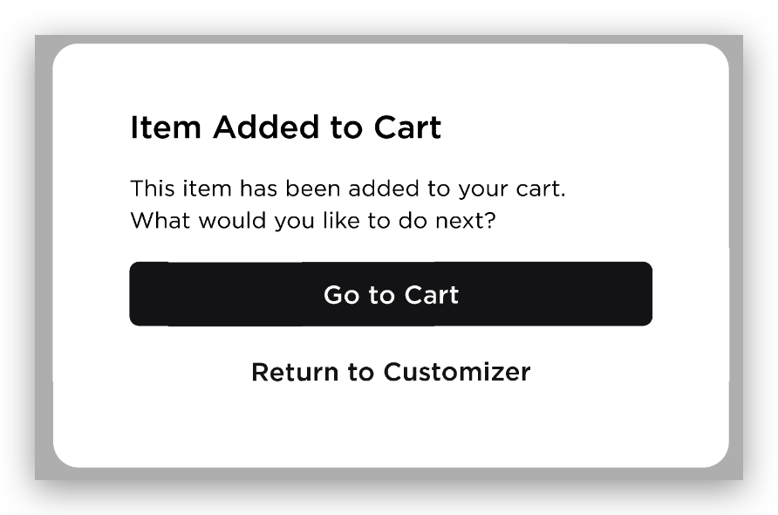  “This item has been added to your cart. What would you like to do next?”  - Go to Cart  - The user will be redirected to the Shopping Cart  - Return to Customizer  - If the user came from the picker page, they will be redirected to the picker page with any filters and team details applied (Follow sticky filters current behavior)  - If the user came from saved designs, the button will be changed to “Return to Saved Designs” and they will be redirected to the Saved Designs page  - If the user came from the URL Builder accessed from anywhere outside the Customizer or other pages aside from the two scenarios mentioned above, they will be redirected to the Picker Page and filtered by sport to which the uniform belongs to  - Add to Cart button will change to ‘Update Item’ when the user opens the builder from the Shopping Cart
3 | STYLE CANVAS | 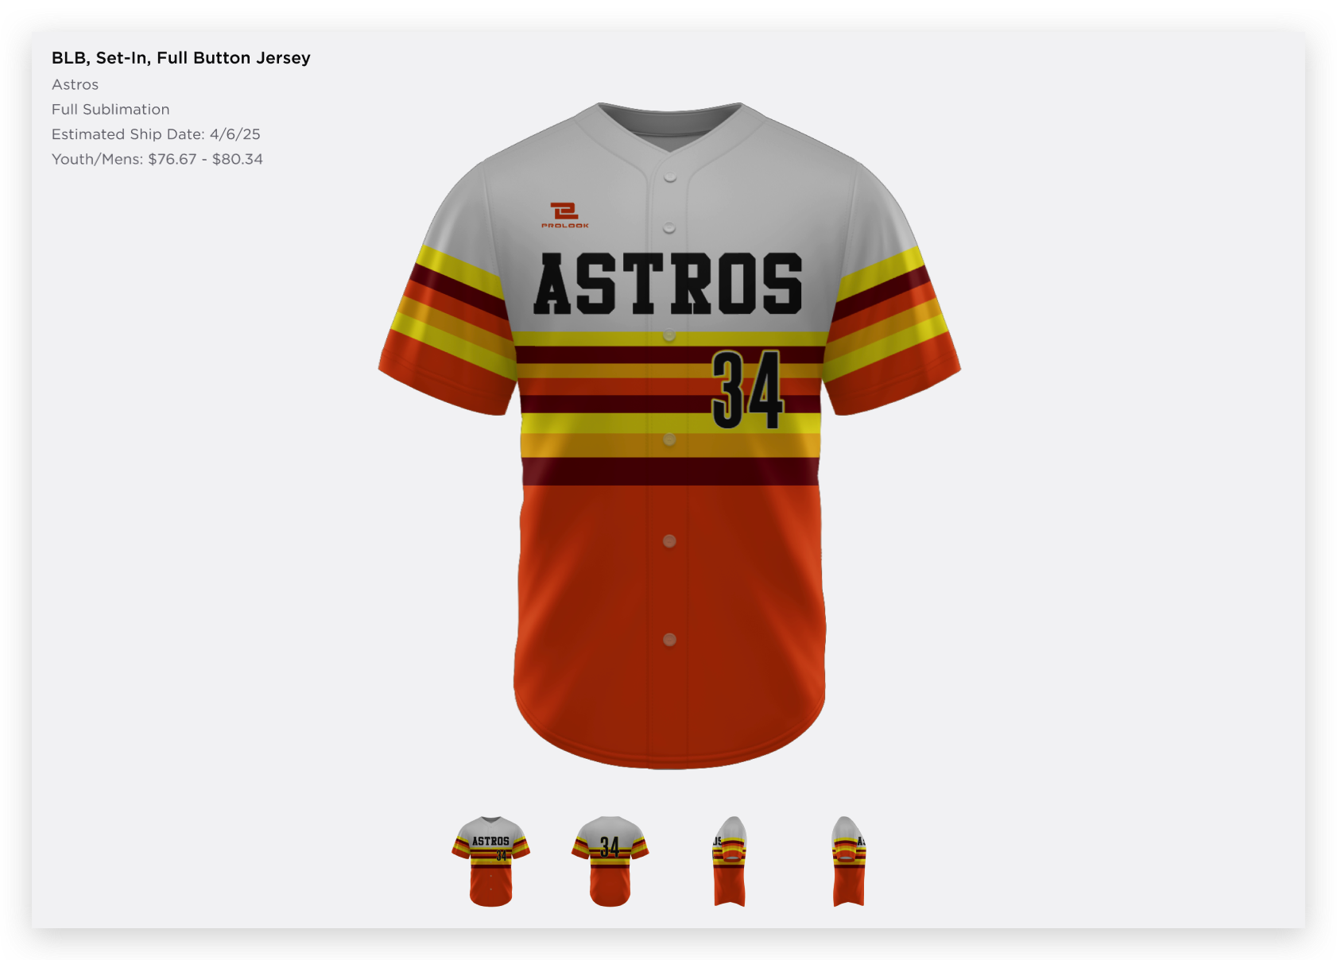  - BLB, Set-in, Full Button Jersey - Product name (Brand Style Request Page (https://staging-qx7.prolook.com/admin/brand_style/edit/1430))  - Astros - Style Name  - Full Sublimation - Product Functionality Type  - Estimated Ship Date: 4/6/25  - Youth/Mens: $76.67 - $80.34  - Main Uniform Canvas  - Different Product Views  - Fix the issue on updating the thumbnails  - The thumbnails should be updated upon clicking;  - Different perspectives  - Another tab (Details, Options, Customize, Application, Roster and Summary)  - Save button (header buttons)  - Disclaimer Message: Display the following message at the bottom part of the Product Views: “Thumbnails update when you switch tabs.”
4 | DETAILS TAB | 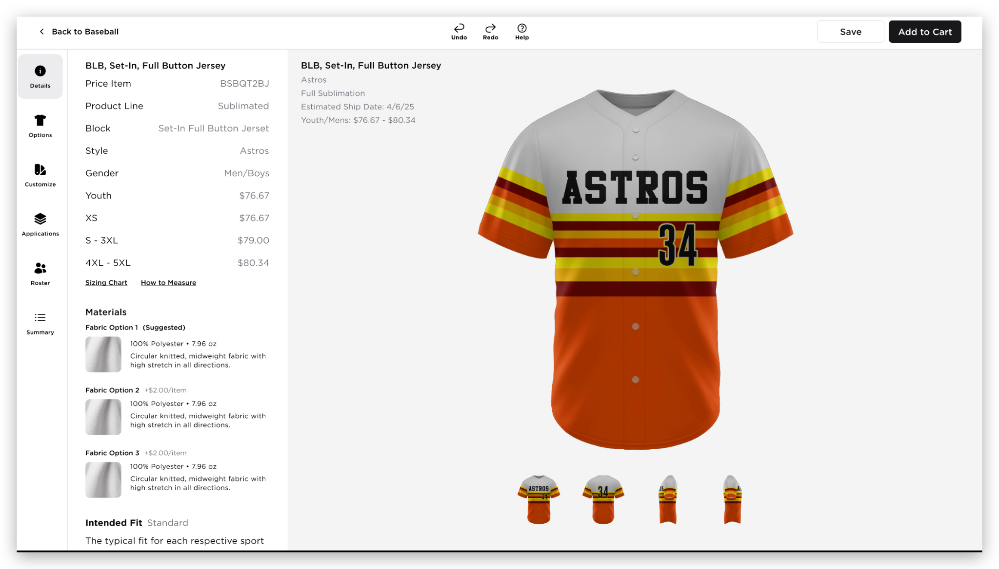  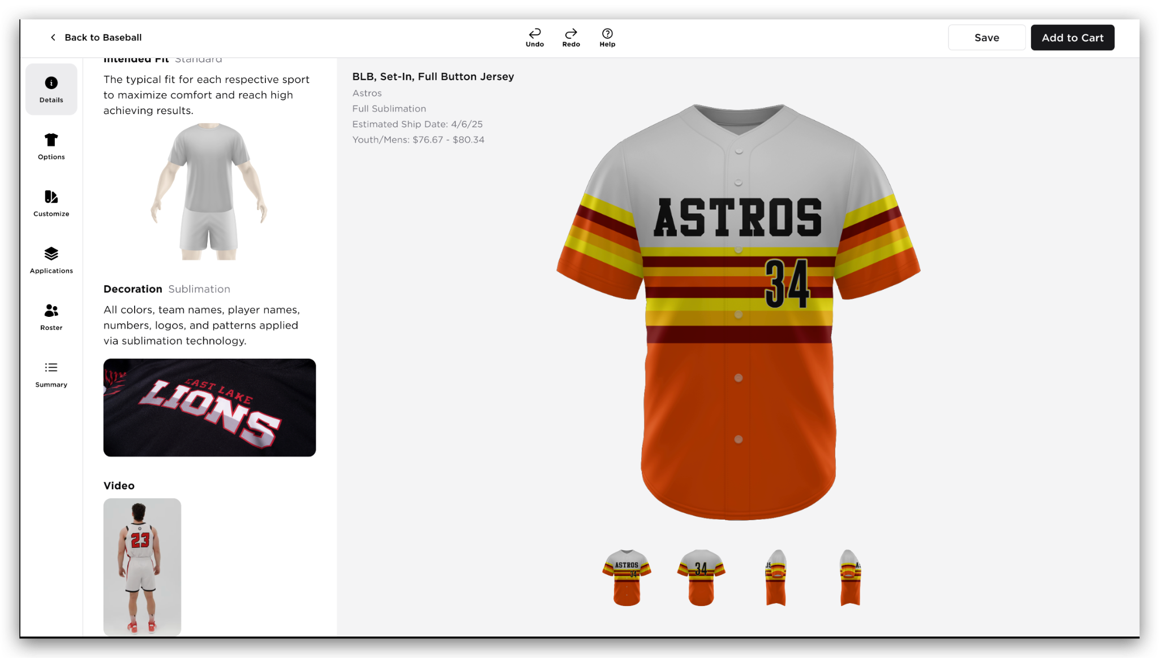  - BLB, Set-in, Full Button Jersey - Product name (Brand Style Request Page (https://staging-qx7.prolook.com/admin/brand_style/edit/1430))  - Price Item  - Product Line  - Block  - Style  - Gender  - Youth  - Adult  - Sizing Chart Link  - How to Measure  - Materials  - Show all the fabric options with its details (https://staging-qx7.prolook.com/admin/master_fabric/edit/57)  - Fabric Name (Suggested)  - Image  - Content  - Weight  - Construction, Function/Features  - Fabric images are clickable and will open its modal  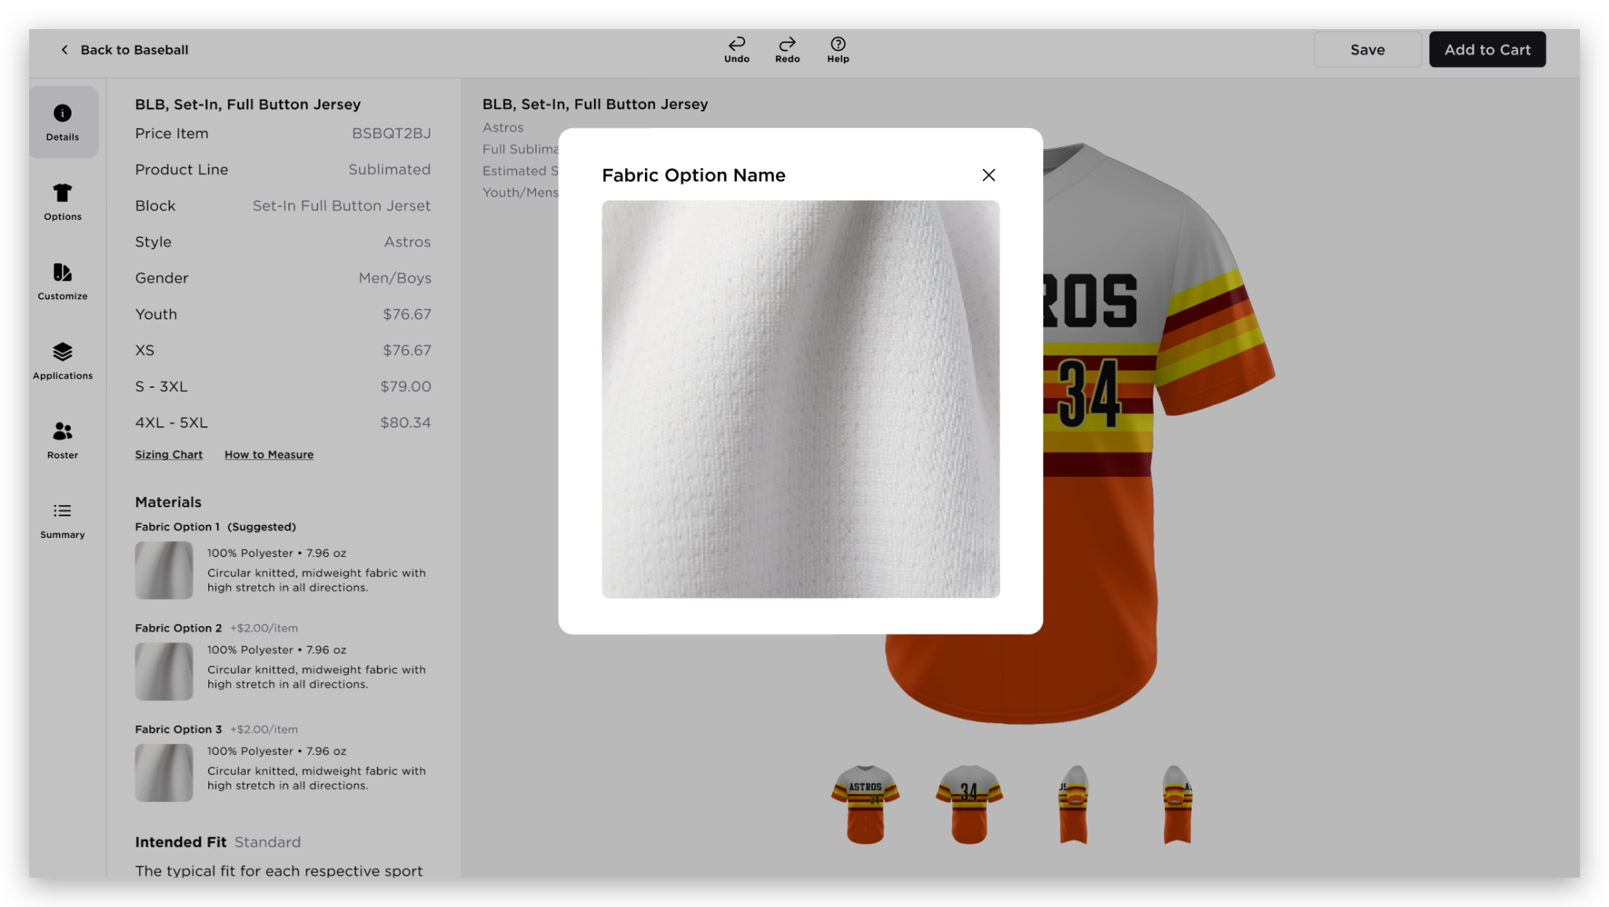  - Intended Fit  - Image is clickable and will open its modal  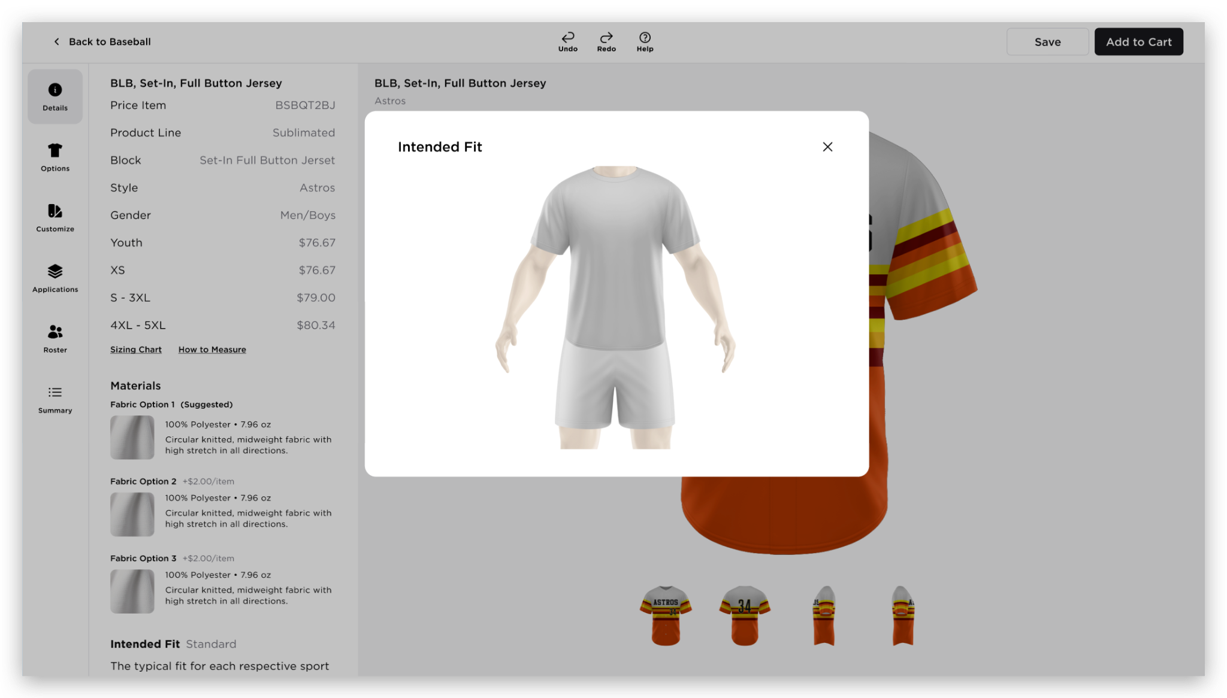  - Decoration  - Video - if there’s any  DECORATION THUMBNAIL MODAL  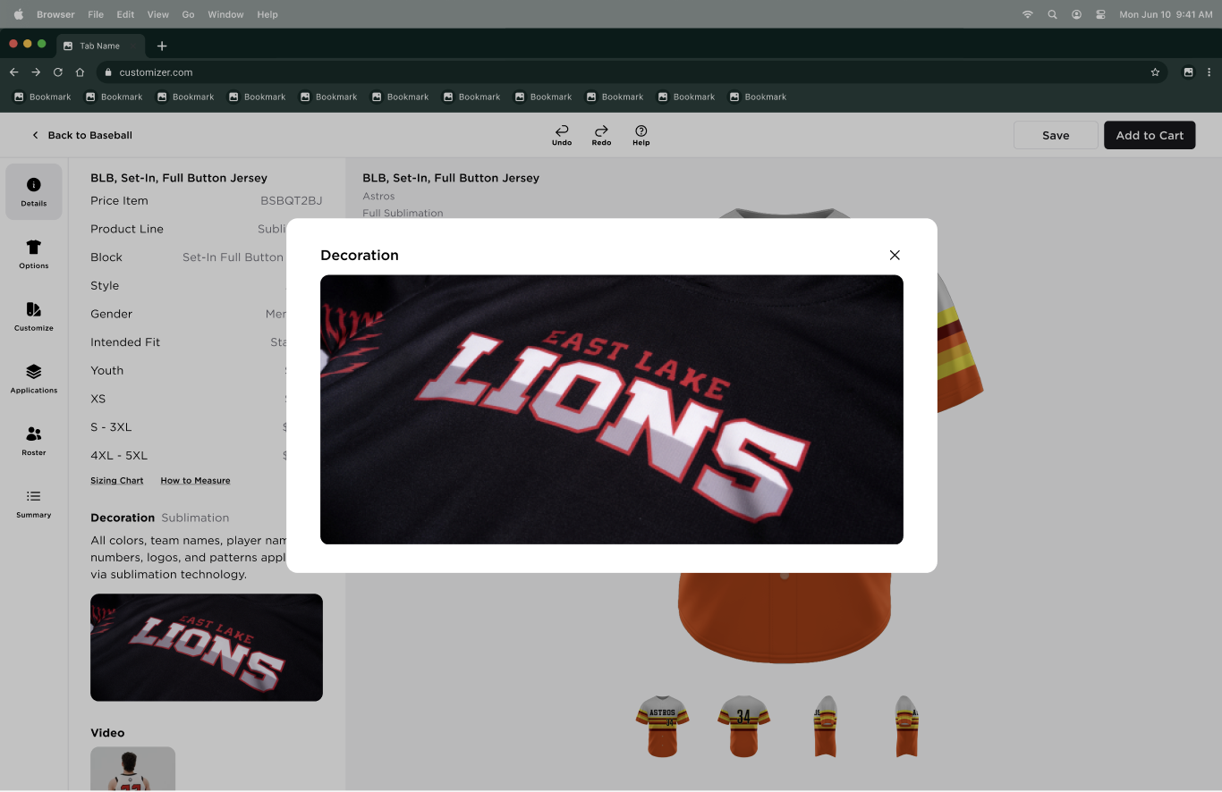  VIDEO MODAL  - When the user clicks the video thumbnail. The video modal will be displayed and the video is automatically played (same as the Prolook.com video)  - Current Skin: YouTube videos are displayed, and the user needs to click the play button for the video to play  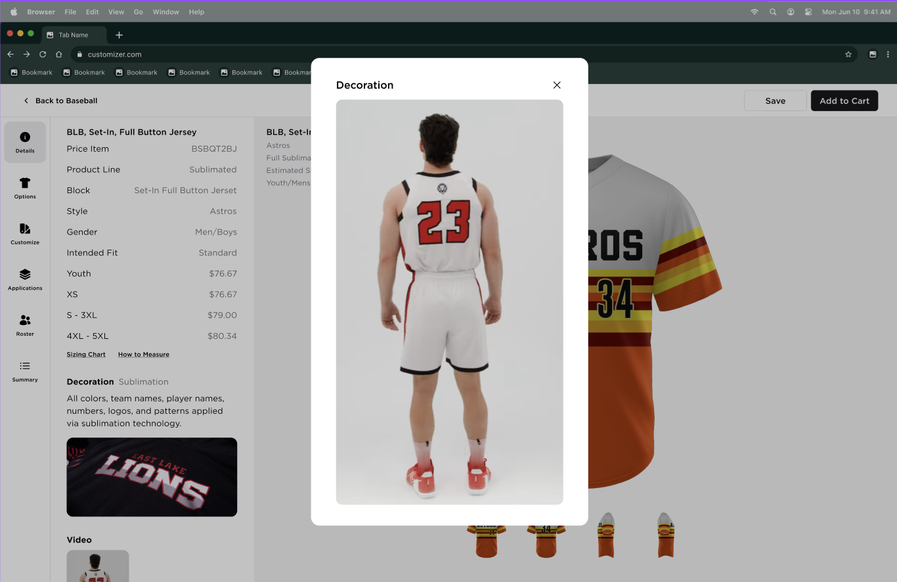
5 | OPTIONS TAB | 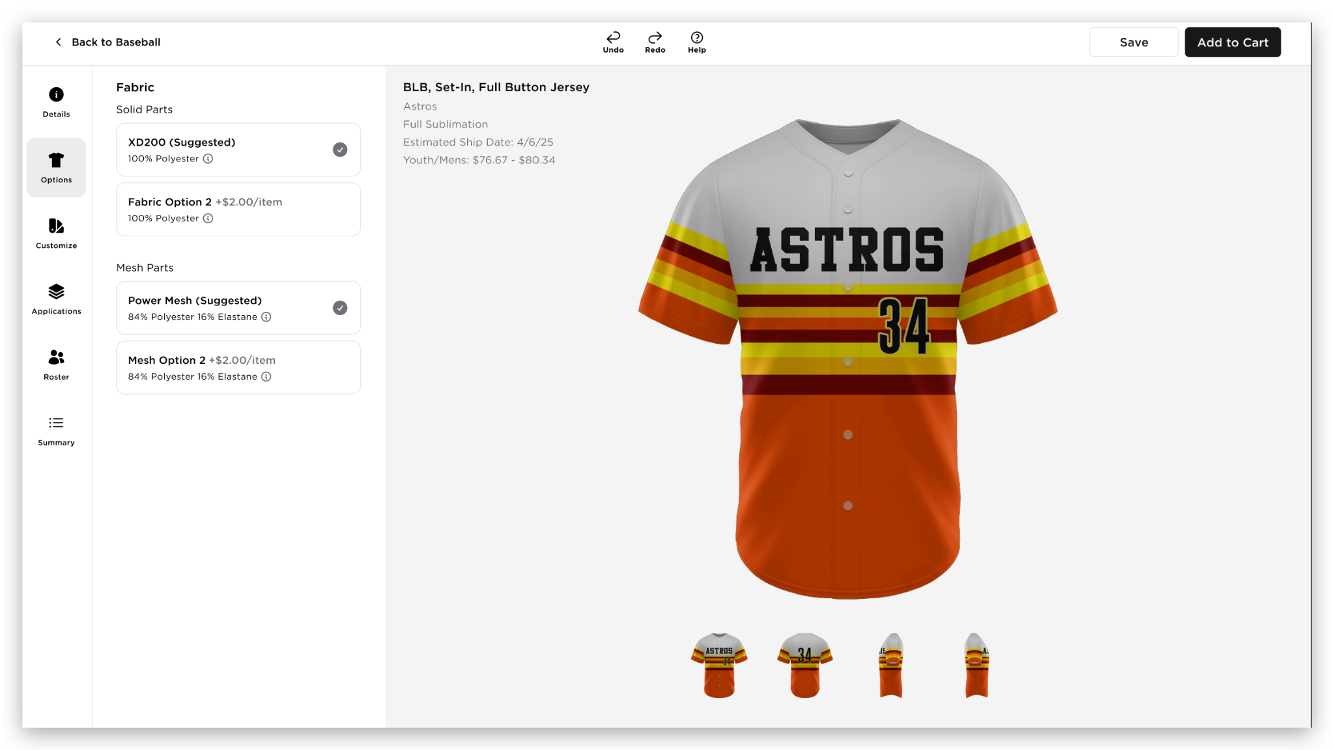  - The Options tab will be the default landing page when the uniform first loads in the builder  - The Options tab will include Fabric options  - The Fabric options will display the following:  - Fabric - header label  - Body Part Group - e.g Body, Panel  - Fabric details  - Fabric Content (with information icon)  - Hovering over the info icon will display tooltip modal to display the additional details about the fabric  - Fabric Name  - Image  - Content  - Weight  - Construction, Function/Features  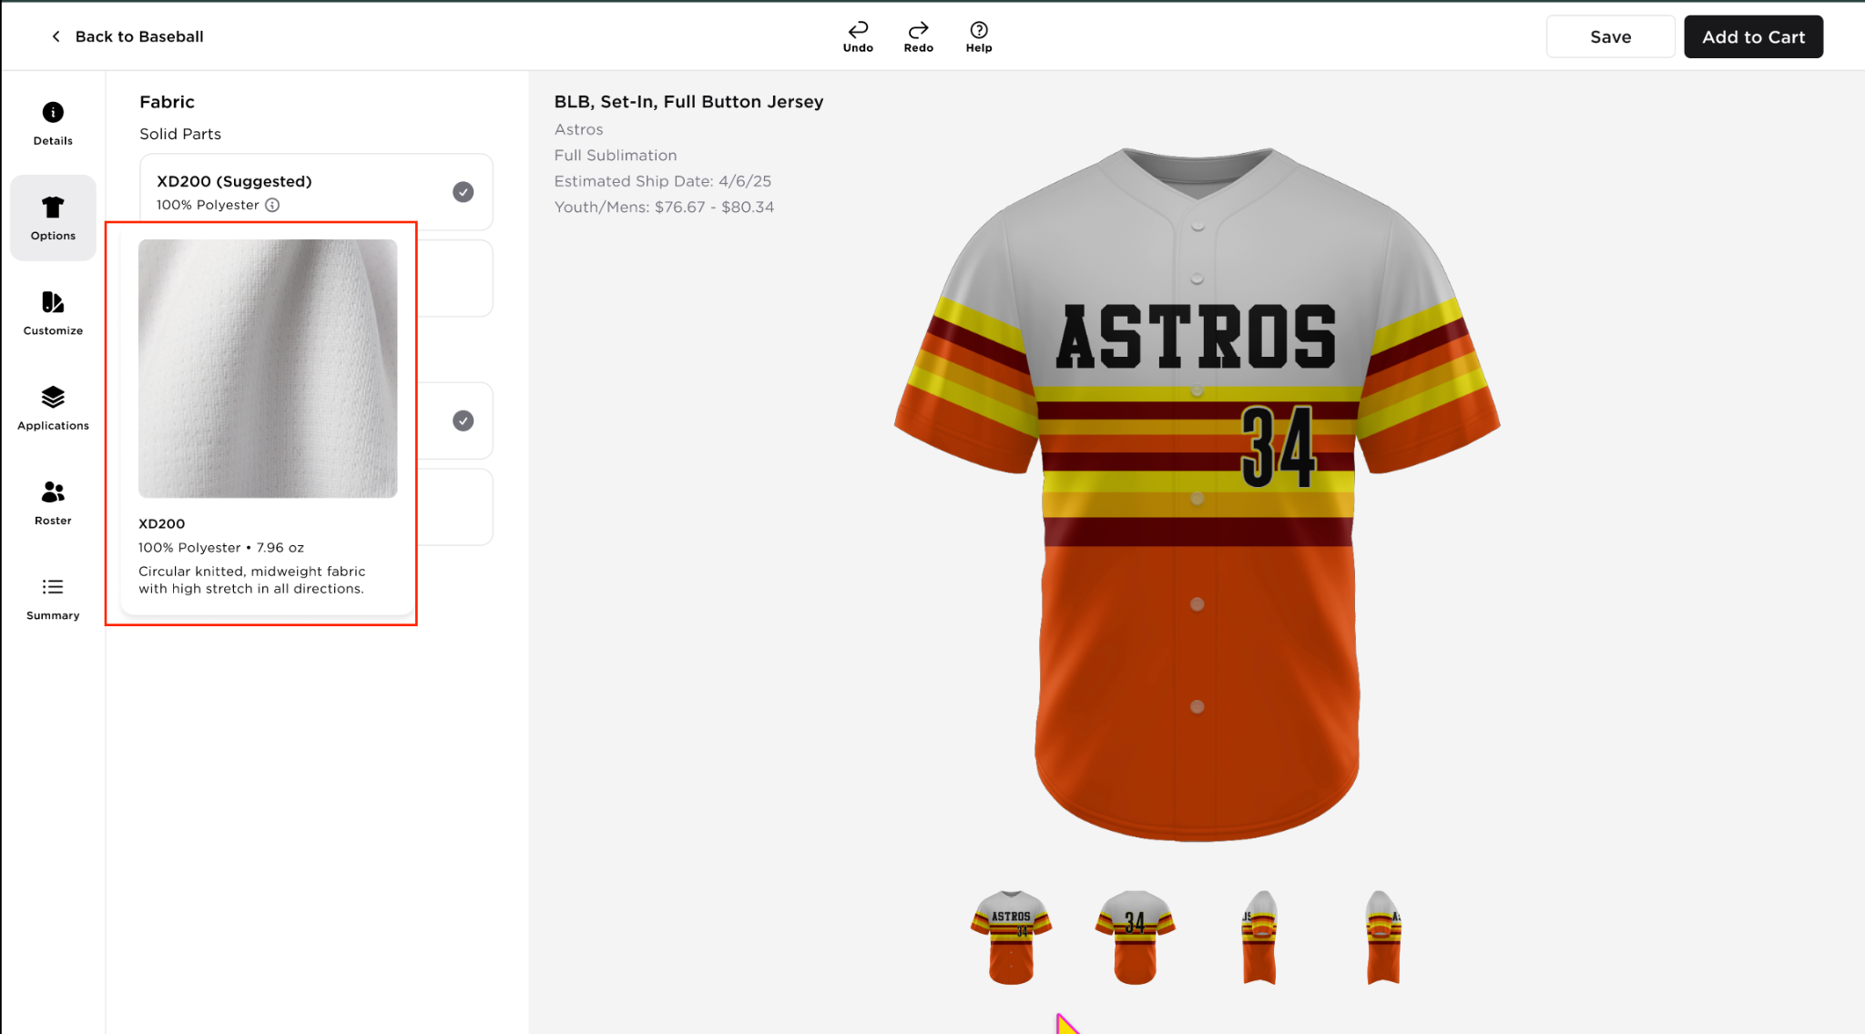  - Fabric upgrade charge is displayed if there’s any applicable fee (+$xx.xx/item)  - The fabric upgrade charge should automatically added in the Summary Tab  - BRD_ABILITY TO ADD AN ITEM TO THE CART WITHOUT A FABRIC SELECTED  - Options tab for Reversible  - There will be additional information added below the Fabric header  - “Fabric selection will be applied to both Side A and Side B”  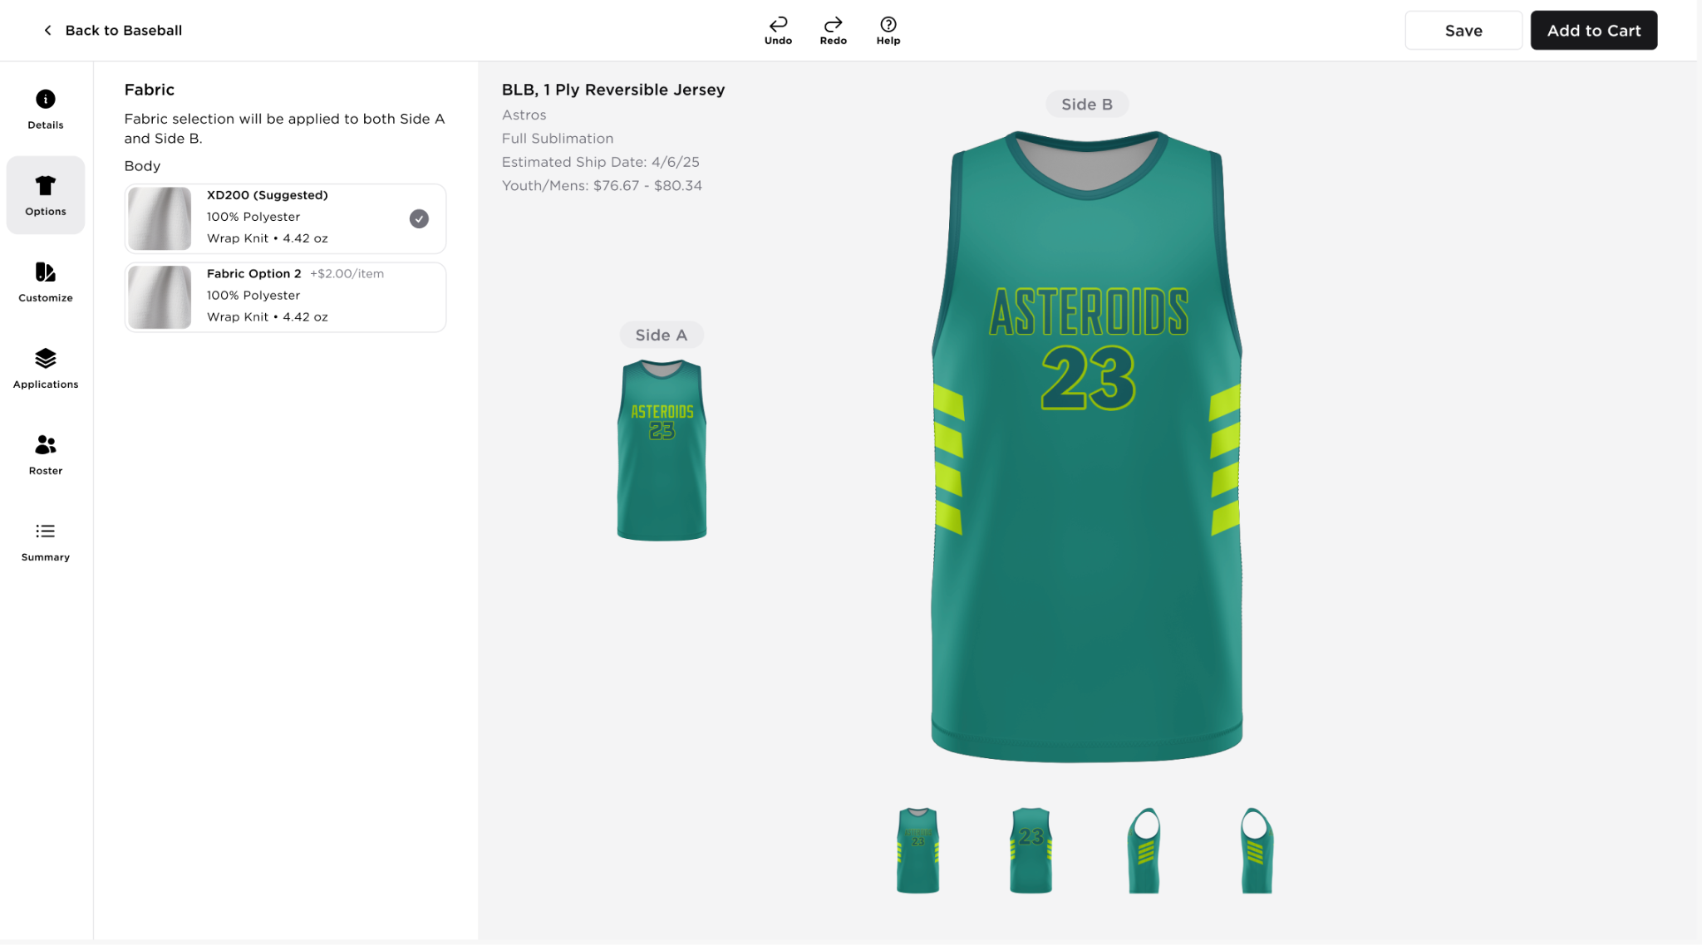
6 | CUSTOMIZE TAB - REGULAR UNIFORM | 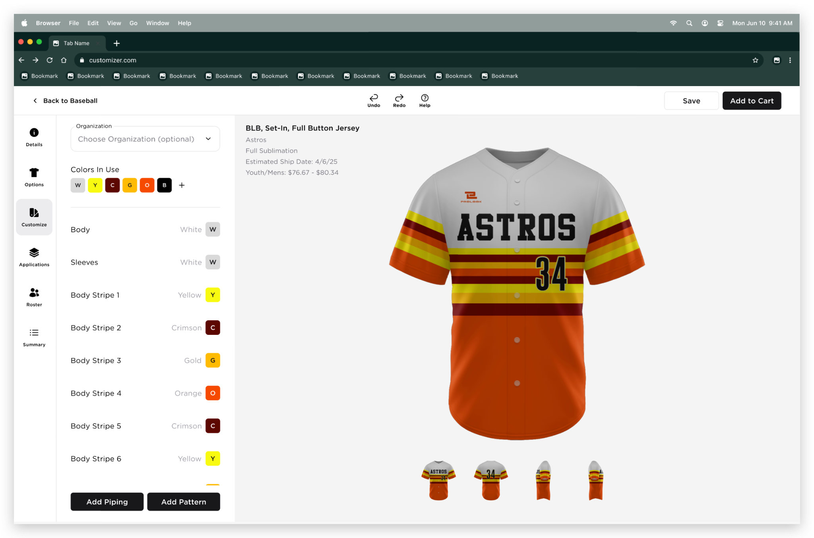  - Organization - This section is present if the brand has an active team database functionality  - Organization dropdown should not be present and the Colors In Use will be the top most section  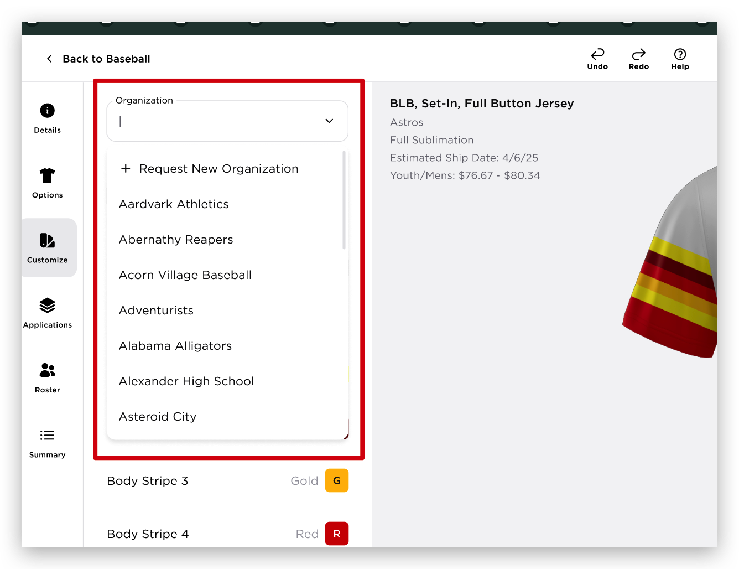  - This dropdown will display all the organizations(teams) linked to the user  - The organization (teams) dropdown items should contain the following details  - Image  - Organization Name  - Location Details  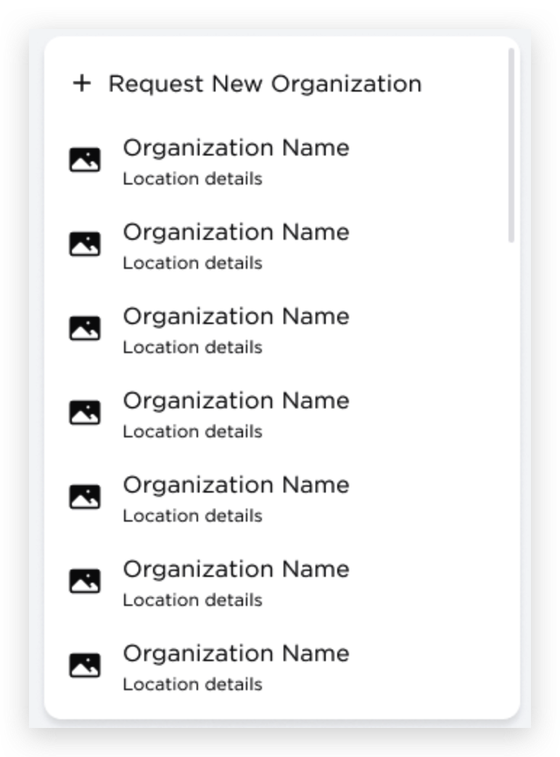  - This dropdown will function as filter (e.g. if the user entered As, all the teams starts with As will be filtered)  - {Request New Organization - this will be part of the future Team Database functionality}  - If the user selects another organization, Colors In Use modal will be displayed.  - “The colors for <organization selected> are different from your current Colors In Use. Choose which colors you’d like to use:  - Color Tiles + New Color + Checkbox (default selection)  - Color Tiles + Current Color + Checkbox  - Cancel - this button will cancel the action and no changes will be applied  - Continue - this button will update the colors in use list and will be applied to the parts.  - If the new organization has a new set of colors, the “Colors in Use” modal will be displayed, showing the New Colors and Current Colors  Modal for Equal Number of Colors  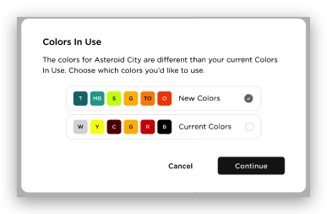  Modal for Unequal Colors  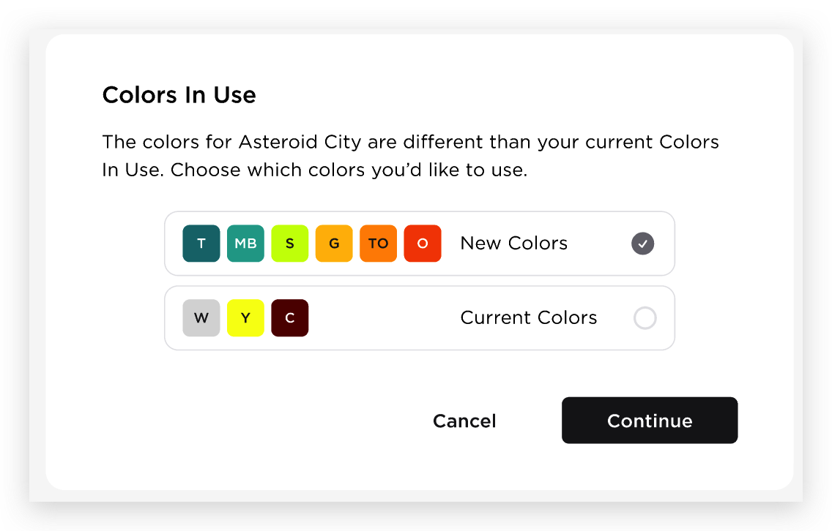  Modal for Large Number of Colors  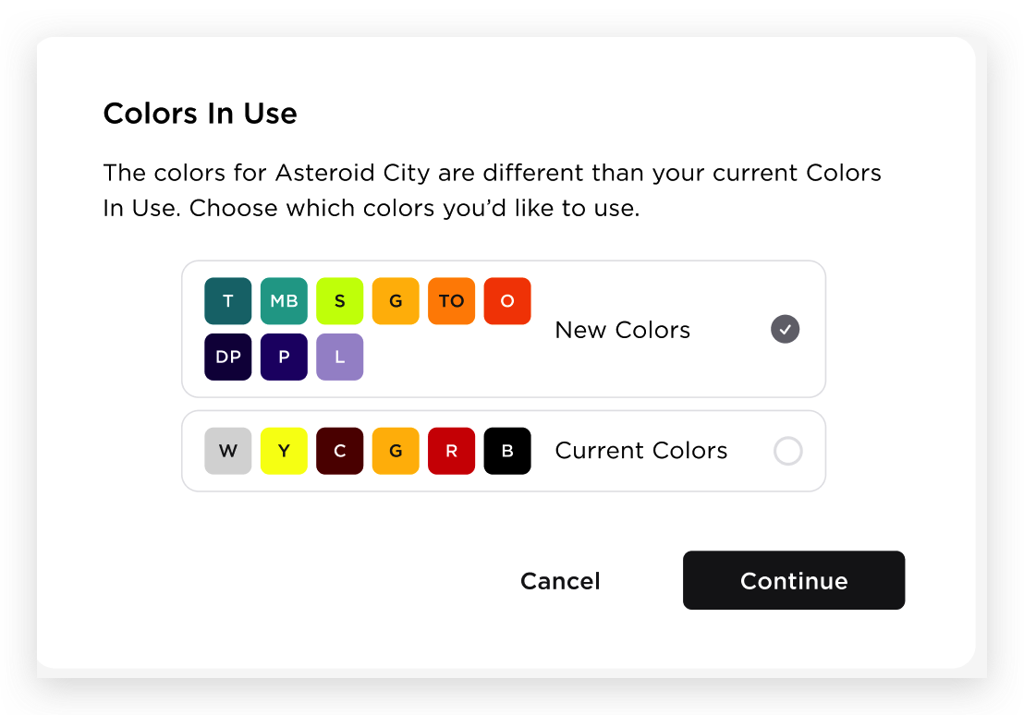  - Upon clicking the Continue button, if the new organization has a different set of colors that is not available in the selected style, the “Colors Unavailable” modal will be displayed, allowing the user to update and replace the unavailable colors. Once the user clicks the Update Colors button, the modal will be closed and the Colors In Used will be updated  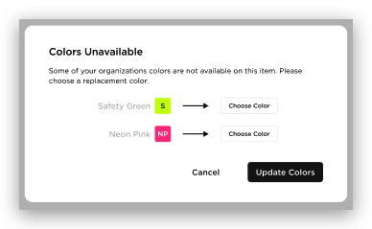  - Upon clicking the Continue button, if the new organization has less than 2 new sets of colors, the user must select one more color before they can update the organization. Once the user clicks the Continue button, the modal will be closed and the Colors In Used will be updated.  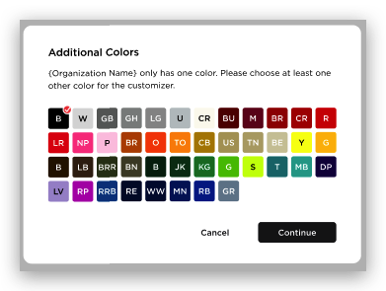  - If the new organization has no set of colors, the Color in Use modal will not be displayed and it will just change the organization  - Colors In Use  - Colors in Use will display the default colors of the uniform upon loading, or the colors applied from the Picker page  - The user can change the colors by clicking each color tile  - Upon clicking the color tile, color picker will be displayed below the selected section  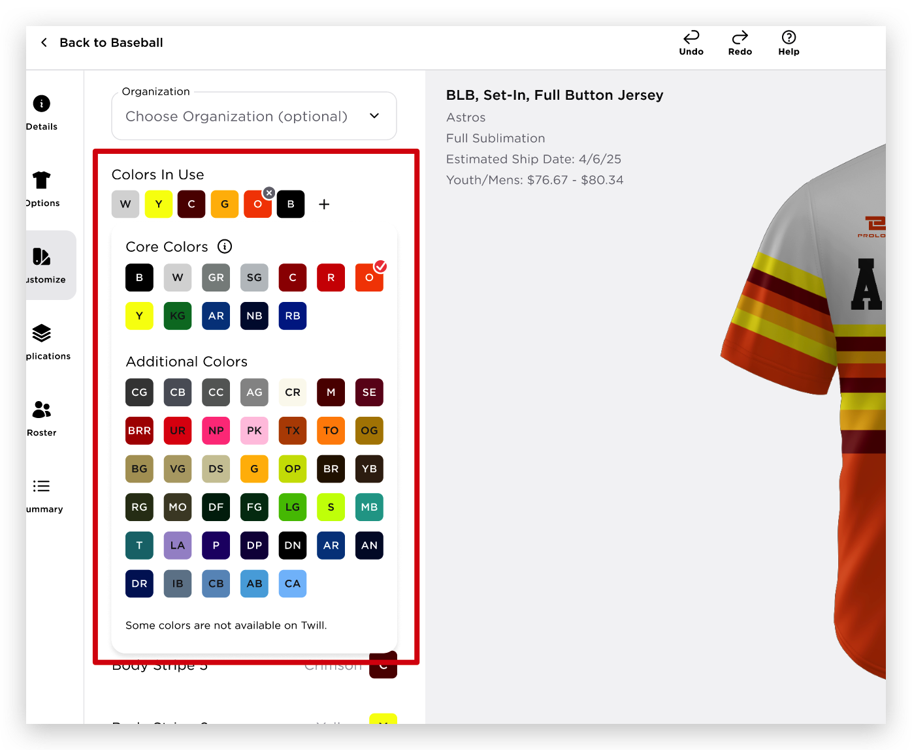  - Core Colors are set of colors determined by the brand  RD_Core Colors Toggle in Colors By Brand Page  - Info Icon - a color guide that will open a full modal (TBC)  - New QX7 config for the info icon  - Hardcoded for now  - Additional Colors will be the other colors other than the Core Colors  - If there are no Core Colors, will only show “Colors”  - Some colors are not available on Twill  - Once the user changed the color, all the the parts with the same color will be updated to the new color selected  - When the user hovers over the color tile, it will display the color name  - Adding a new color via ‘+’ button  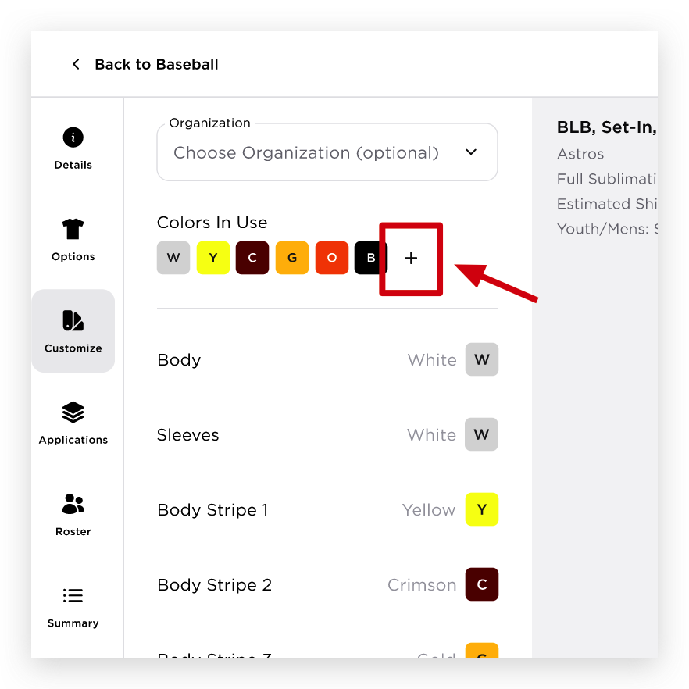  - When the user clicks the ‘+’, the color picker will be displayed  - The user can only select 1 color at a time  - There will be a 15 colors limit  - Removing a color via ‘x’button on color tiles  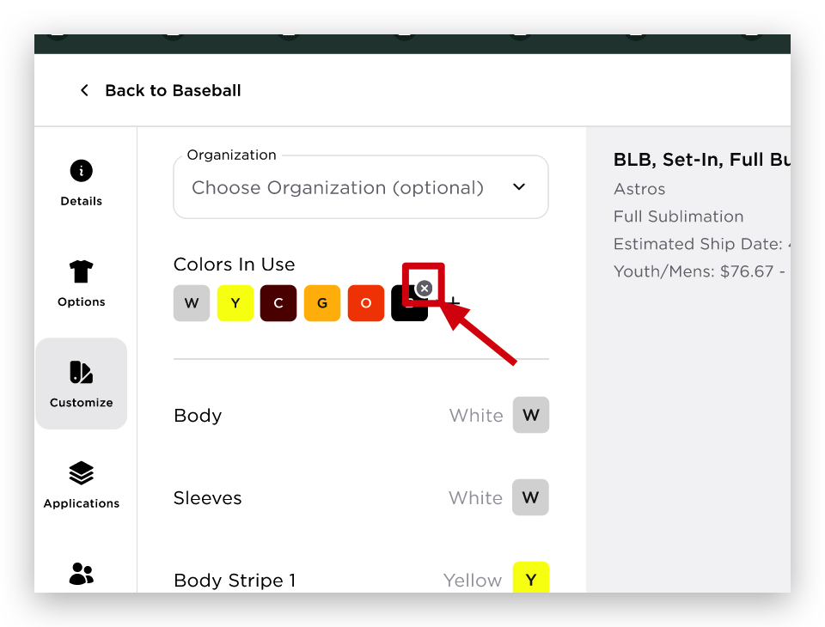  - When the users clicks the ‘x’ on the color tile;  - The color will be removed in the Colors In Use list if this color is not applied in any parts and applications  - If the user has only 2 colors in the Colors In Use list, and tries to remove a color, ‘Color In Use Minimum Color’ modal will be displayed and the user either must cancel the action or replace the color  Colors In Use Minimum Colors  A minimum of two colors is required for customization. Please choose a replacement color  - If the user choose to remove a color that is currently applied in parts and applications, Remove Color modal will be displayed  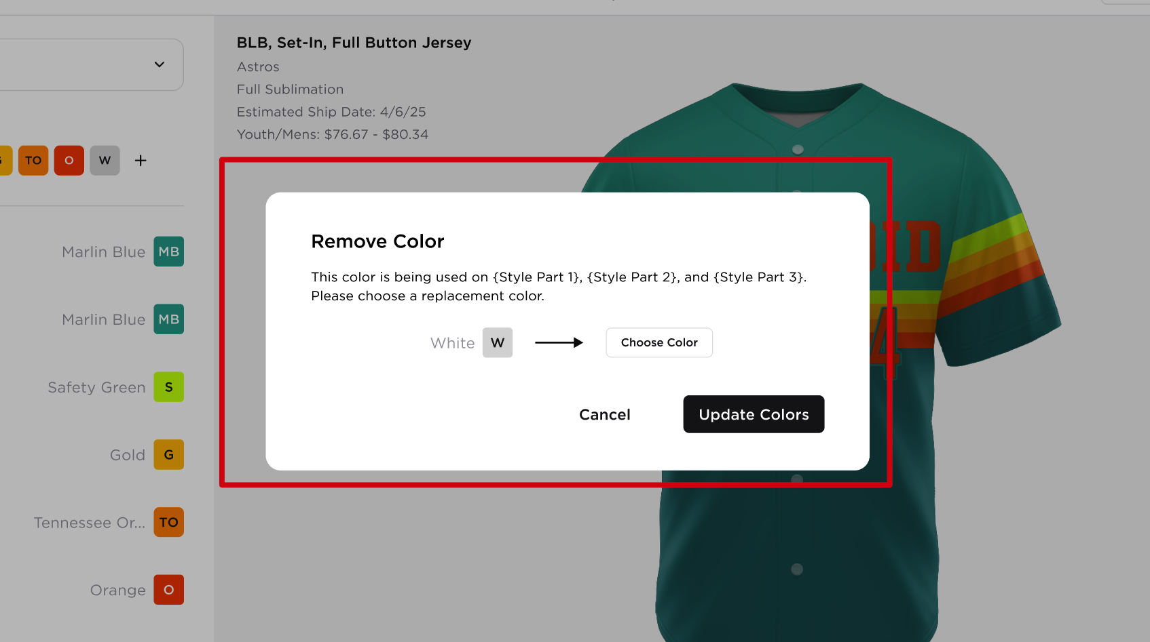  Remove Color  This color is being used on {Style Part 1}, {Style Part 2} and {Application Name}. Please choose a replacement color.  Current Color Name + Color Tile → Choose Color Button  - Choose Color Button - will open the color picker, allowing the user to select a replacement  - Cancel button - this button will cancel the action and no changes will be applied  - Update Colors button - this button will update the colors in use list and related parts colors  - If the user clicks Update Colors without selecting a color, the button will be highlighted in red to indicate that a color selection is required.  - Updating of Colors in Colors In Use List  - When the user updates a color tile to an existing color from the list, the original color tile will be removed from the list.  - Example:  - Existing colors in the Colors In Use list: White, Blue, Orange, Pink  - If the user replaces White with Pink, the updated Colors In Use list will be: Pink, Blue, Orange.  - Note: If Pink is currently used in any parts, there will be no changes to those parts. Pink will still be applied to them. All parts (including patterns, piping, application) that previously had White applied will be updated to Pink.  - Parts  - All the parts are listed within this section  - Each part will display: Part Name + Color Name + Color Tile  - When the user hovers over a “part name”, the corresponding part will be highlighted on the uniform canvas  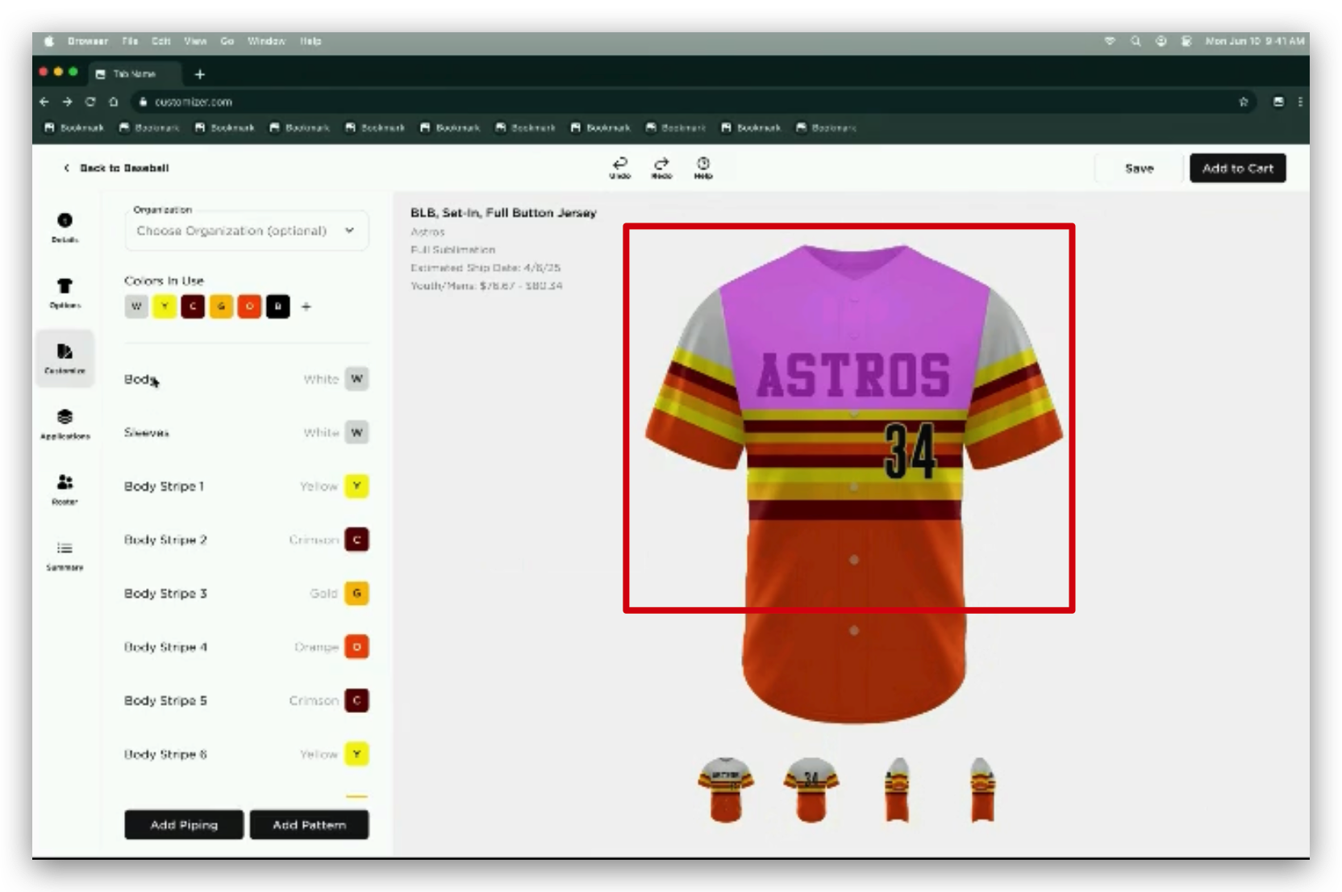  - If the color name exceeds the available space, it will be truncated accordingly  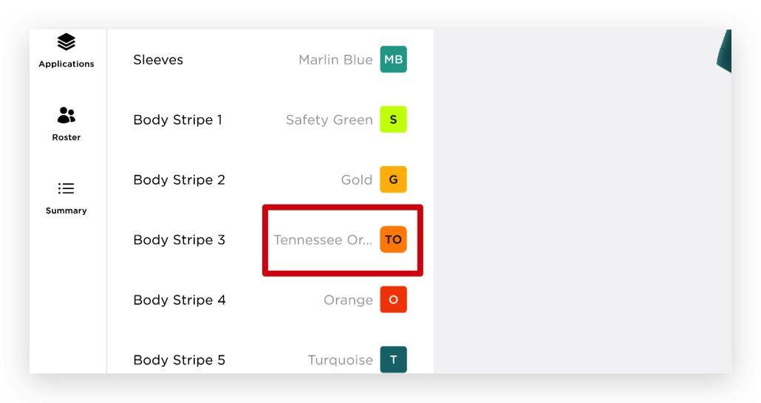  - When the user hovers over a color tile, the list of Colors in Use overlay will be displayed, allowing the user to select the desired color for the corresponding part.  - Once the user updates the color, the uniform canvas will be updated accordingly  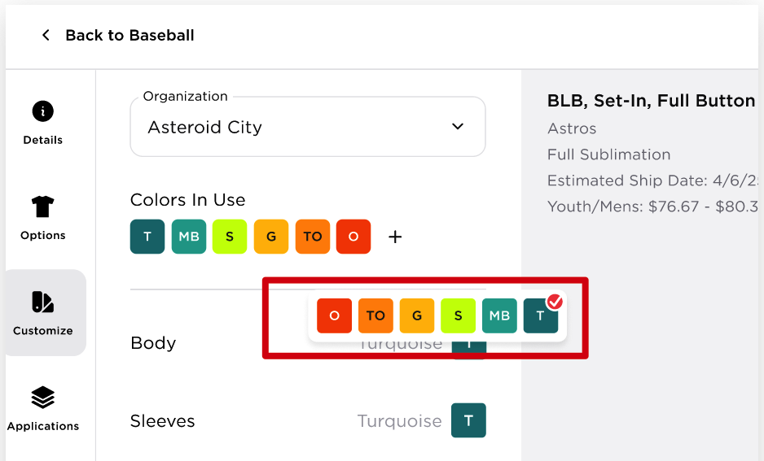  - Brand Logo  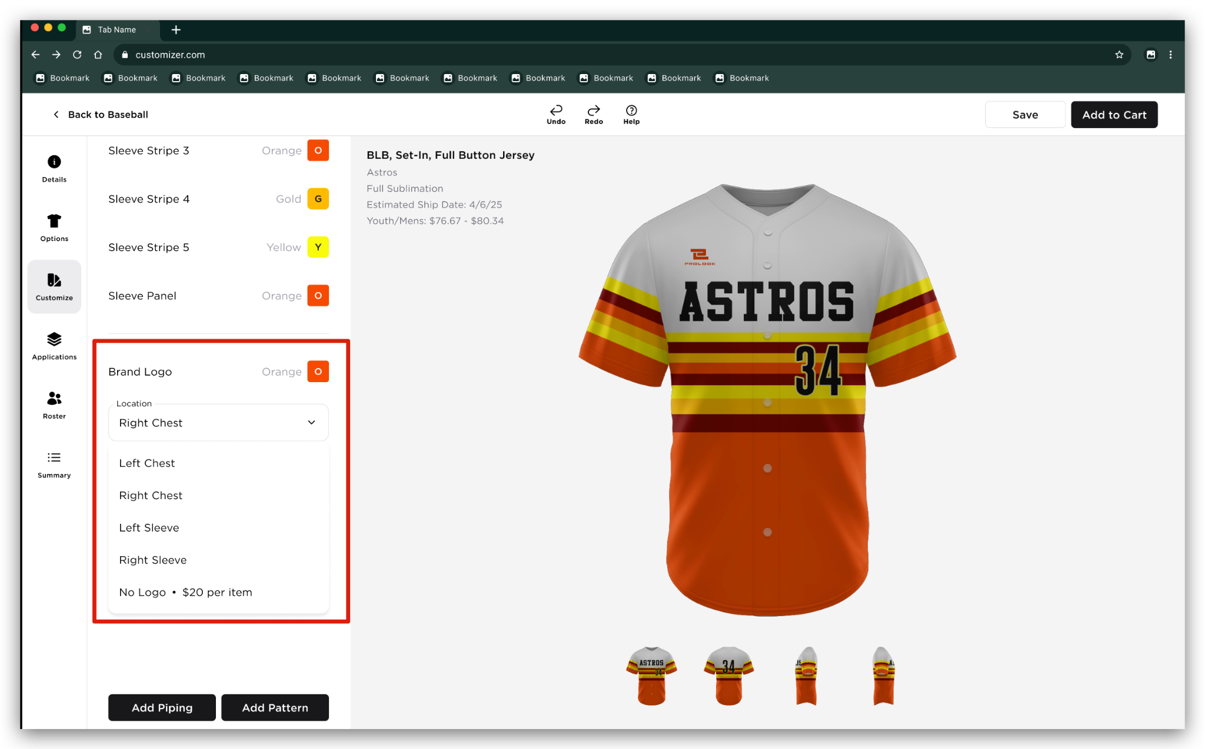  - The Brand Logo section will display: ‘Brand Logo’ label + Color Name + Color Tile  - If there are multiple brand logos, the brand logo will be  - Brand Logo 1 and Brand Logo 2  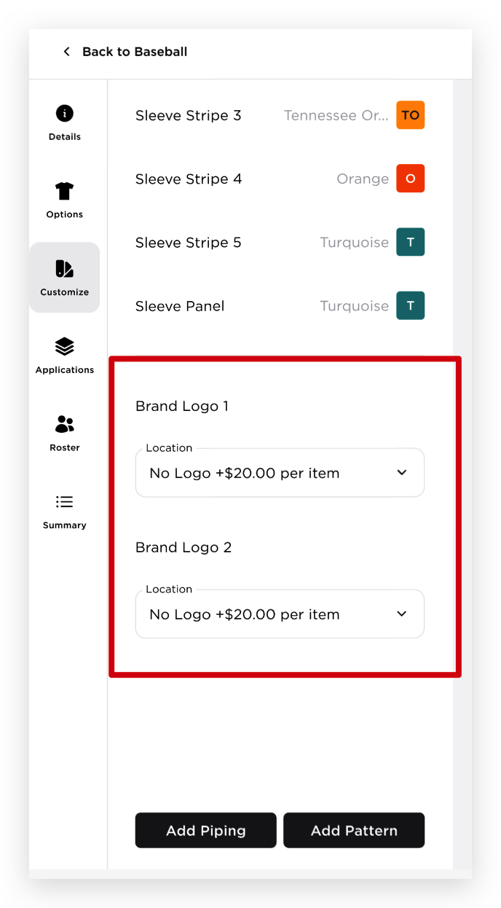  - Location - Dropdown showing all the applicable locations for the brand logo  - If the uniform has a “Remove Brand Logo” add-on associated with it, the Location dropdown will include an option labeled “No Logo +$XX per item” as the last option in the dropdown list  - If “No Logo” is selected, no color tile will be displayed  - BRAND LOGO COLOR SELECTION:  - Upon hovering over a Brand Logo color tile, the system will display the Colors in Use overlay with a "+" button  - Upon clicking the "+" button, the Additional Trim Colors section will display only the color options available for the selected Brand Logo  - Upon selecting a color tile from the Additional Trim Colors section, the selected color will be automatically applied to the corresponding Brand Logo and added to the Colors in Use section  - The user can remove a color from the Colors in Use section by clicking the "x" button (). When the color is removed, it will only be removed from the Brand Logo Colors In Use section. This matches the existing behavior, where trims function as independent entities  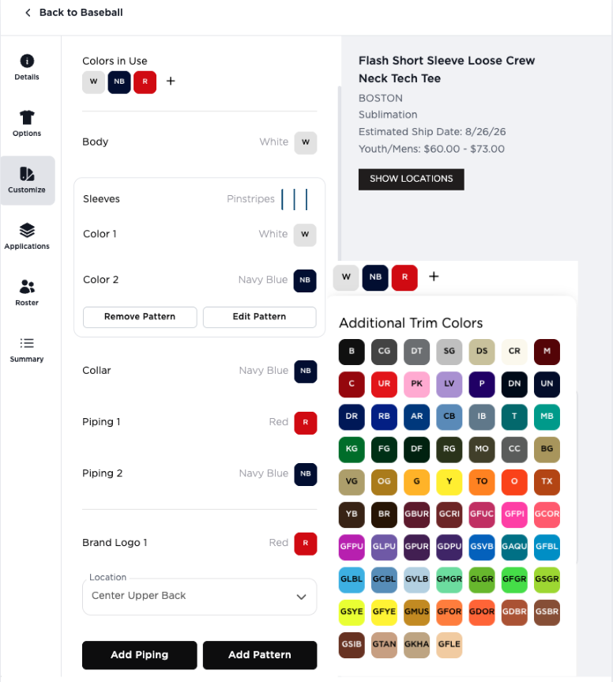  - Add Piping  - Add Pattern - this button switches the Colors panel to the Patterns functionality.
7 | CUSTOMIZE TAB - REVERSIBLE UNIFORM | 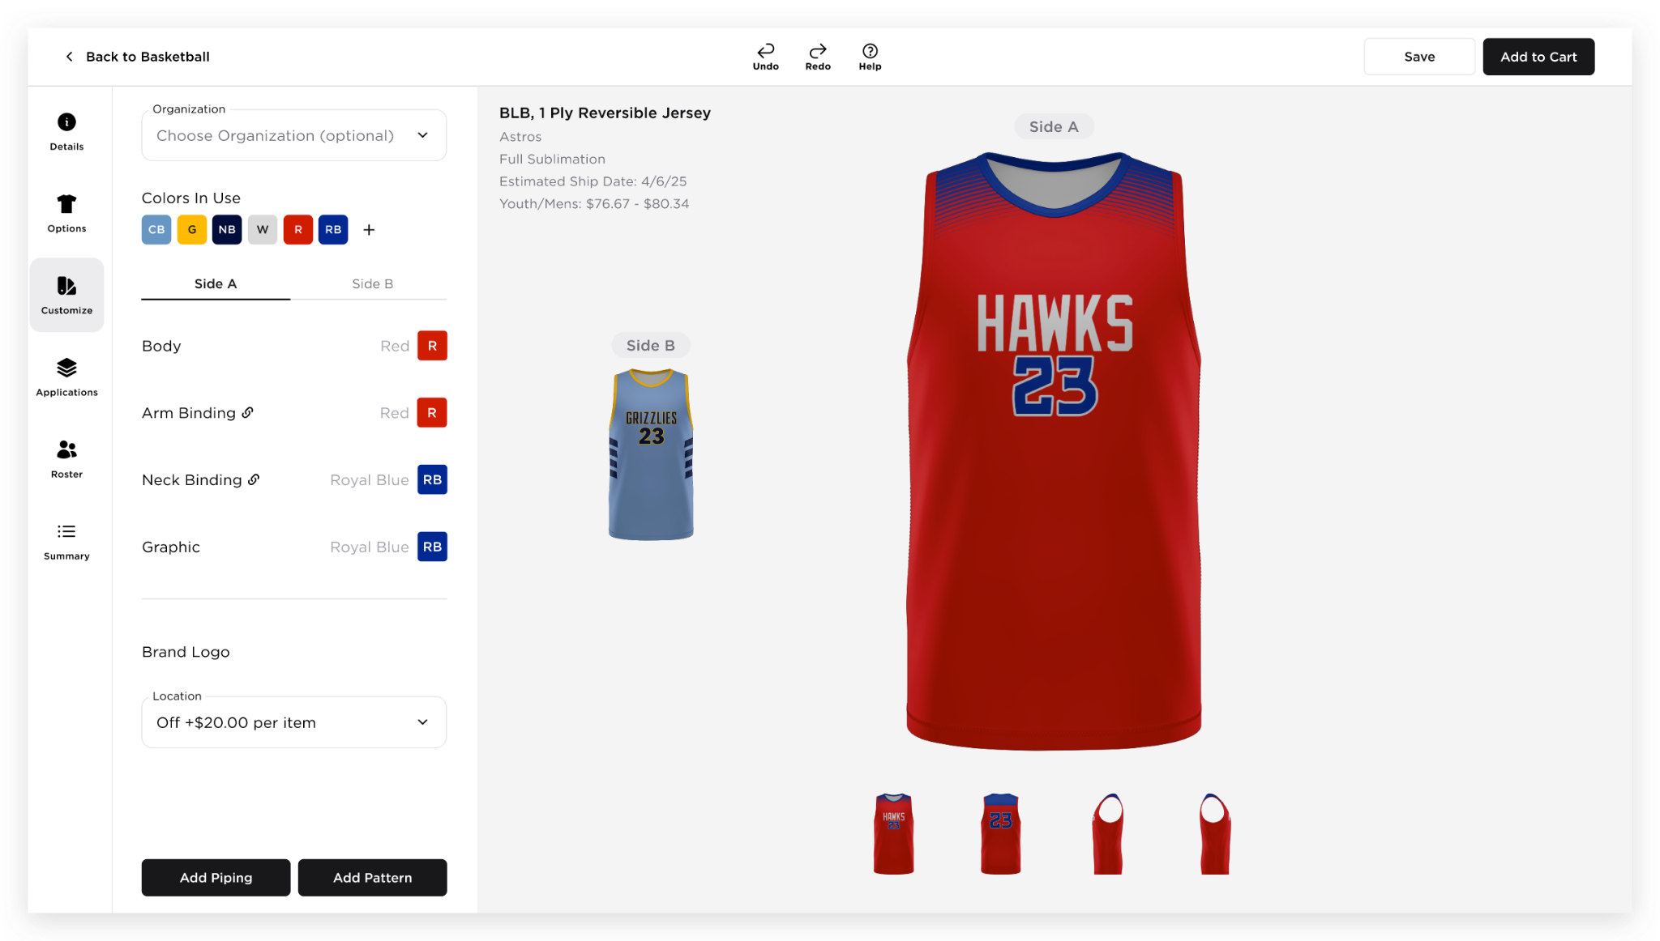  - Colors In Use  - This section will display the combined colors used on both sides of the uniform  - Both sides will only have one set of Colors In Used  - Side A default colors will be displayed first, followed by the default colors of Side B  - Duplicate colors will not be displayed  - If the user changes or updates the Colors In Use, the selected colors of the corresponding body parts/style parts on both sides of the uniform will also be updated  - Note: The existing reversible uniform rule that prevents the other side from having the same body part color will be removed, as the Find and Replace Colors In Use functionality will now be applied.  - If the user selected an organization, selected colors on both sides will also be updated  - If the user removes a color, it will follow the flow of Removing a color via ‘x’button on color tiles  - Side A and Side B tab  - Each side will display the parts: Part Name + Color Name + Color Tile  - If the reversible styles have parts that should have the same color, a link icon will be displayed and once hovered, a tooltip will be displayed, “The color must be the same on both sides” BRD_Reversible Trim functionality, physical binding  - Colors selected on both sides should be the same on the same parts  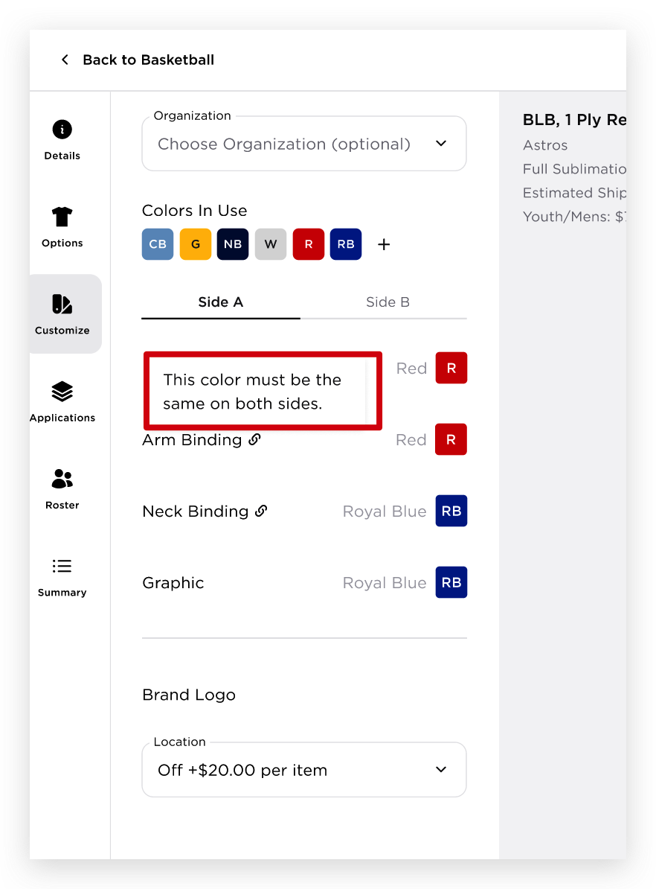  - Brand Logo  - The user can select different configuration of each side brand logo  - When both sides have brand logo configured, if the user selects “No Logo” on another side, the other side should also be updated to “No Logo” and should be charged as one add-on  - When only one side is configured to have the “No Logo” option, this side will only be affected by this add-on  BRD_NOTIFICATIONS IN THE FRONT END - Add Ons  - When the brand logo has some changes, the canvas should be updated accordingly  - Side tab and Canvas behavior - when the user switches the other tab, the corresponding side in the canvas should be selected accordingly
8 | APPLICATION TAB - REVERSIBLE UNIFORM | 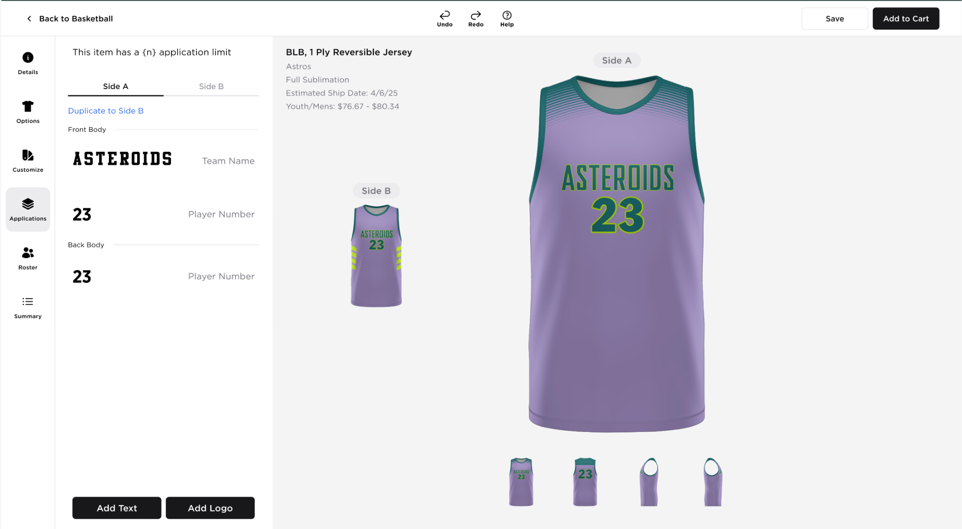  - Add Text - same flow/behavior as the regular uniform  - Add Logo - same flow/behavior as the regular uniform  - Duplicate to Side A/B link  - This functionality will duplicate all applications from one side to the other side  - Duplicate Application  - When the user clicks the duplicate icon, duplicate logo/text panel will display  - User will choose which “Side”  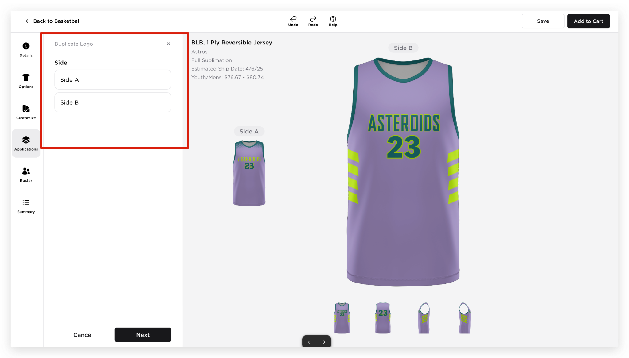  - Then choose “Location”  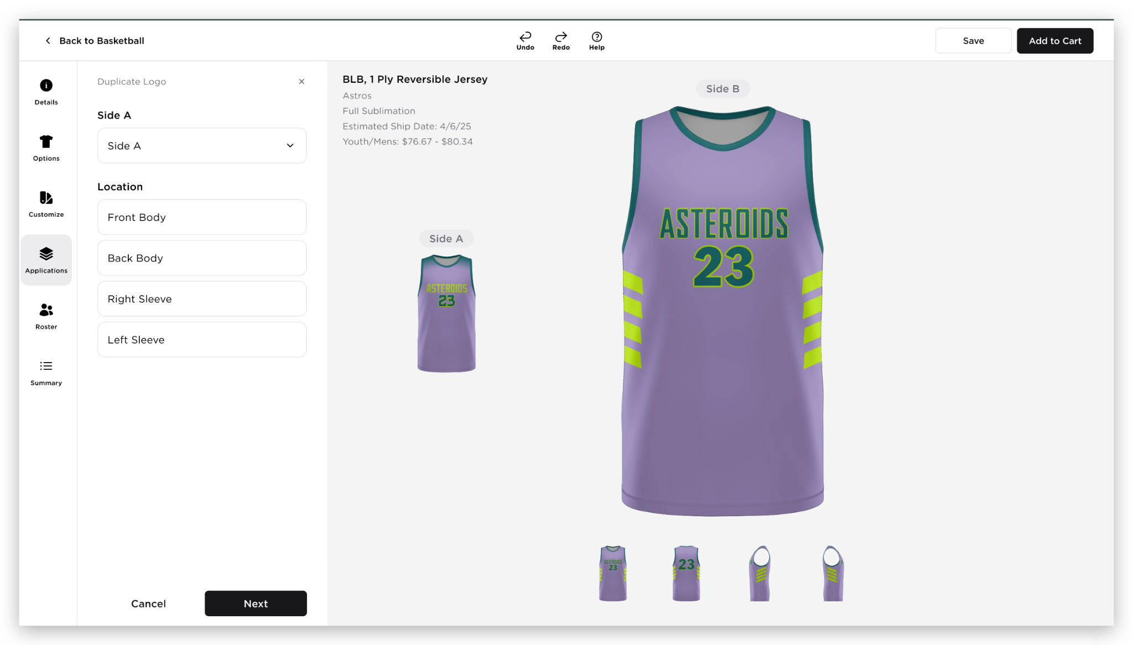  - Then choose “Part Location”  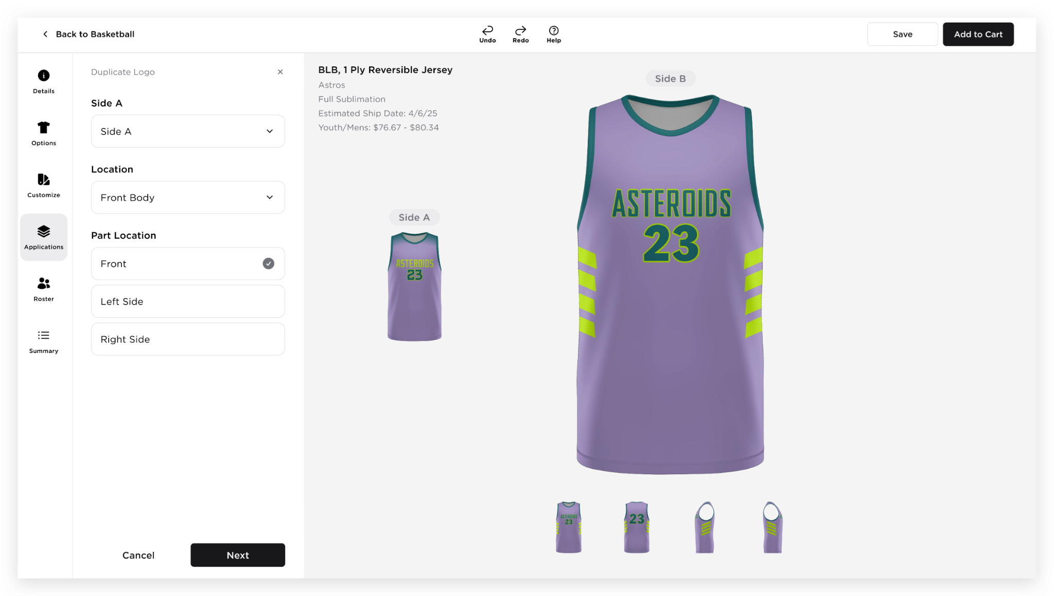  - Clicking Next will add the application to the tab of the selected Side accordingly  Note: When selecting Side, Location, and Part Location, a validation message will be displayed in red if the user clicks the Next button without making a selection. The message will read: "Please select a Side/Location/Part Location."
9 | CUSTOMIZE TAB - PATTERNS | Clicking the "Add Pattern" button at the bottom of the left panel will change the left panel view to display Add Patterns functionality  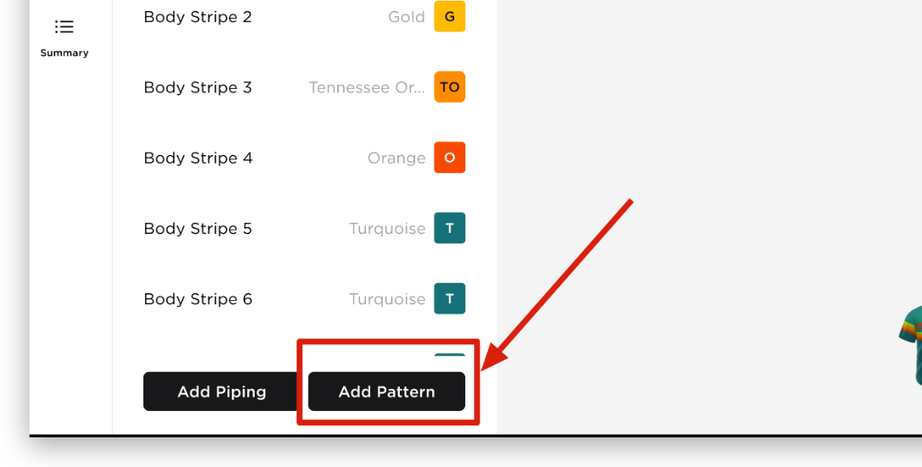  Adding Pattern will follow the process specified below:  - Locations - this section will show all the available location where the user can apply a pattern  - The user can select multiple locations  - Clicking Next button  - If the user has selected a Location, clicking the Next button will display the Pattern list.  - If the user has not selected a Location, clicking the Next button will display the following validation message: “Please select a Location.”  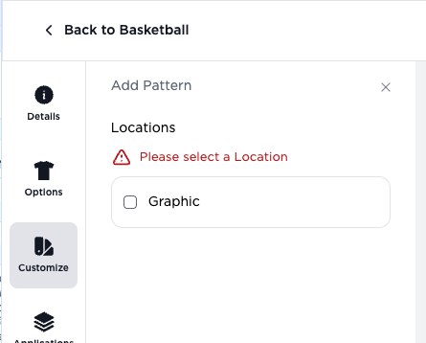  - Clicking Cancel button - will close the Pattern left panel and will go back to the Colors panel  - Clicking Next will display the ‘Pattern’ list  - This section will display all the Patterns that are applicable to the selected uniform  - The user can only select one pattern at a time  - When the user clicks a pattern thumbnail, the selected pattern will be applied to the uniform canvas  - Custom pattern - This will be removed for now as this is not yet implemented, will be covered in BRD_Custom Pattern Functionality  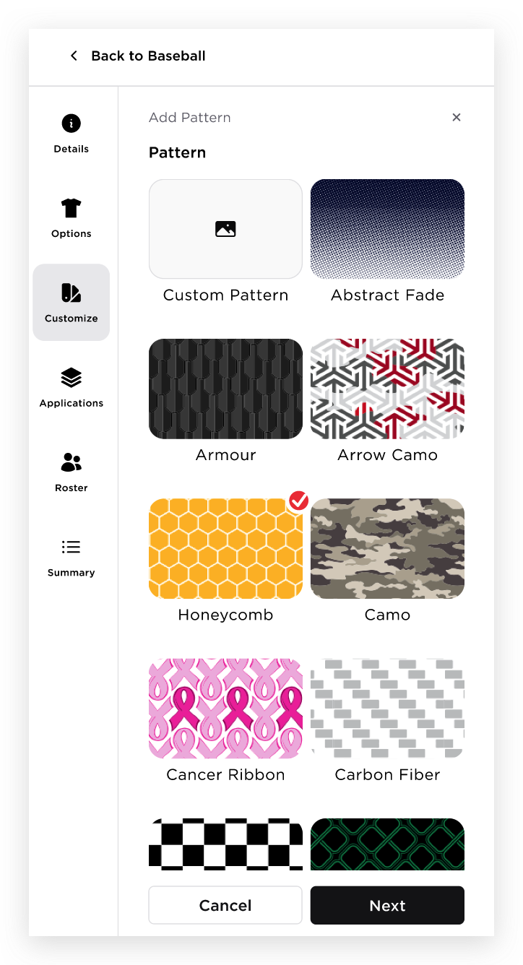  - Clicking Next button  - If the user has selected a Pattern, clicking the Next button will display the pattern configuration panel  - If the user has not selected a Pattern, clicking the Next button will display the following validation message: “Please select a Pattern.”  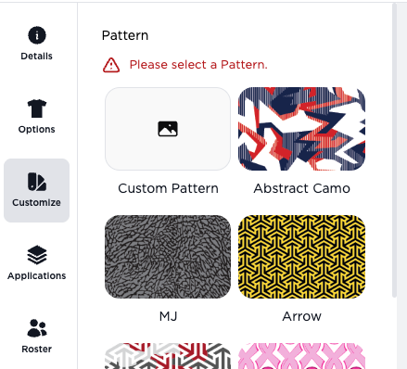  - Clicking Cancel  - Clicking Next button will let the user configure the Pattern  - Configure the Pattern  - This will show the following details of the Pattern  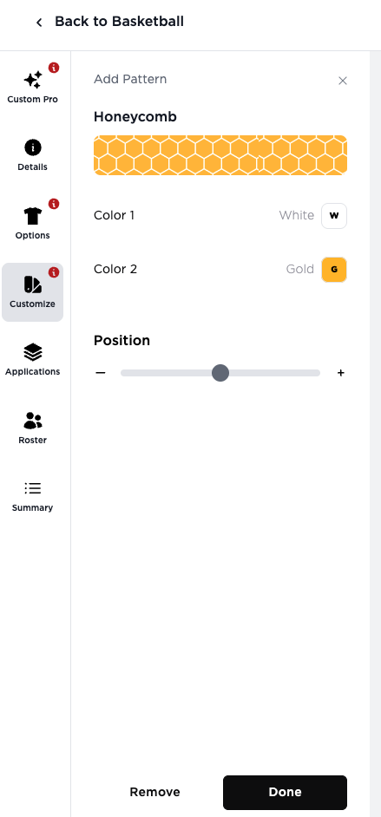  - Name of the Pattern  - Pattern Thumbnail  - When the user hovers over the Pattern Thumbnail, a tooltip will be displayed with the text: “Click to update.”  - The pattern thumbnail is clickable. When the user clicks the Pattern Thumbnail, the system will redirect the user to the previous Pattern page, allowing them to update the applied pattern.  - Colors of the Pattern  - Pre selected colors of the tiles will be based on the Colors In Use  - The user can change the color of the pattern by hovering the color tile and the Colors in Use colors will be displayed  - Position  - Slider where the user can adjust the position of the pattern  - The ‘+’ and ‘-’ buttons are interactive; the user can click them to adjust the position by 1 unit  - Clicking Done - will close the Pattern panel and will display the Colors panel  - Clicking Remove - will remove the applied pattern in the uniform canvas and will also close the Add Pattern panel  - Colors panel  - The specific parts where the Patterns are applied should be updated  - Part Name + Pattern Name + Pattern Tile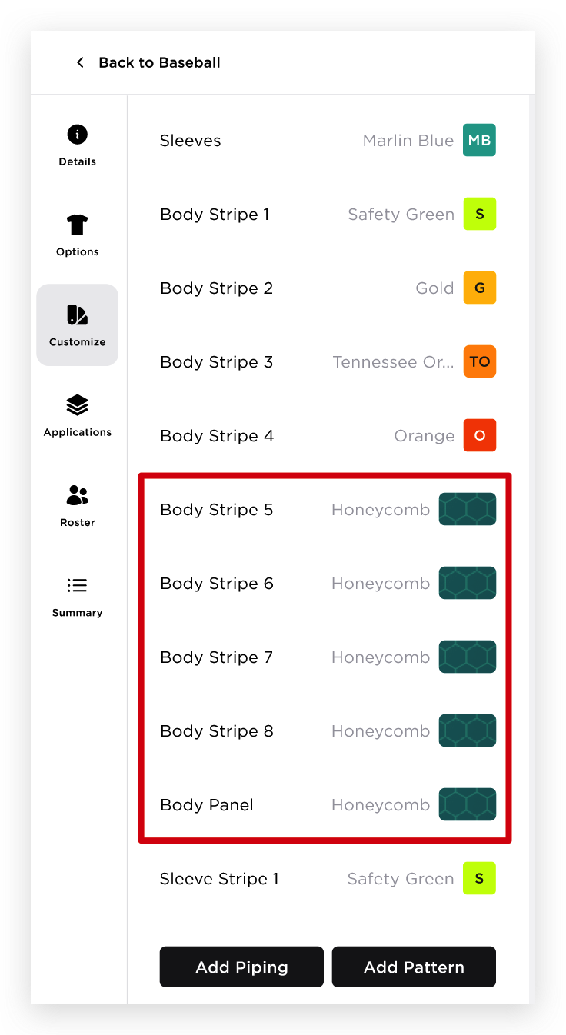  - When the user clicks the Pattern tile, it will show the Pattern colors, Remove Pattern and Edit Pattern button. The user can also change the color from here.  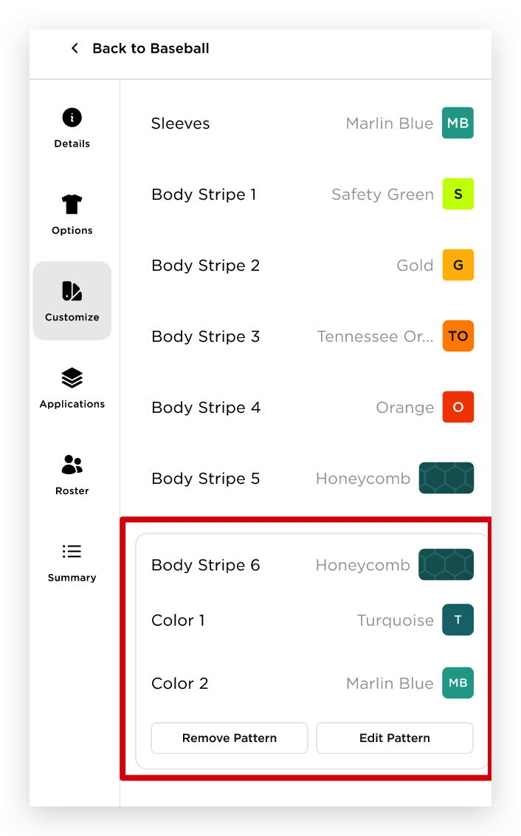  - Remove Pattern  - This will remove the pattern on the uniform and also will change the pattern tile. Pattern tile will be replaced by the previously selected color.  - Edit Pattern  - This will return the user to the Edit Pattern panel  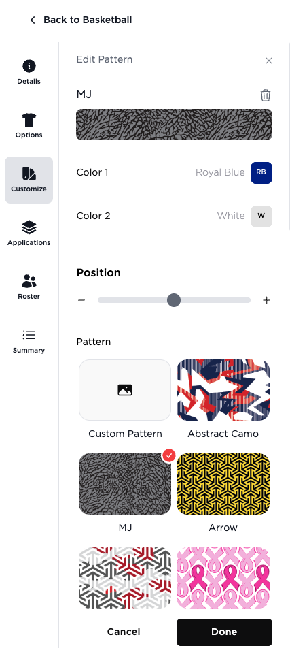  - In the Edit Pattern panel, the user can;  - Update the pattern by changing the colors, position or just change the pattern  - Remove the Pattern by clicking the delete icon  - When the user deletes the pattern from here, the body part in the Colors panel will automatically have the Color 1 as its color  - The Pattern panel will automatically close and will be back to the Colors panel  - Clicking Done will close the Edit Pattern panel  - Clicking Cancel will cancel the action of editing the pattern  **Please note that once the Pattern is already applied in the uniform, they will be treated now as independent entities.  - If the user edits/removes a pattern for a specific part, other patterns are not affected with those changes.
10 | CUSTOMIZE TAB - PIPING | Clicking the "Add Piping" button at the bottom of the left panel will change the left panel view to display Add Piping functionality  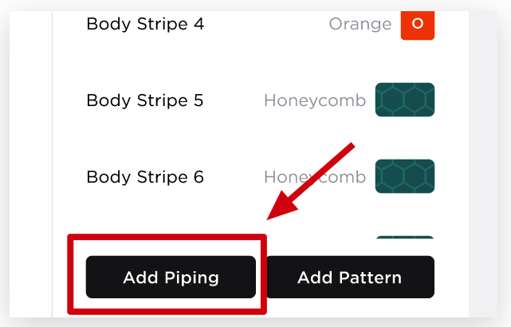  Adding Piping will follow the process specified below:  - Location - this section will show all the available location where the user can apply a pattern  - This section displays a message below ‘Location’ indicating the piping type:  "Piping on this item is sublimated."  Hard coded based on the table below:  - The default state has no selections  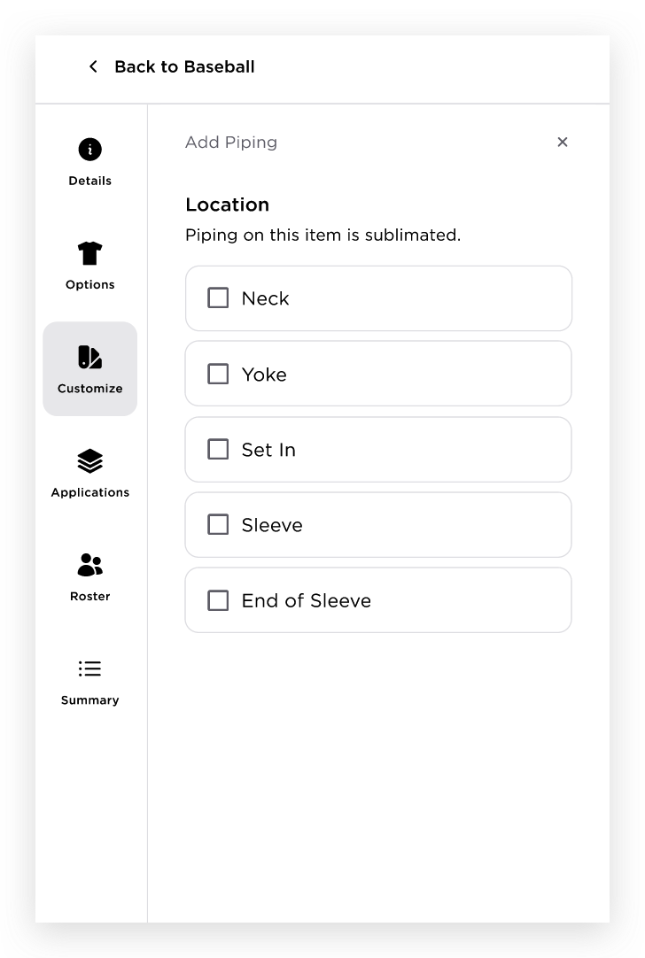  - The user can select multiple pipings  - When the user selects the piping, it will automatically expand to allow the user to configure the piping. It will stay expanded as long as the location is selected  - Size  - Colors  - Color 1 - Color 2 and Color 3 will be added below the Color 1 if the user chooses 2 or 3  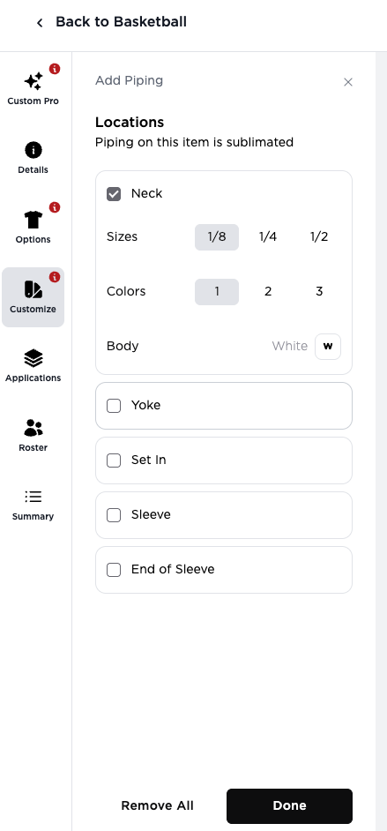  - Clicking Done - will close the Piping panel and will display the Colors panel  - Clicking Remove All  - When the user clicks the Remove All button, all currently selected Pipings will be unselected  - All selected Pipings will be removed from the uniform canvas  - Colors Panel  - The specific parts where the Patterns are applied should be added  - Piping Name + Size + # of Colors  - Piping on this section is expandable showing a chevron  - The user can configure the piping from this expanded section  - The user can remove the piping by clicking the Remove Piping button.  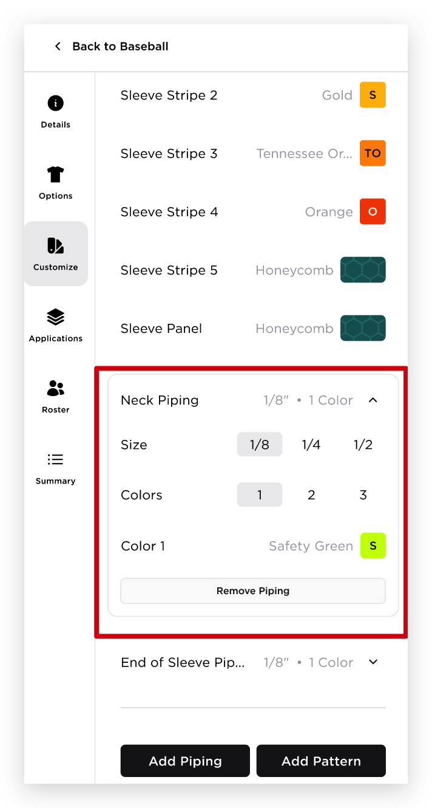
  Product Functionality Type | Piping Type
  Tackle Twill | Physical  e.g. "Piping on this item is physical piping."
  Sublimated | Sublimated  e.g. "Piping on this item is sublimated."
  Stock | N/A  No pipings for Stock products
  Hybrid | Sublimated  e.g. "Piping on this item is sublimated."
11 | APPLICATIONS TAB | 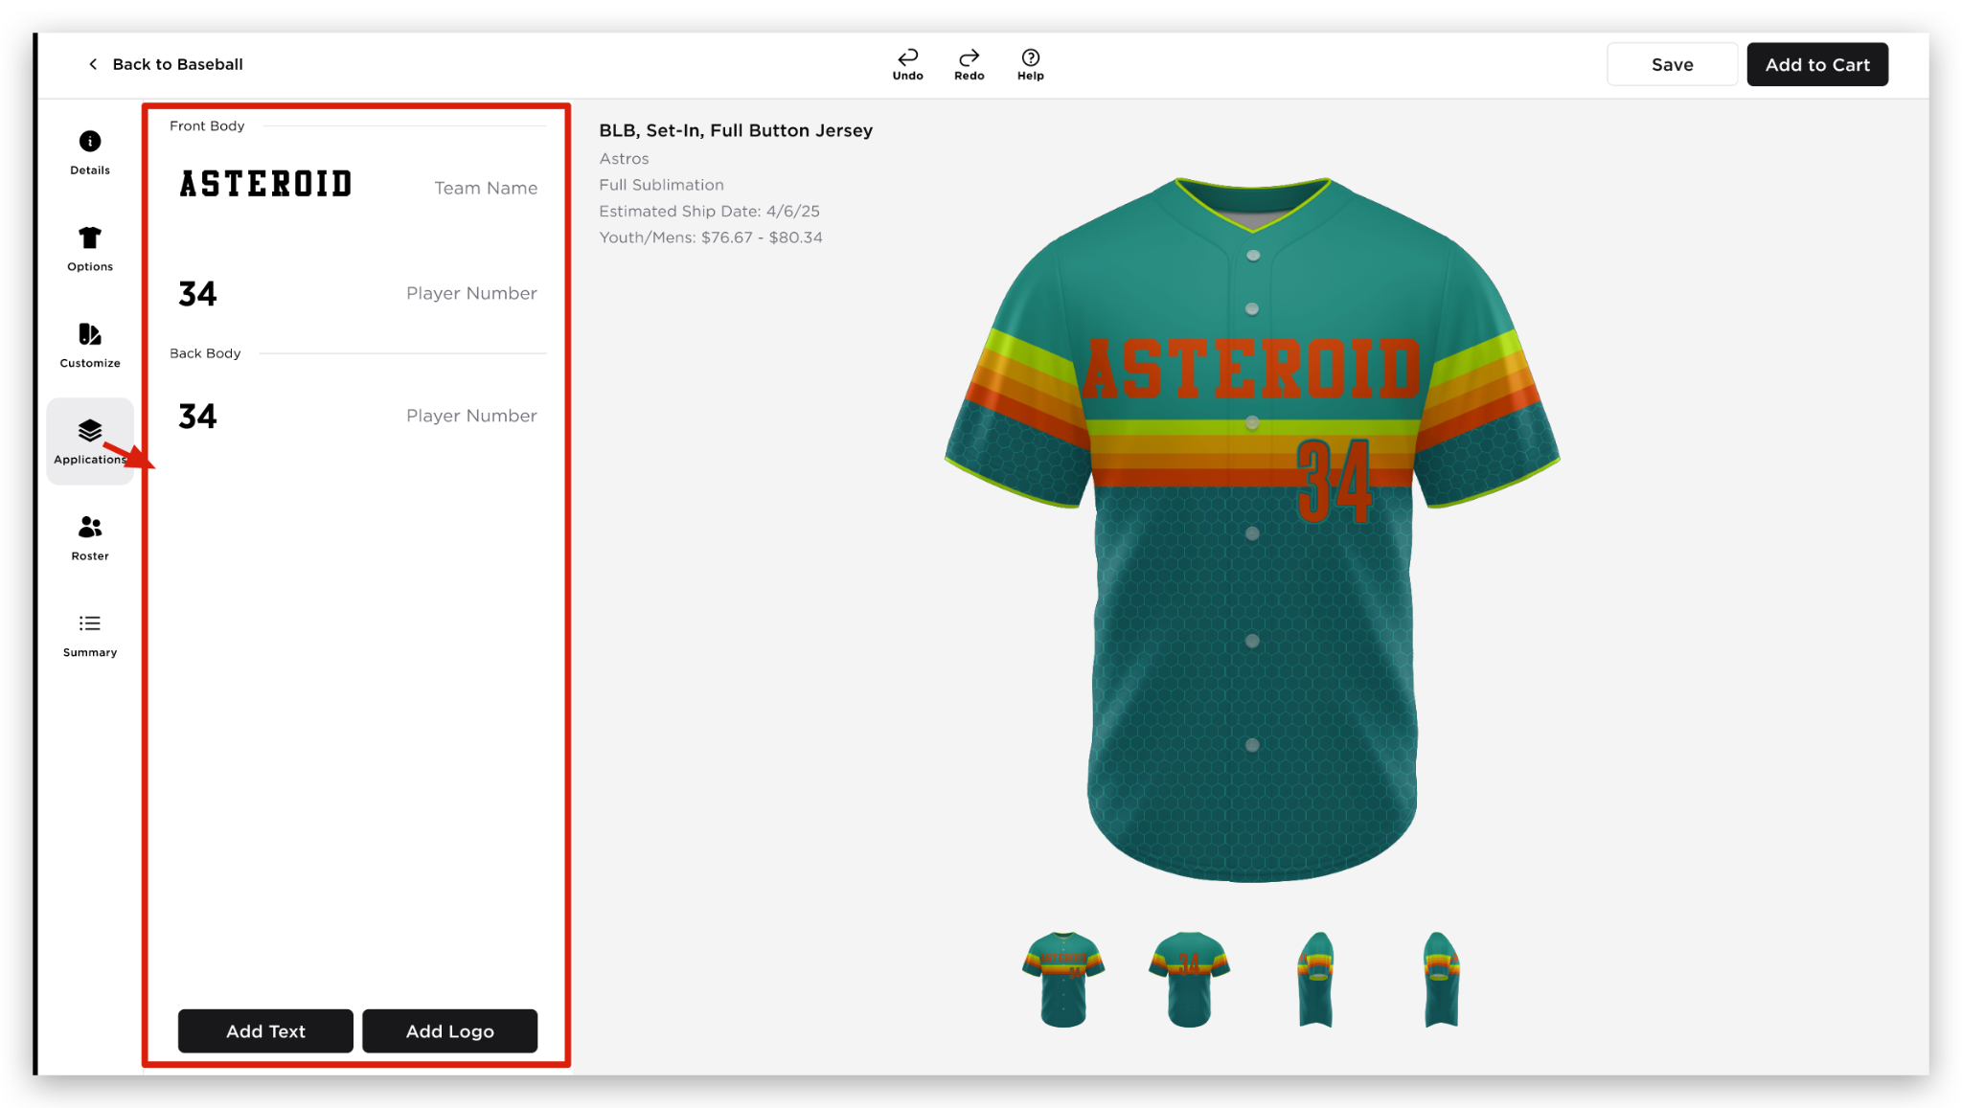  - Applications tab consists of the following:  - Will be grouped by body parts  - Value of the application  - Application type  - When the user hovers on the application, duplicate, remove and grip dots will be displayed. When the user hover on this icons, there will be a tooltip displaying the function of each icon, Duplicate, Delete, and Adjust Layering  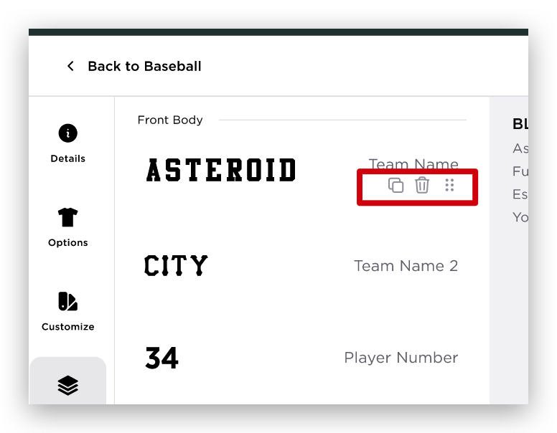  - Duplicate  - Clicking this will open the Part where the user can select a part where the duplicated application will be placed  - When the user clicks the part, Part Location will be displayed where the user can select a part location  - Clicking the Next button will let the user configure the application (See Edit Application Panel requirements below)  - The default values will be the same with the original application  - Once Done, the duplicated application will have the {Application Type} {space} {2} in the Application tab (e.g. Team Name 2)  - Duplicate Logos Functionality  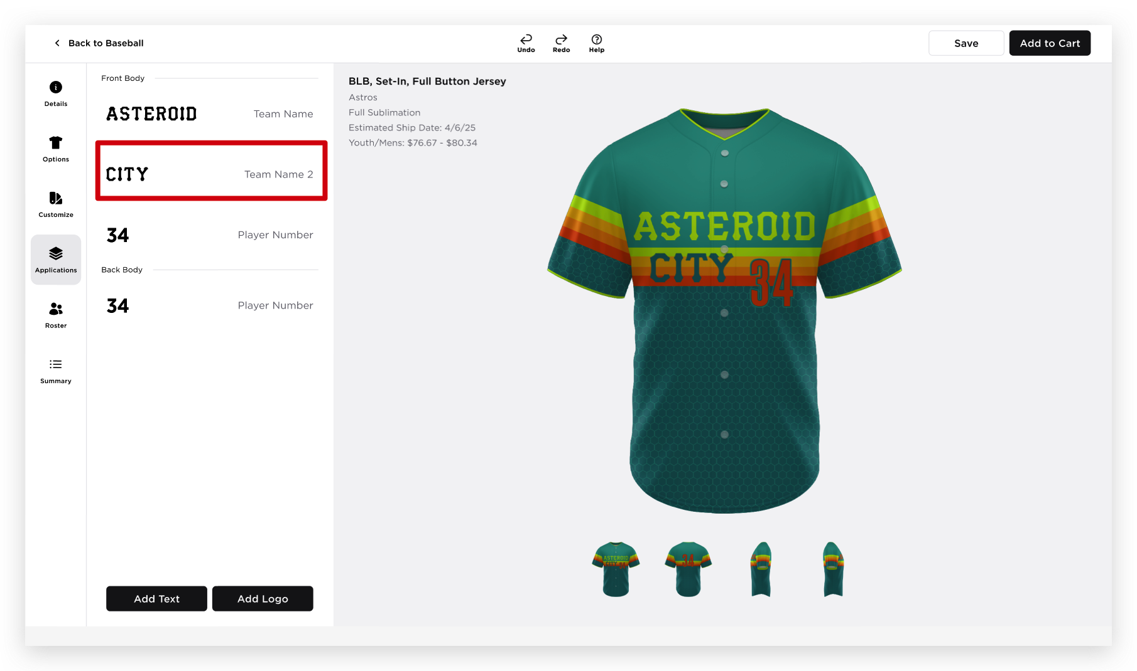  - Remove  - Grip Dots - the user can grab this and move the applications up and down within its group. The application is not movable to other groups  - If the user wants to edit the application, the application is clickable and it will open the edit panel  - If the user edits the application, canvas will show the floating tools to indicate what application the user is currently editing  - Floating Tool:  - Delete  - Rotate  - Move  - Resize  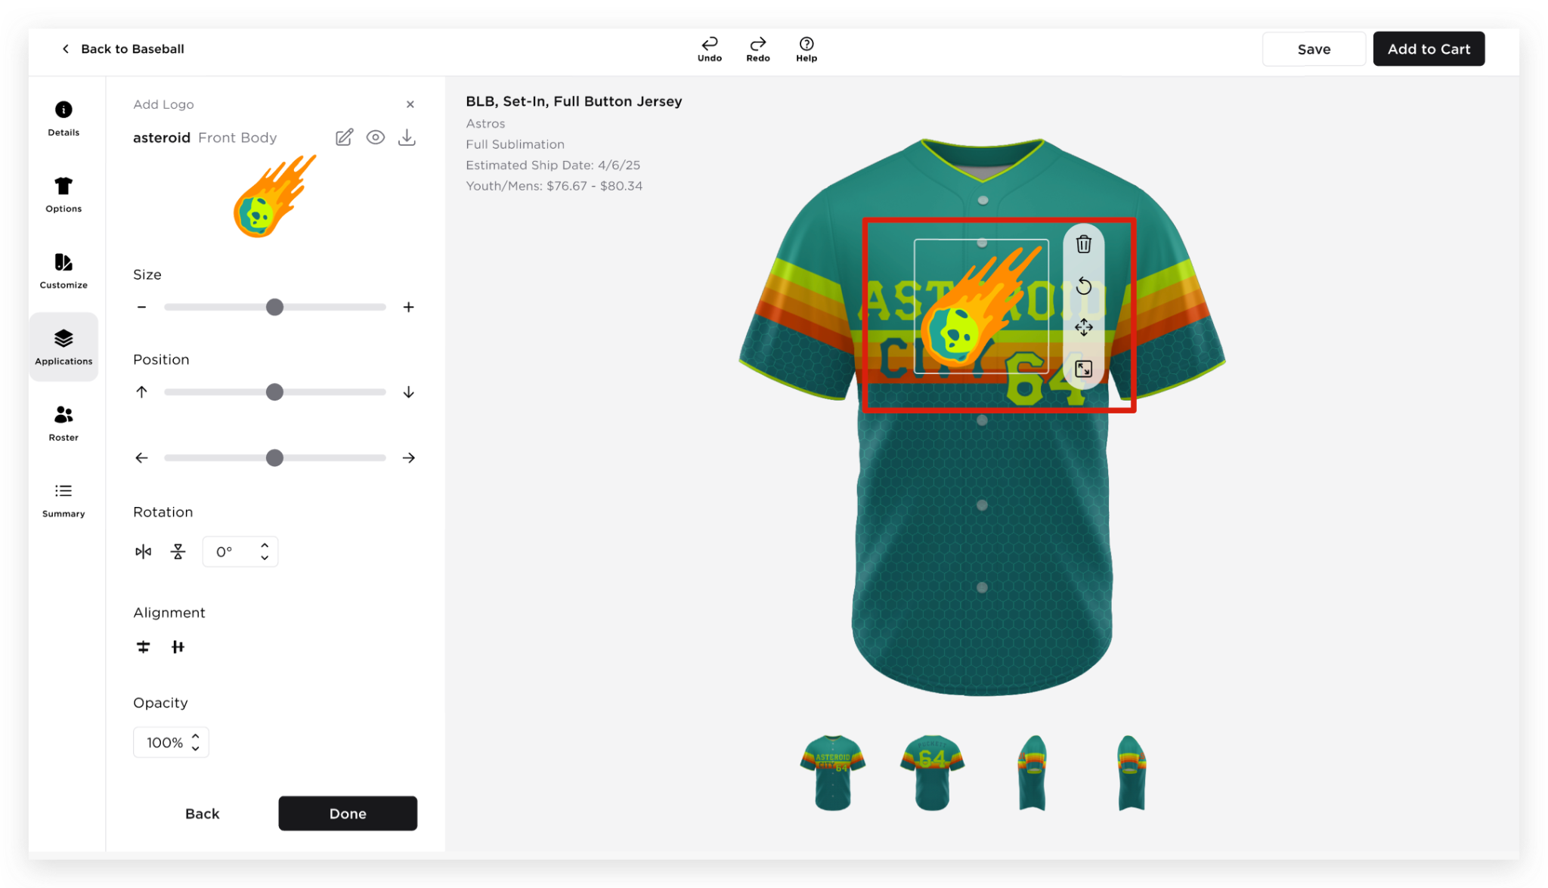  - Application Hard Limit Functionality  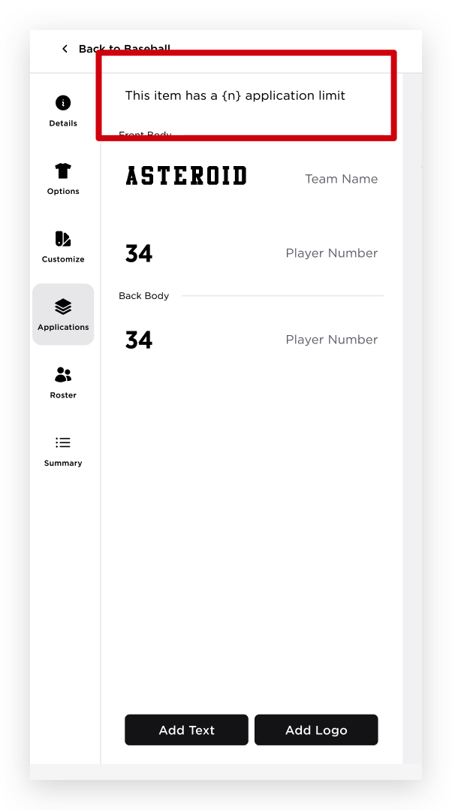  - Hard limit rule:  - If the user has already reached the maximum number of allowed applications, the Add Text and Add Logo buttons will be disabled, preventing the user from adding additional text or logo applications  - Reversible Products additional rule:  - If the user has already reached the maximum number of allowed applications, or if duplicating the applications to the other side would exceed the maximum limit, the Duplicate to Side A/B option will be disabled, preventing the user from duplicating the applications  - Application Soft Limit Functionality  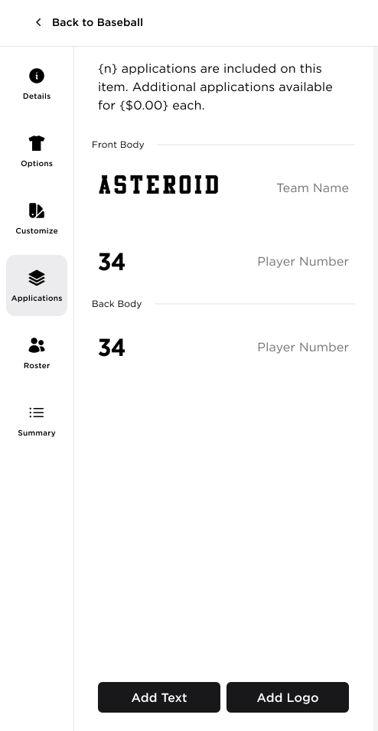  - Soft Limit – Additional Changes to the Existing Behavior  - The informational modals related to the soft limit will no longer be displayed.  - The pricing displayed on the canvas will automatically update to reflect any additional charges.  - The Summary tab will also automatically update to display the additional add-on and its corresponding charge  - Application Location Soft Limit Functionality  - Changes to the Wording - Update the message to:  "{n} application locations are included on this item. Additional application locations are available for {$0.00} each."  - Additional Changes to the Existing Behavior  - The informational modals related to the soft limit will no longer be displayed.  - The pricing displayed on the canvas will automatically update to reflect any additional charges.  - The Summary tab will also automatically update to display the additional add-on and its corresponding charge
12 | APPLICATIONS TAB - TEAM NAME APPLICATION | 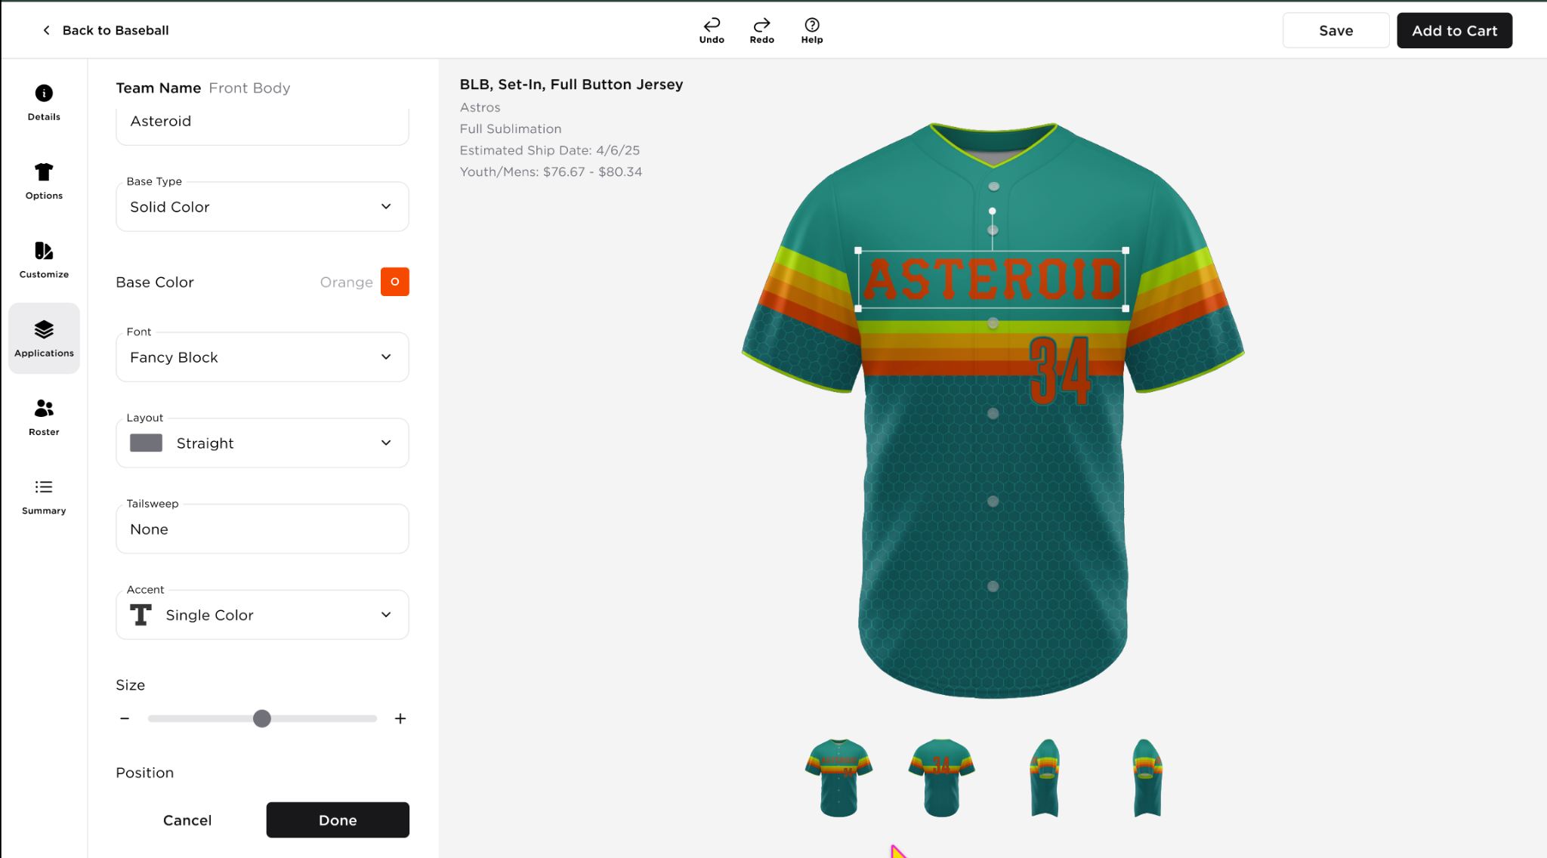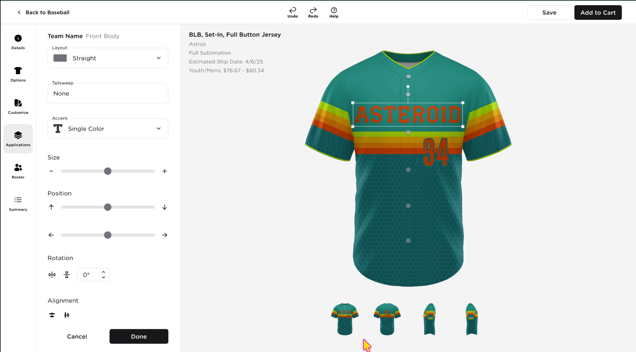  Edit Team Name Application Panel  - The header will display the Application Type, with the Body Part shown beside it.  - Application Name (Team Name)- text field  - Accent - dropdown list  - Base Type - dropdown list  - Solid Color  - Pattern  - Application Colors - there will be different items listed depending on the accent selected. The user can change the color of each item by clicking the color tile. The user can only select colors from the Color In Use selection  - Base Color  - Outline 1  - Outline 2  - Shadow  - Font - dropdown list  - Layout - dropdown list  - Tailsweep - dropdown list  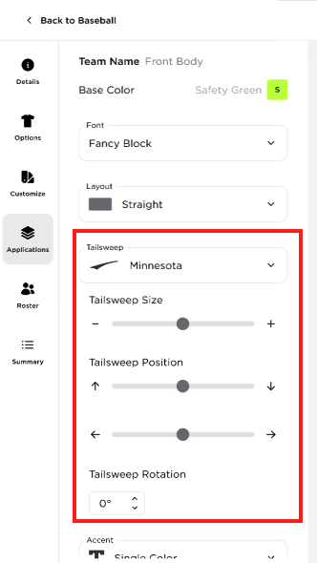  - Tailsweep Size  - Slider where the user can adjust the size of the application  - The ‘+’ and ‘-’ buttons are interactive; the user can click them to adjust the position by 1 unit.  - Tailsweep Position  - Slider where the user can adjust the position of the application up and down, left and right  - The ‘+’ and ‘-’ buttons are interactive; the user can click them to adjust the position by 1 unit.  - Tailsweep Rotation  - Horizontal flip  - Vertical flip  - Angle adjustment - the user can also type the angle they want  - Size  - Slider where the user can adjust the size of the application  - The ‘+’ and ‘-’ buttons are interactive; the user can click them to adjust the position by 1 unit.  - Position  - Slider where the user can adjust the position of the application up and down, left and right  - The ‘+’ and ‘-’ buttons are interactive; the user can click them to adjust the position by 1 unit.  - Rotation  - Horizontal flip  - Vertical flip  - Angle adjustment - the user can also type the angle they want  - Alignment -  - Horizontal alignment  - Vertical alignment  - A preset for Position configuration  - Done – Adds the application to the list  - Cancel – Discards changes and returns to the Application tab
13 | APPLICATIONS TAB - PLAYER NUMBER APPLICATION | 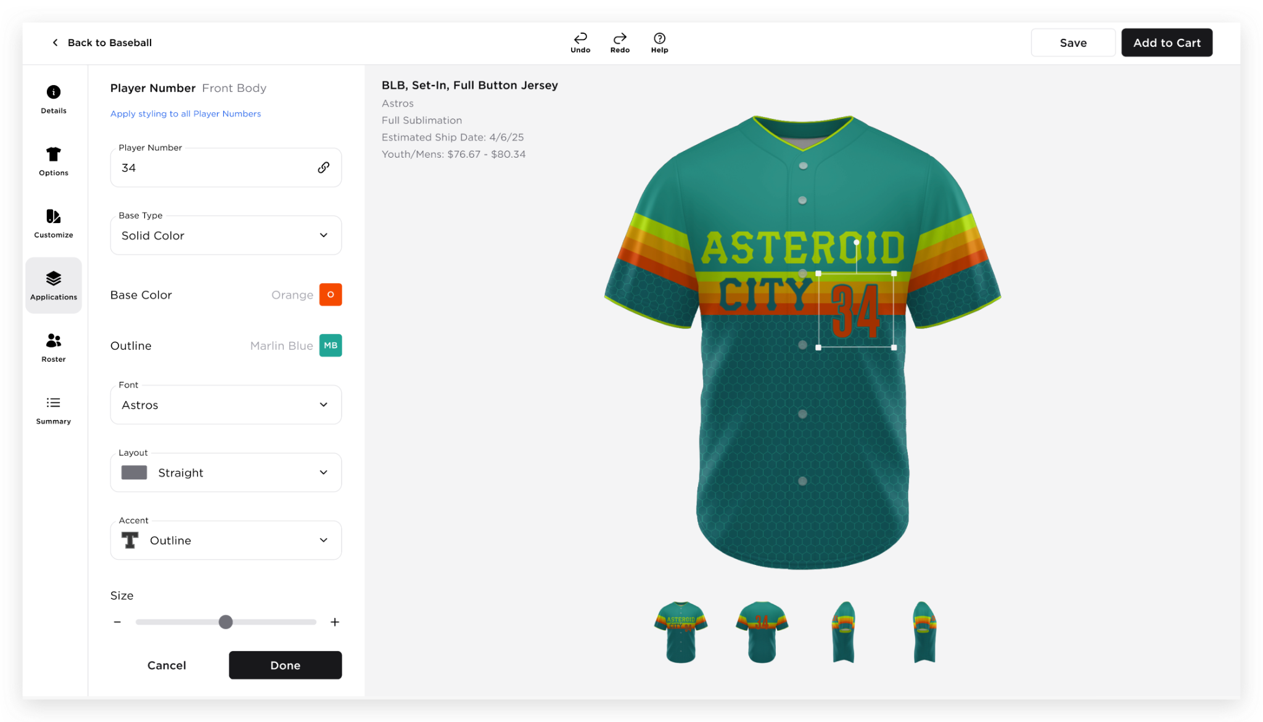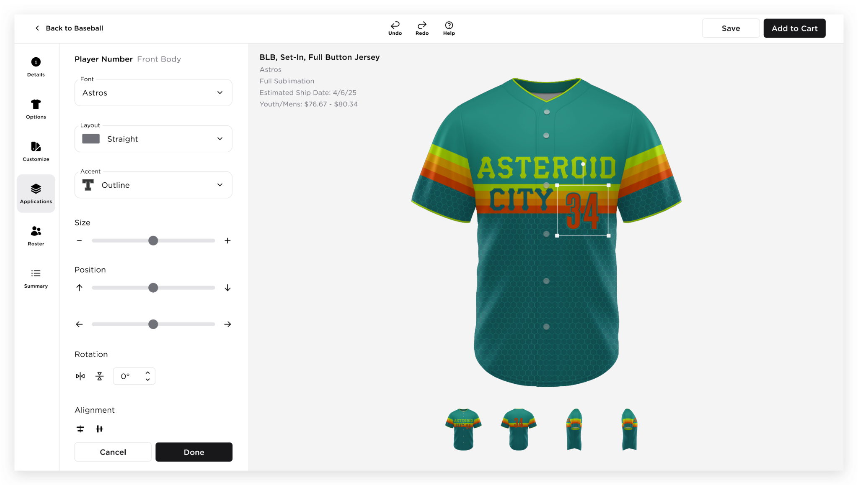  Edit Player Number Application Panel  - The header will display the Application Type, with the Body Part shown beside it.  - “Apply styling to all Player Numbers”  - Clickable link - When the user clicks this link, the style of the Player Number will be applied to all other player numbers application  - All or nothing selection  - If the uniform has 2 or more Player Numbers, they should have the same number, font, layout, accent and colors.  - Application Name (Player Number) - text field  - Link icon - to indicate that “All player numbers on a jersey display the same number”  - If the user uses another Player Number application, it will automatically have the same player number. If the user updates the player number, all player number application will have that number  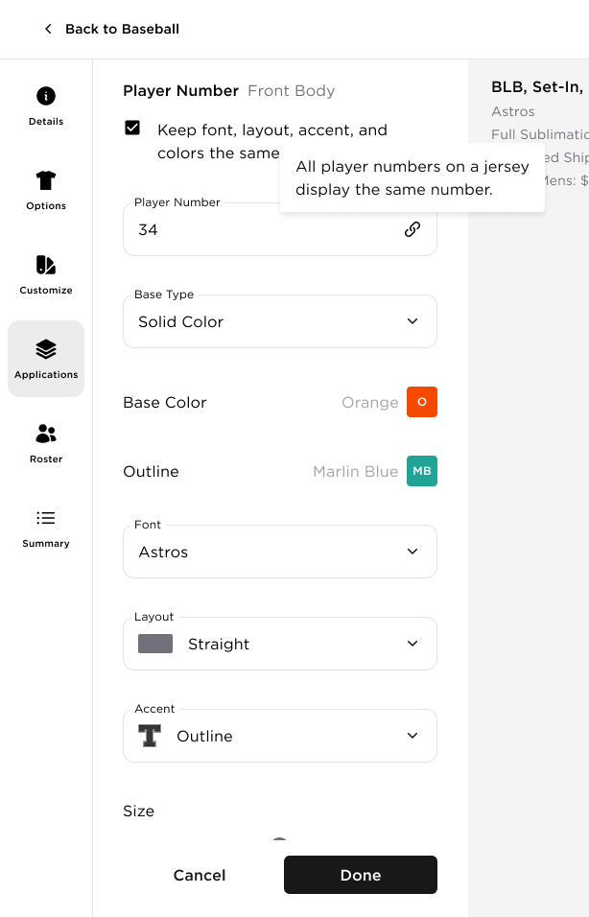  - Accent - dropdown list  - Base Type - dropdown list  - Solid Color  - Pattern  - Application Colors - there will be different items listed depending on the accent selected. The user can change the color of each item by clicking the color tile. The user can only select colors from the Color In Use selection  - Base Color  - Outline 1  - Outline 2  - Shadow  - Font - dropdown list  - Size  - Slider where the user can adjust the size of the application  - The ‘+’ and ‘-’ buttons are interactive; the user can click them to adjust the position by 1 unit.  - Position  - Slider where the user can adjust the position of the application up and down, left and right  - The ‘+’ and ‘-’ buttons are interactive; the user can click them to adjust the position by 1 unit.  - Rotation  - Horizontal flip  - Vertical flip  - Angle adjustment - the user can also type the angle they want  - Alignment  - Horizontal alignment  - Vertical alignment  - A preset for Position configuration  - Done – Adds the application to the list  - Cancel – Discards changes and returns to the Application tab
14 | APPLICATIONS TAB - PLAYER NAME APPLICATION | 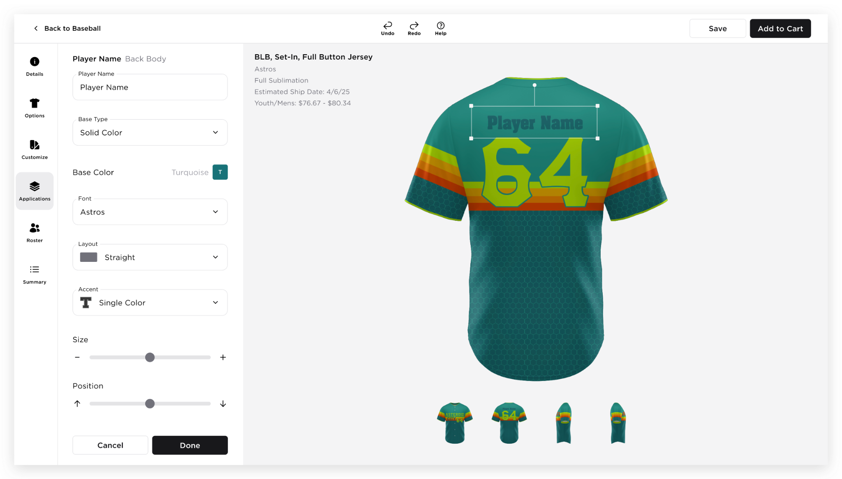  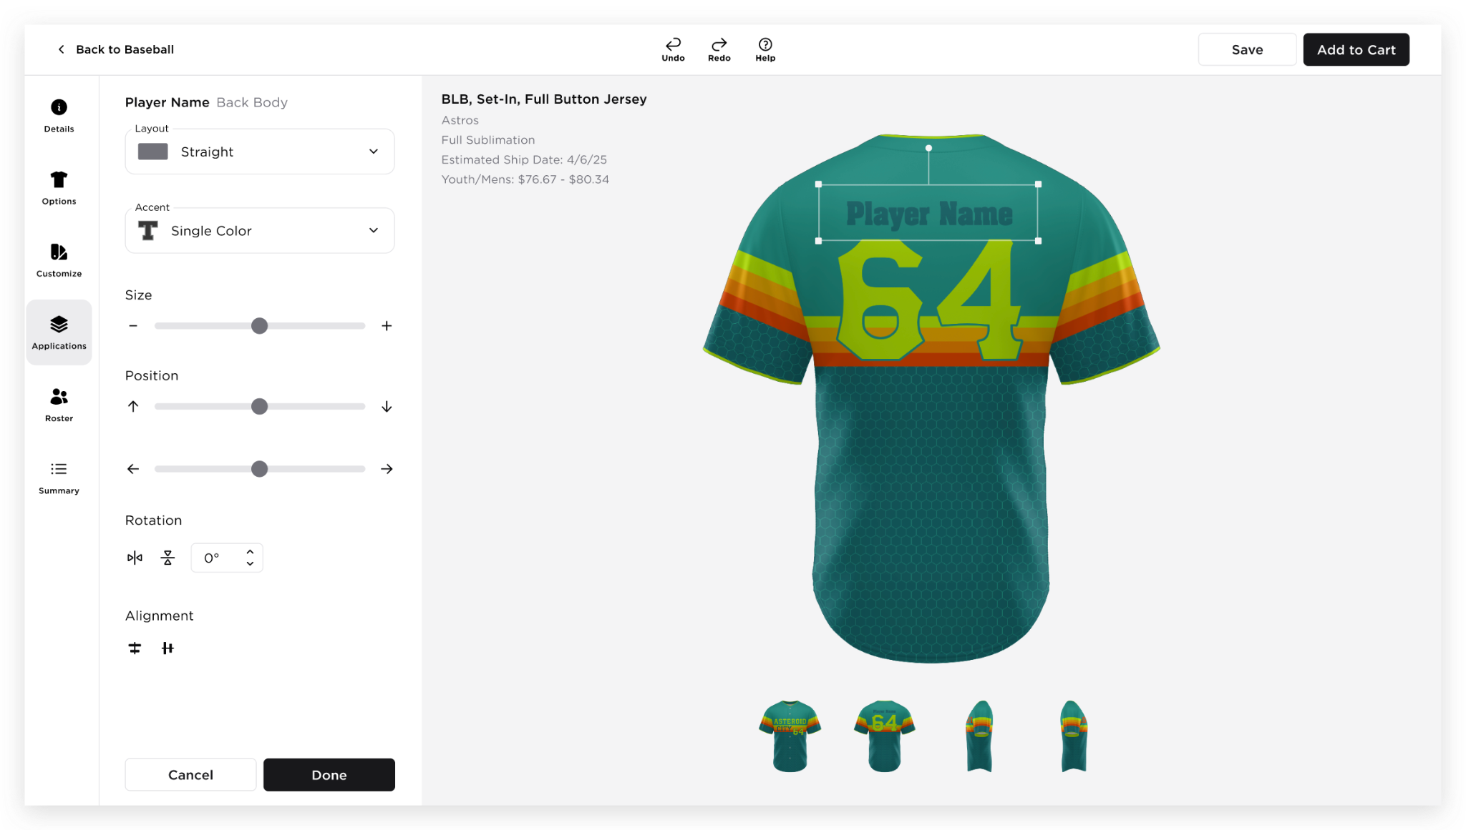  Edit Player Number Application Panel  - The header will display the Application Type, with the Body Part shown beside it.  - Application Name (Player Name) - text field  - Accent - dropdown list  - Base Type - dropdown list  - Solid Color  - Pattern (Flow will follow)  - Application Colors - there will be different items listed depending on the accent selected. The user can change the color of each item by clicking the color tile. The user can only select colors from the Color In Use selection  - Base Color  - Outline 1  - Outline 2  - Shadow  - Font - dropdown list  - Layout - dropdown list  - Size  - Slider where the user can adjust the size of the application  - The ‘+’ and ‘-’ buttons are interactive; the user can click them to adjust the position by 1 unit.  - Position  - Slider where the user can adjust the position of the application up and down, left and right  - The ‘+’ and ‘-’ buttons are interactive; the user can click them to adjust the position by 1 unit.  - Rotation  - Horizontal flip  - Vertical flip  - Angle adjustment - the user can also type the angle they want  - Alignment  - Horizontal alignment  - Vertical alignment  - A preset for Position configuration  - Done – Adds the application to the list  - Cancel – Discards changes and returns to the Application tab
15 | APPLICATIONS TAB - ADD TEXT  Check each application rule | 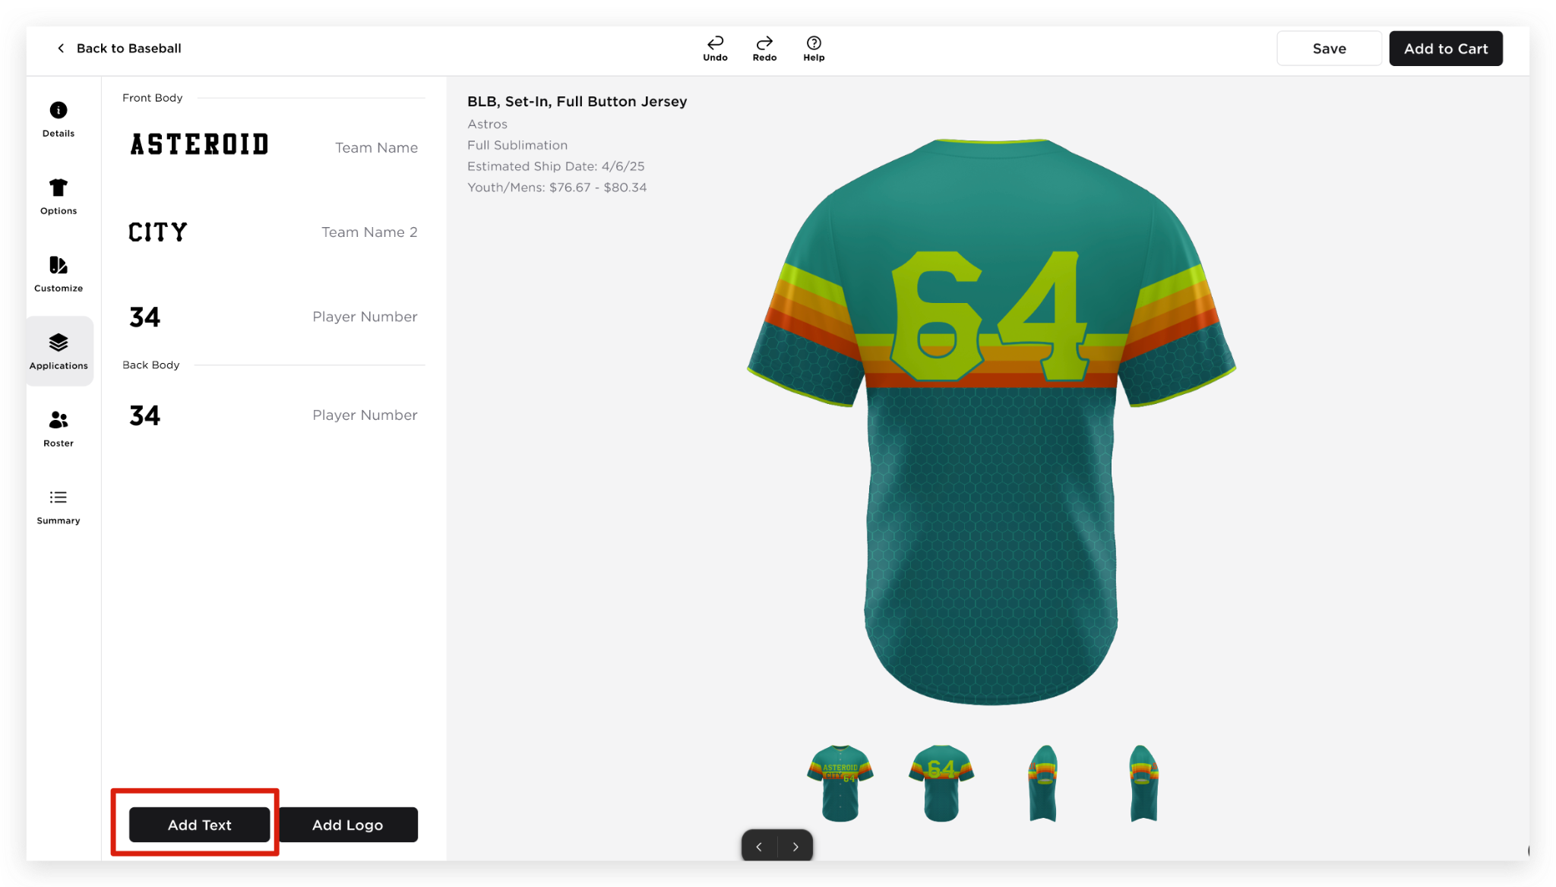  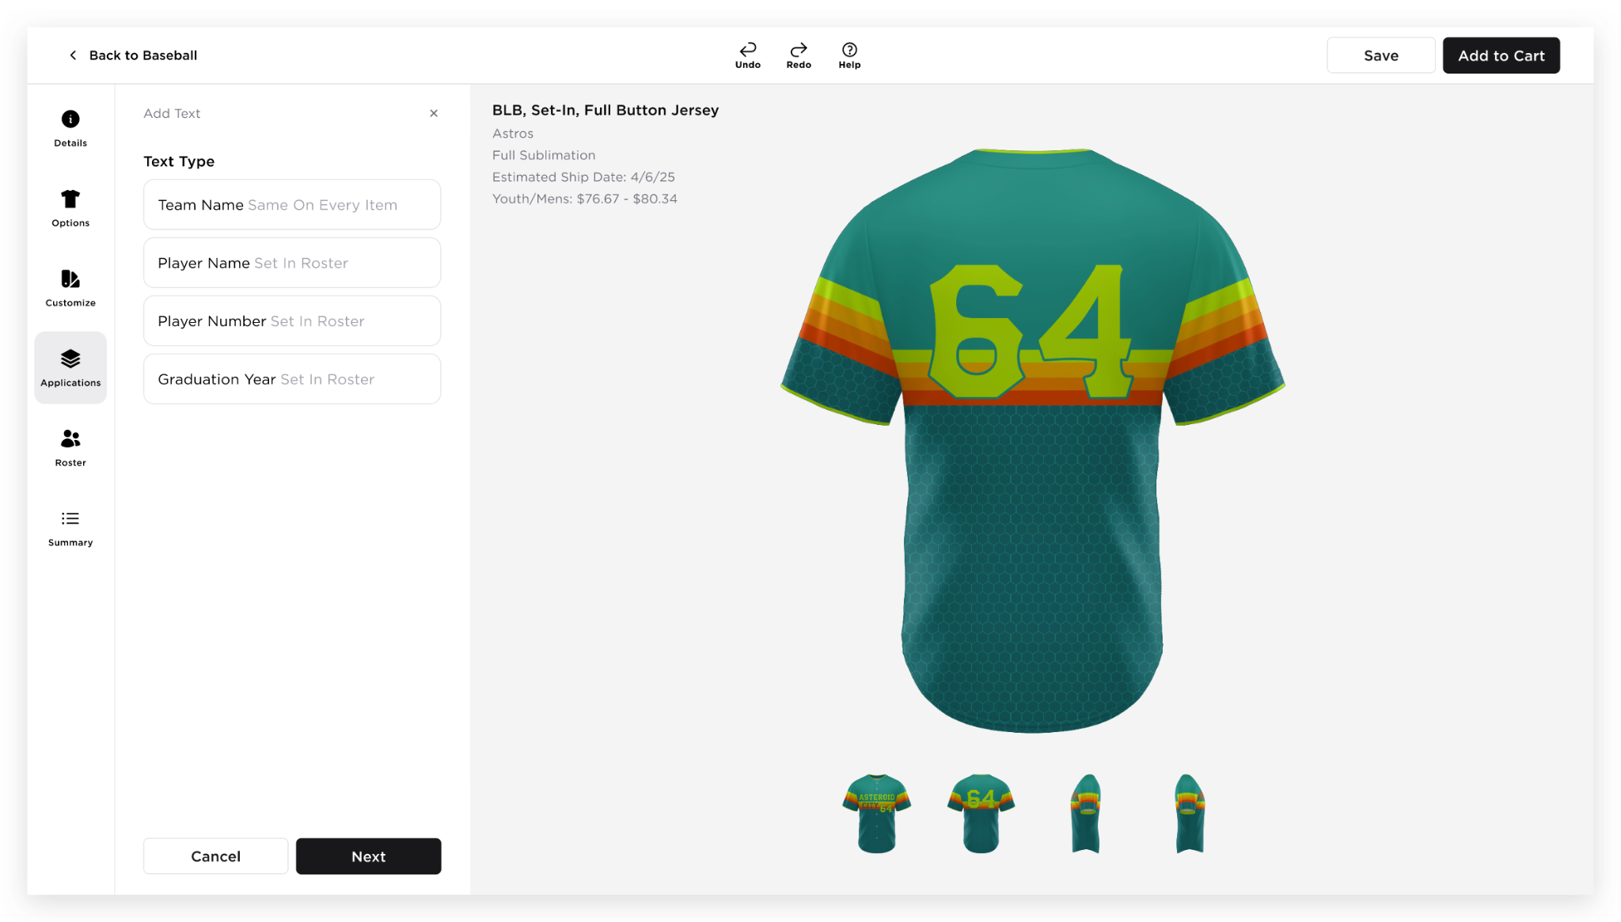  - Add Text as the header  - ‘X’ button to close the Add Text panel  - Text Type  - Team Name Same On Every Item  - Player Name Set In Roster  - Player Number Set In Roster  - Graduation on Year Set In Roster  - Once a Text type is selected, the other options will disappear  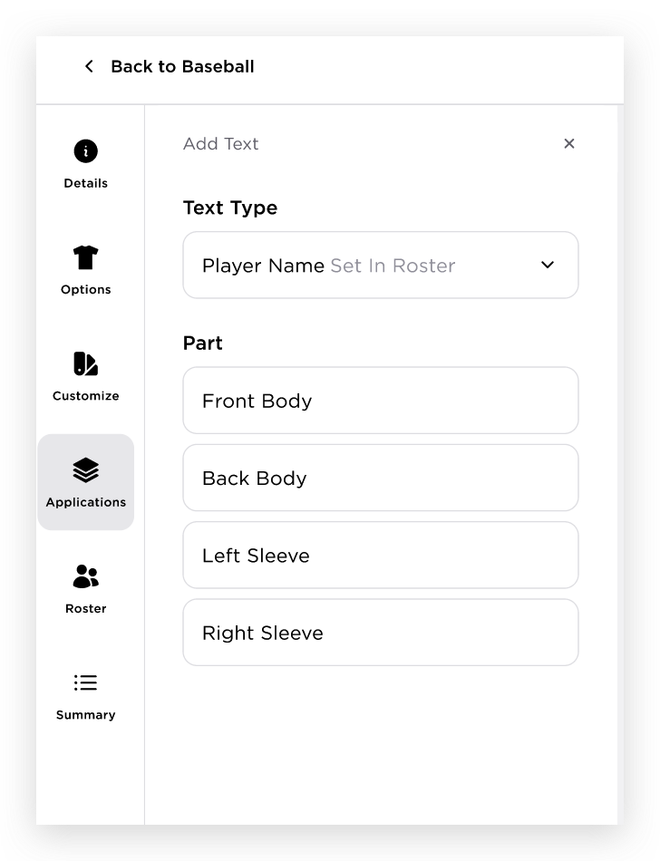  - After selecting a Text Type, the Text Type field will change to a dropdown, allowing the user to modify the selected text type from here  - “Part” section will be displayed, allowing the user to select where they want to add the text application.  - Once a Part is selected, the other options will disappear  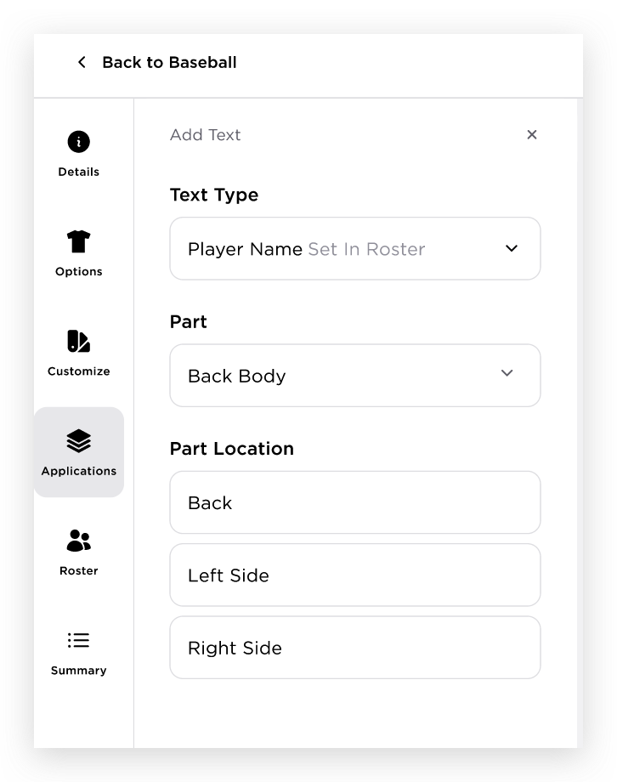  - After selecting a Part, the Part field will change to a dropdown, allowing the user to modify the selected part from here  - “Part Location” section will be displayed, allowing the user to select where they want to add the text application  - Once a Part Location is selected, Add application panel will be displayed  Note: When selecting Text Type, Part, and Part Location, a validation message will be displayed in red if the user clicks the Next button without making a selection. The message will read: "Please select a Text Type/Part/Part Location."
16 | APPLICATION TAB - ADDING/EDITING TEXT WITH PATTERN AS BASE TYPE | 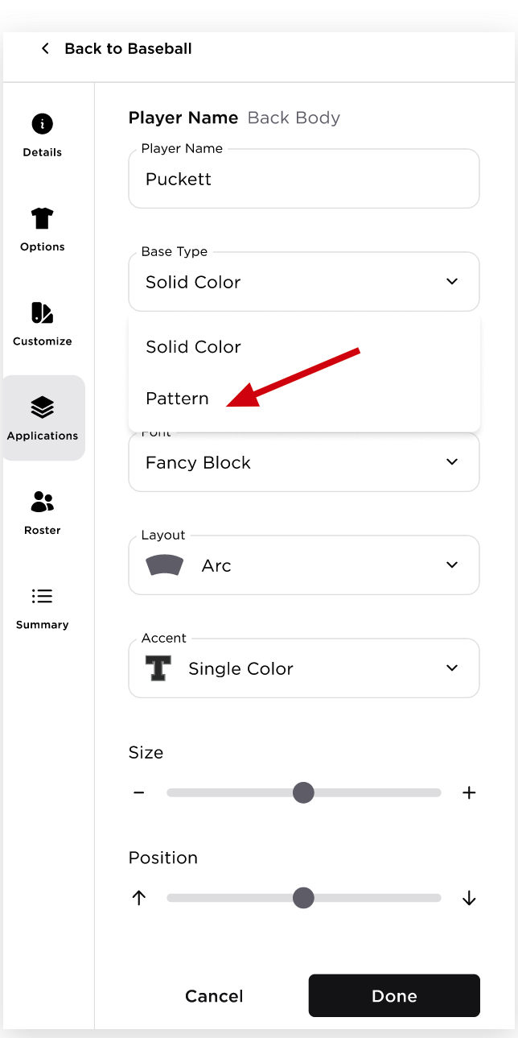  When the user selects the Pattern as the Base type, the Text Base Pattern panel will appear  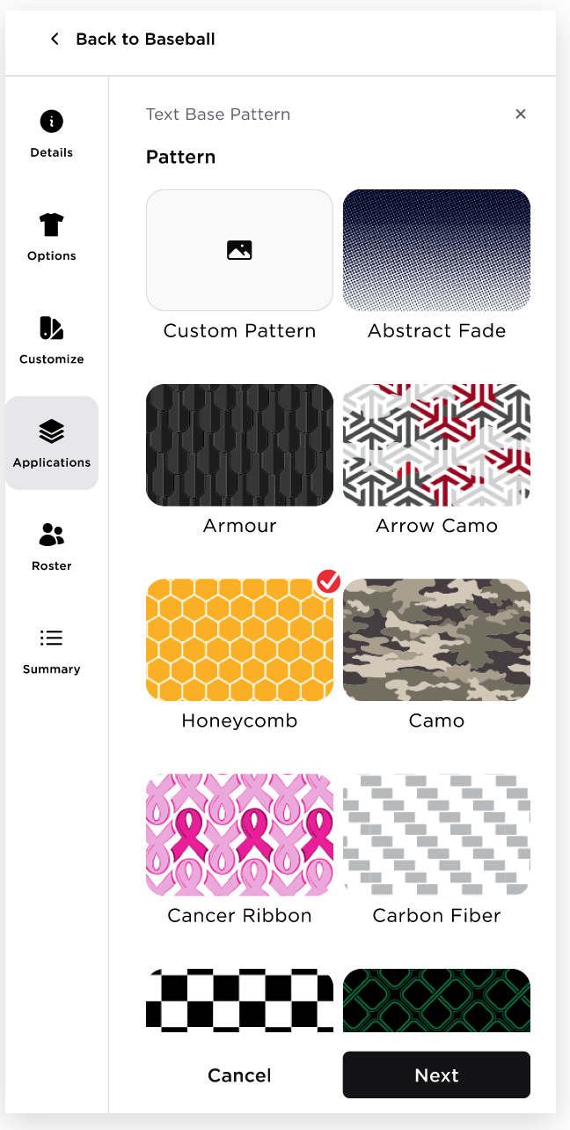  - The user can select the text base pattern.  - Once they have selected a pattern, the user should click the Next button to proceed to the configure text base pattern panel  - If there is no pattern selected and the user clicks the Next button, there will be a validation message: “Please select a Pattern.”  - In configure text base pattern panel,  - This will show the following details of the Pattern:  - Name of the Pattern  - Pattern Thumbnail  - When the user hovers over the Pattern Thumbnail, a tooltip will be displayed with the text: “Click to update.”  - The pattern thumbnail is clickable. When the user clicks the Pattern Thumbnail, the system will redirect the user to the previous Pattern page, allowing them to update the applied pattern.  - Colors of the Pattern  - Pre selected colors of the tiles will be based on the Colors In Use  - The user can change the color of the pattern by hovering the color tile and the Colors in Use colors will be displayed  - Position  - Slider where the user can adjust the position of the pattern  - The ‘+’ and ‘-’ buttons are interactive; the user can click them to adjust the position by 1 unit  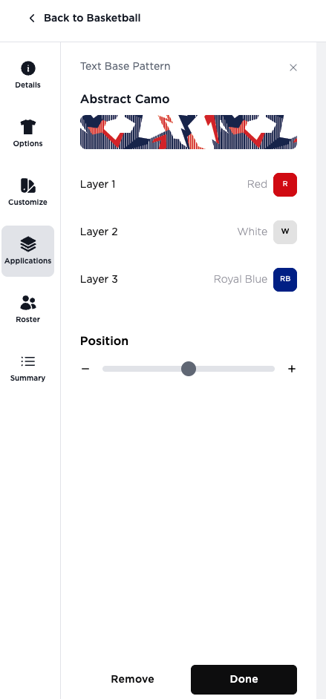  - Once they have configured the pattern, clicking:  - Done button - will close the Text Base Pattern panel and will return to the application settings panel, and the Base Type will change from “Solid Color” to “Pattern,” alongside the pattern name and tile.  - Remove button - will close the the Text Base Pattern panel and will remove the applied text base pattern from the uniform canvas  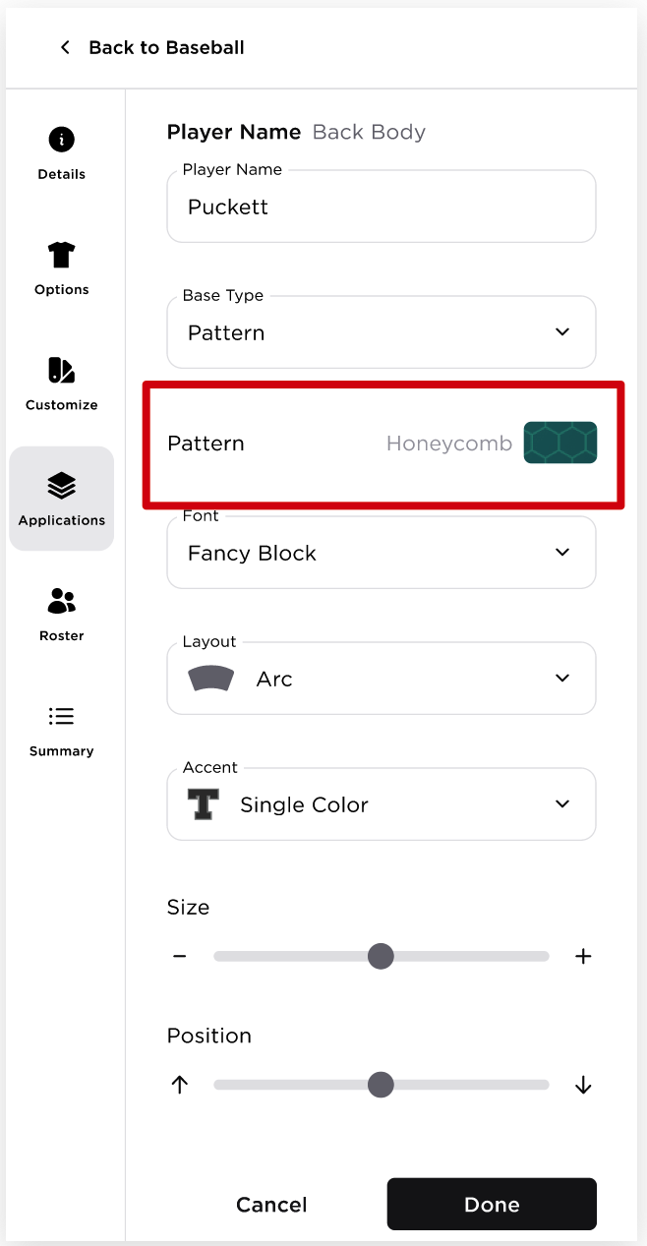  - In the Edit application,  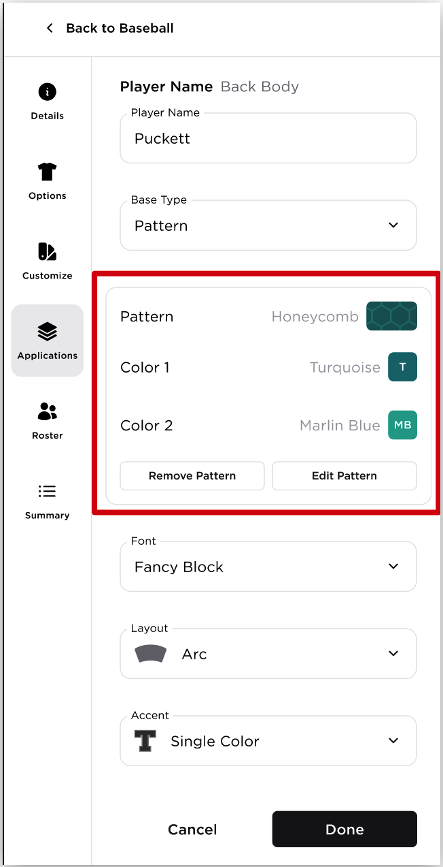  - The user can Edit/Remove the Pattern by clicking the Pattern section  - Change the color of the pattern by hovering the color tile and select the another color  - Remove Pattern button will remove the pattern applied from the uniform canvas  - Edit Pattern button will open the Text Base Pattern settings panel  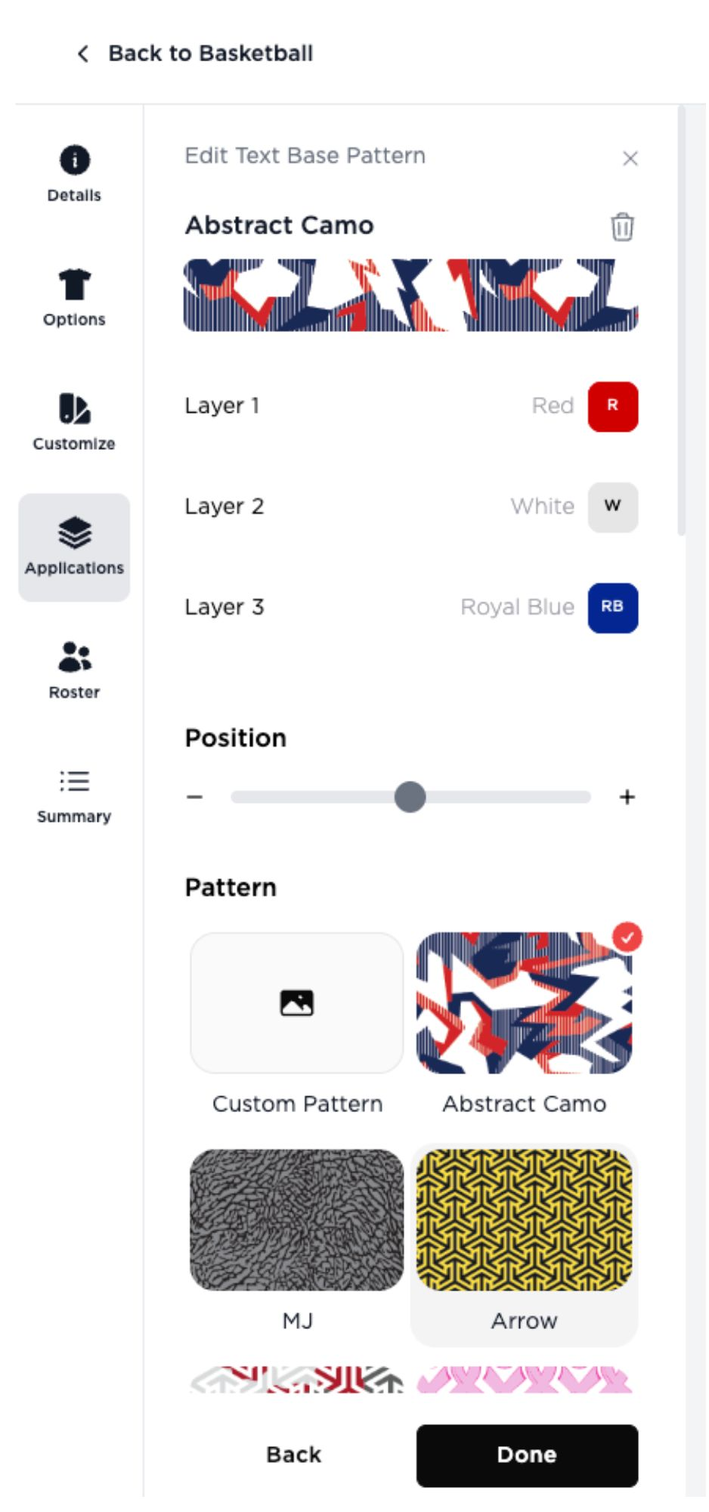  In the Edit Pattern panel, the user can;  - Update the pattern by changing the colors, position or just change the pattern  - Remove the Pattern by clicking the delete icon  - When the user deletes the pattern from here, the body part in the Colors panel will automatically have the Color 1 as its color  - The Pattern panel will automatically close and will be back to the Colors panel  - Clicking Done button will close the Edit Text Base Pattern panel  - Clicking Remove button will remove the applied pattern in the application. There will be a confirmation modal,  Text Base Pattern Limitation  - If the selected Base Type is Pattern,
17 | APPLICATION TAB - ADD LOGO | 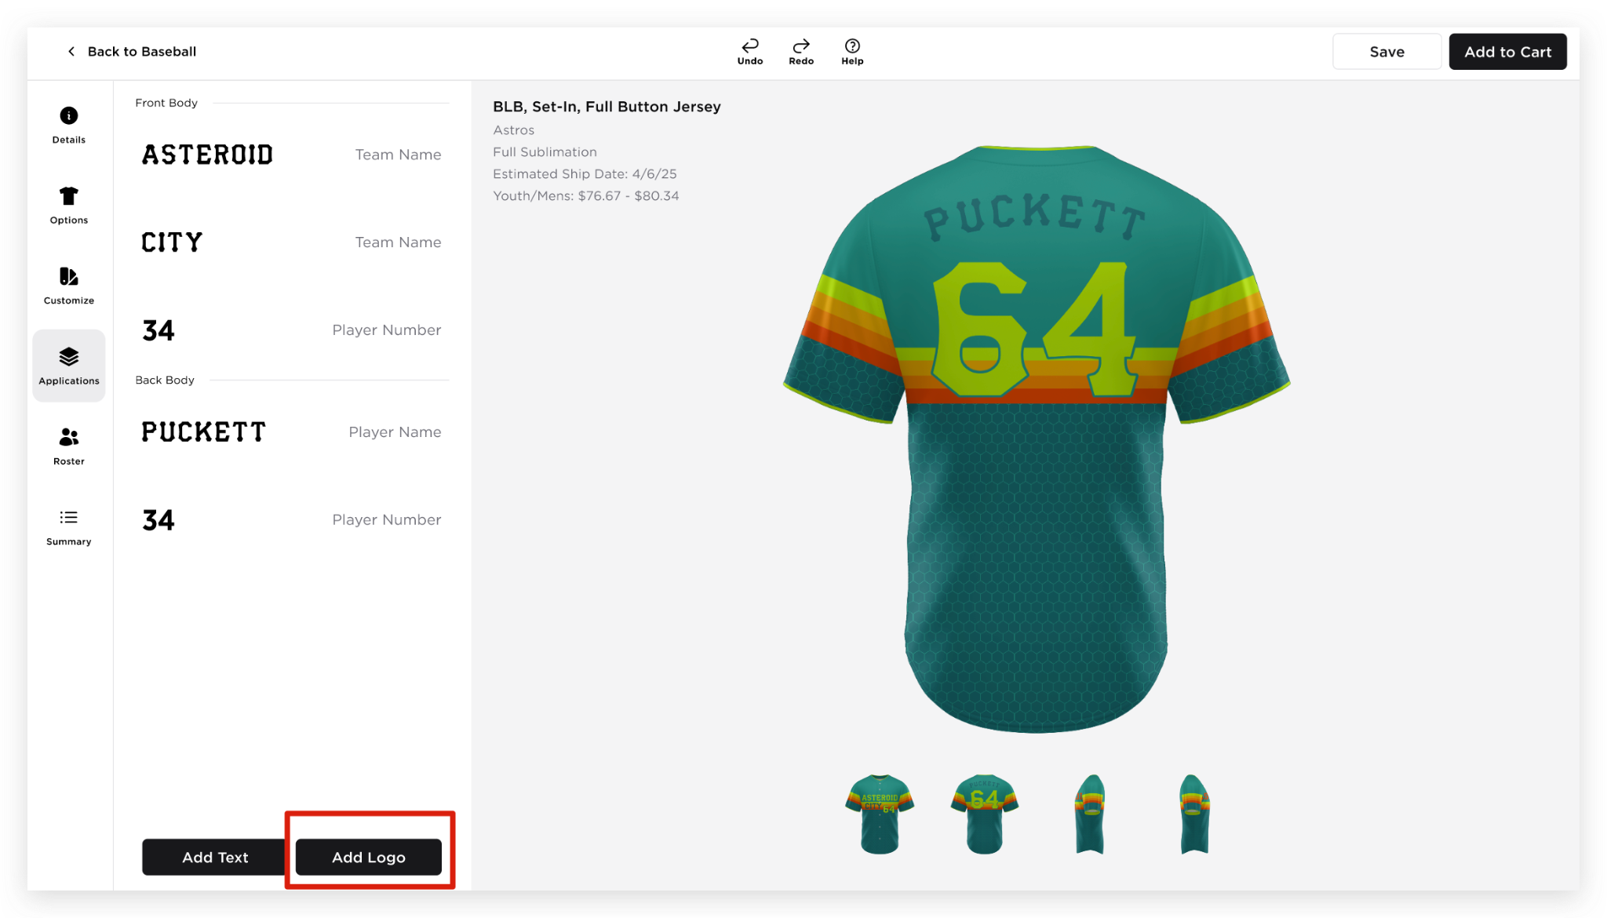  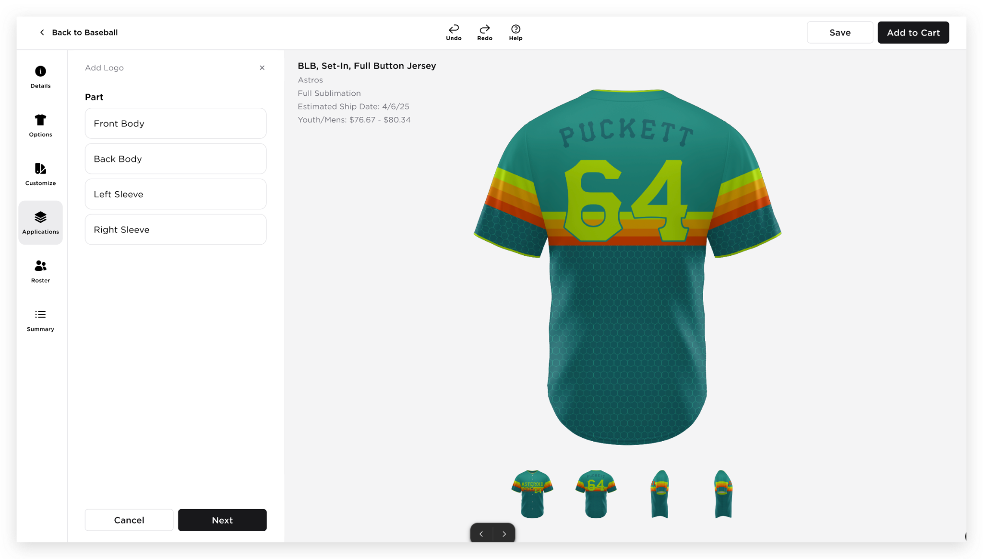  - Add Logo as the header  - ‘X’ button to close the Add Logo panel  - “Part” section will be displayed, allowing the user to select where they want to add the logo application.  - Once a Part is selected, the other options will disappear  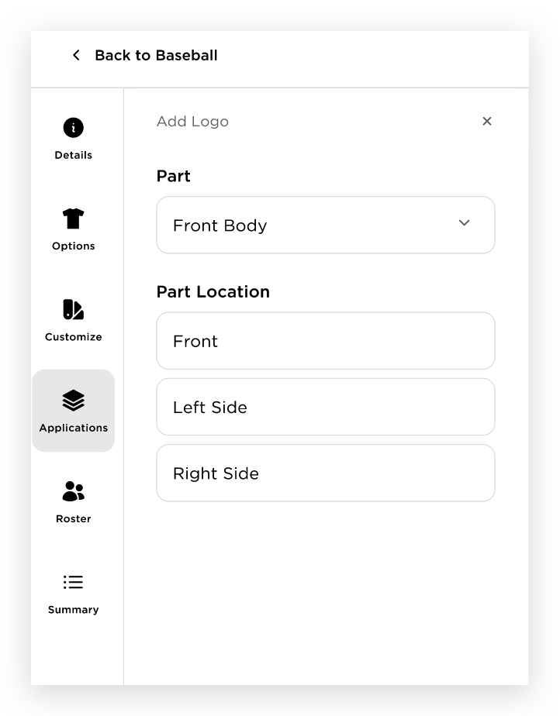  - After selecting a Part, the Part field will change to a dropdown, allowing the user to modify the selected part from here  - “Part Location” section will be displayed, allowing the user to select where they want to add the logo application.  - Once a Part Location is selected, clicking next will display the current Vectorsoft modal, allowing the user to select the logo that they want to add  - Default  RD_Logo Drops Integration to FE  - After selecting a logo from the Design Studio modal, the user will be redirected to the add logo panel  - The logo should already added in the canvas  Add Logo Panel  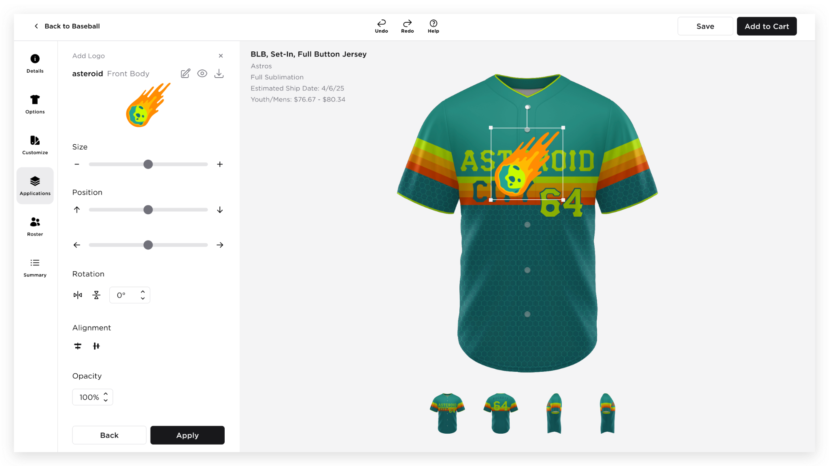  - The subheader will display the name of the logo, with the Body Part shown beside it.  - Icons are also available for Edit, View PDF Ready File and Download file  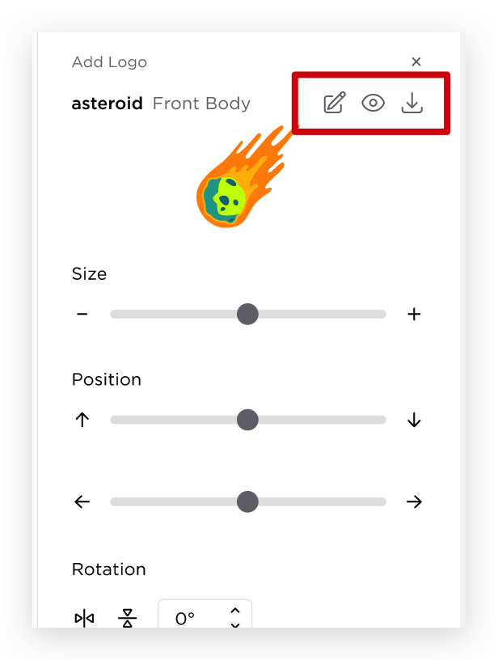  - Edit - clicking this will open the Design Studio modal  - Change Logo – Clicking this button will open the Design Studio modal.  - Once the logo is changed, the style canvas and the logo displayed in the left panel will be dynamically updated to reflect the newly selected logo.  - View Art Details - open the art details modal  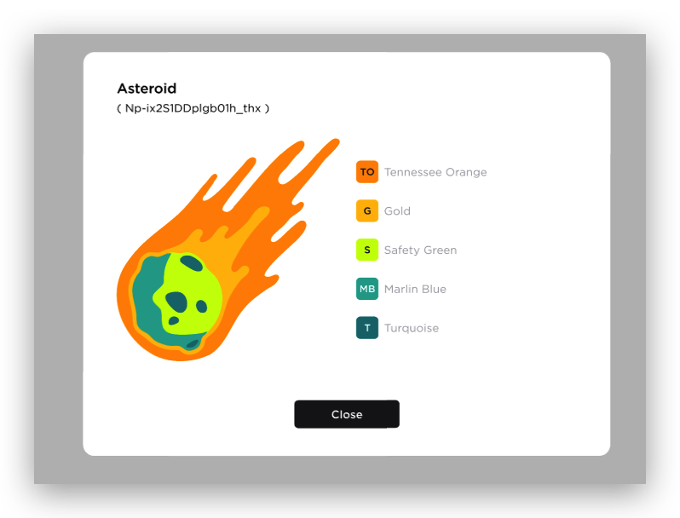  - Download - clicking this will download the logo file (Same as Save As functionality, download as SVG file)  - Size  - Slider where the user can adjust the size of the application  - The ‘+’ and ‘-’ buttons are interactive; the user can click them to adjust the position by 1 unit.  - Position  - Slider where the user can adjust the position of the application up and down, left and right  - The ‘+’ and ‘-’ buttons are interactive; the user can click them to adjust the position by 1 unit.  - Rotation  - Horizontal flip  - Vertical flip  - Angle adjustment - the user can also type the angle they want  - Alignment  - Horizontal alignment  - Vertical alignment  - A preset for Position configuration  - Opacity  - Default value is 100%  - The user can also type the percentage they want
18 | ROSTER TAB | 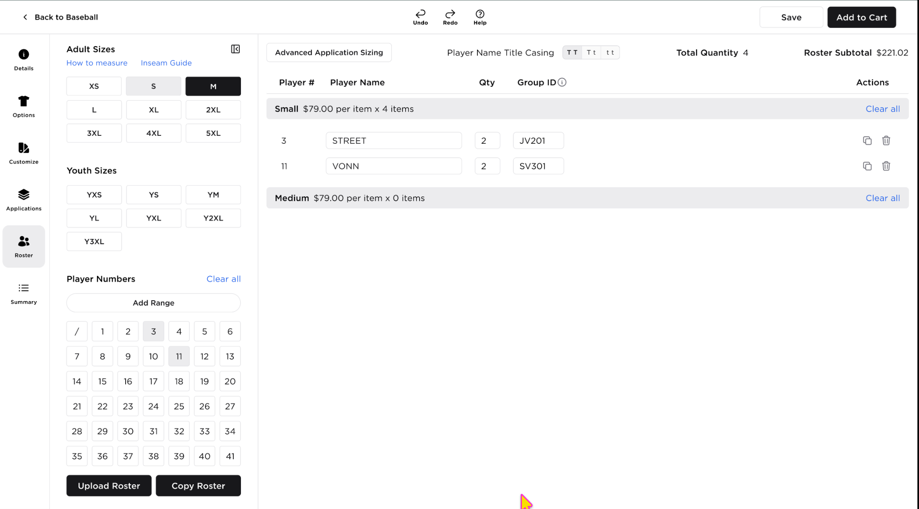  - Adult Sizes  - How to measure link  - Inseam Guide link  - Available Sizes  - Youth Sizes  - Youth sizes  - Player Numbers  - Clear all  - Player Numbers including ‘/’ as no number  - Add Range button  - Clicking the Add Range button will open the Add Range entry fields  - Users can enter a starting number and an ending number to define a range of player numbers.  - The Add Range functionality will exclude the Custom Number option from the selection. Users will only be able to select predefined number ranges and from the numbers added via Add Additional Number.  - If the user included a Custom number in the Add Range, a warning message will be displayed,Warning “Custom numbers can't be added using Add Range. Please select them individually.”  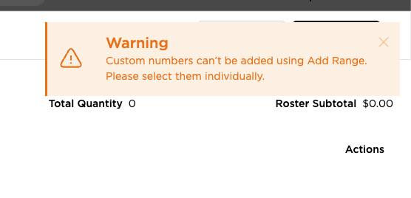  - Submit  - Adds the specified range to the available Player Number options  - Automatically adds the selected range of player numbers to the roster  - Cancel - Closes the range entry fields without saving any changes  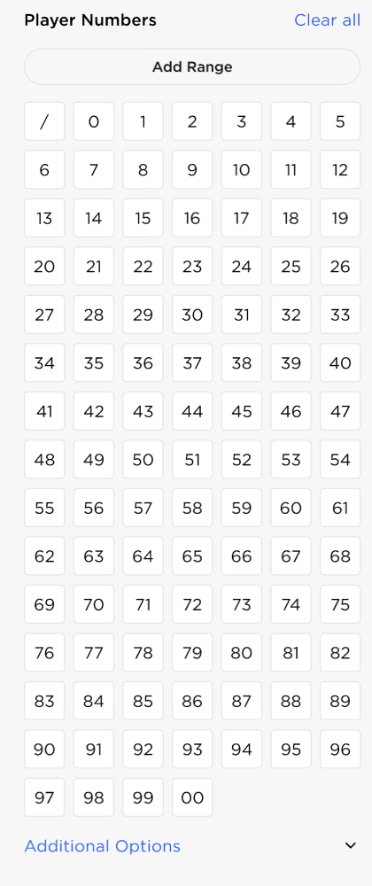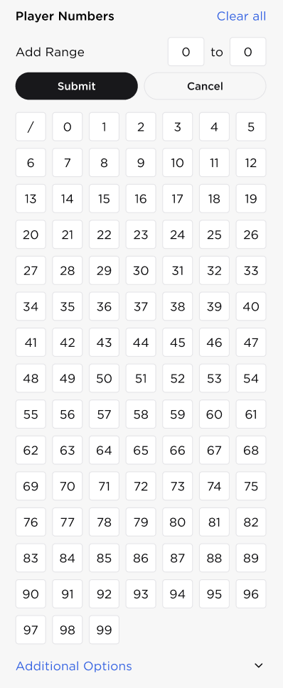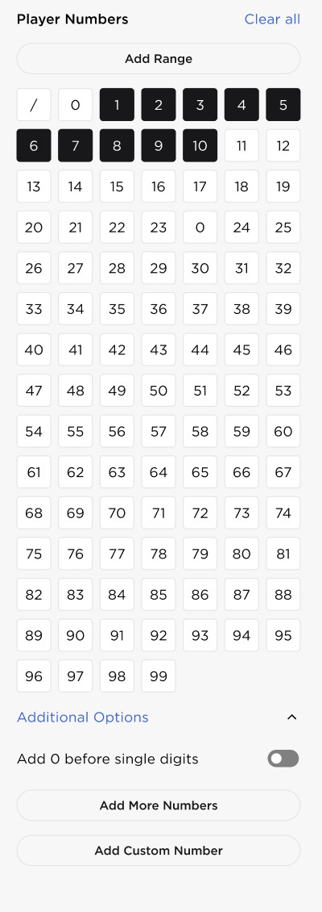  - Additional Options  - Clicking Additional Options will expand the additional configuration options  - Options include:  - “Add 0 before single digits toggle”  - The Add 0 Before Single Digits toggle will add a zero to all single-digit player numbers (0–9)  - If any of these single-digit numbers have already been added to the roster, the corresponding roster entries will be updated automatically  - “Add More Numbers”  - Clicking the Add More Numbers button will open the Additional Number range entry fields  - Submit  - If a number already exists in the Player Number list, it will be skipped to prevent duplicate entries.  - Newly added numbers will remain available in the line row until they are manually removed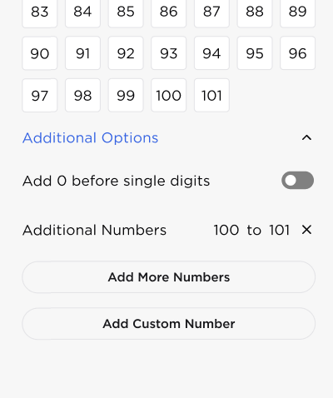  - Removing Additional Numbers  - Users can remove additional numbers by clicking the "X" button next to the number.  - If the numbers are already added in the roster, a confirmation modal will be displayed  - If the number is not currently used in the roster, the number will be removed immediately from the Player Number list.  - If the number is already assigned to one or more roster entries, a confirmation modal will be displayed before the number is removed.  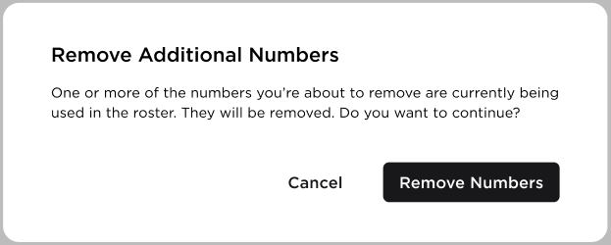  - Cancel - Closes the modal without saving any changes  - Remove Number - Removes the number from the Player Number list and from all the affected roster entries  - “Add Custom Number”  - Clicking the Add Custom Number button will open the Custom Number entry field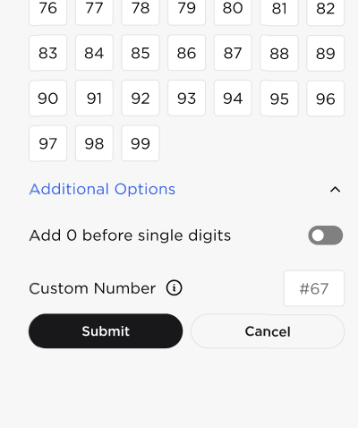  - Information icon - will display a tooltip message, “Any combination of 3 numbers, letters, or special characters”  - Submit  - Automatically adds the custom player numbers to the roster  - Cancel - Closes the range entry fields without saving any changes  - Clicking Submit or Cancel will automatically close the entry fields  - Each Custom Number added will be treated as a separate number entity in the roster.  - Note: A Custom Number may be a duplicate of an existing number in the roster. Duplicate values are allowed and will be treated as separate entries.  - Advanced Application Sizing  - Opens the Advanced Application Sizing modal  - Cancel button  - Save Application Sizes button  - Advance Application Sizing for Reversibles  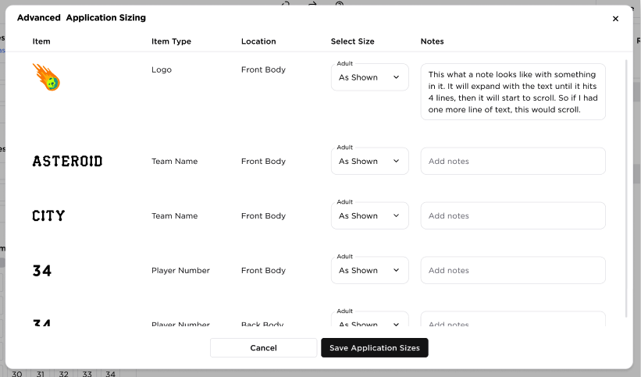  - Advance Application Sizing for Reversibles  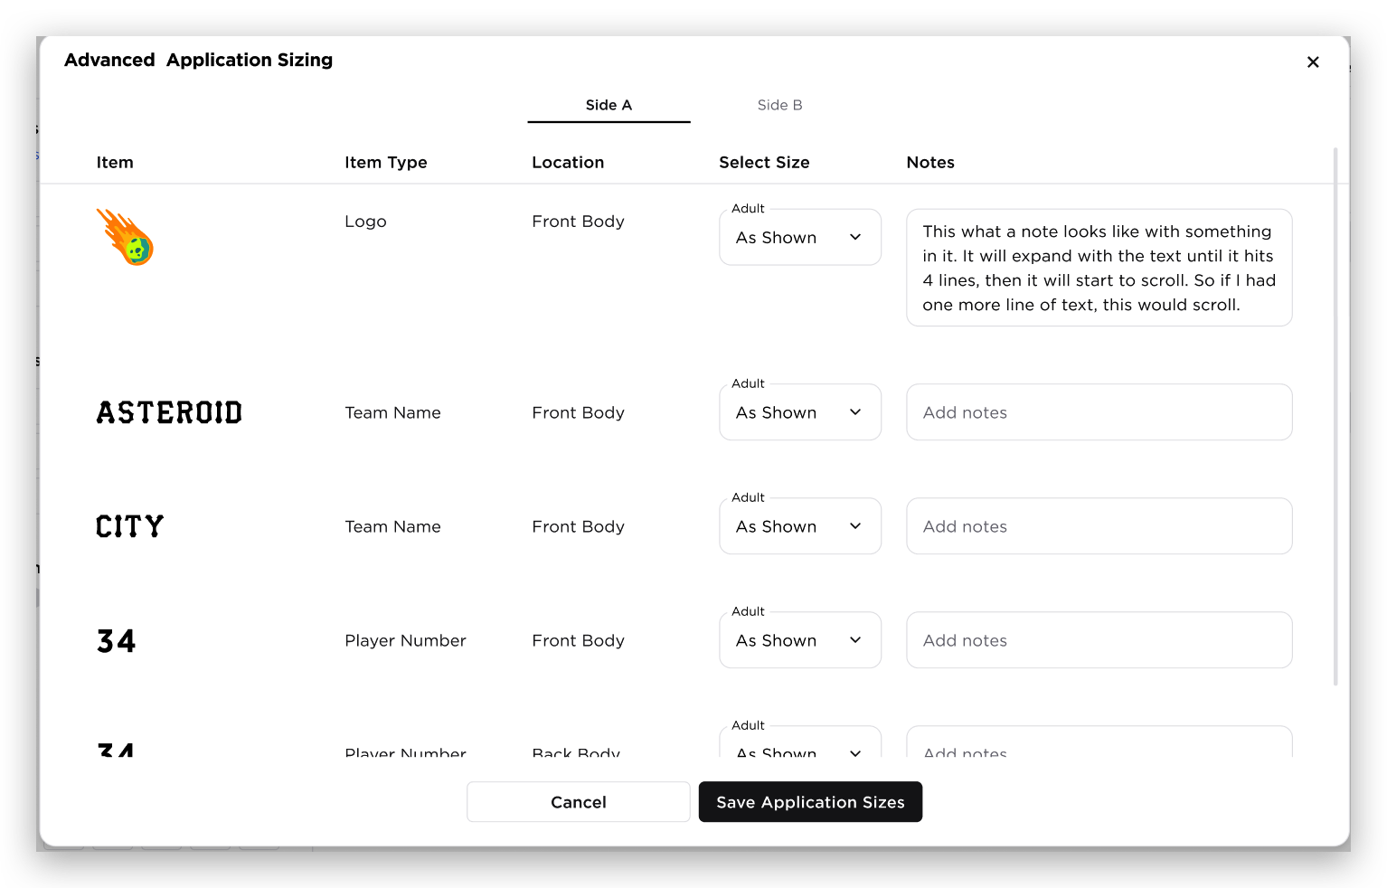  - Player Name Title Casing  - Showing clickable icons for Upper Case(‘TT’), Title Case (‘Tt’) and Lower Case (‘tt’)  - Clicking each icon will apply to the Player name capitalization format  - Total Quantity  - Roster Subtotal  - Only the total of the items, add-ons not included  - Roster Table  - Column Headers and values  - Player # - selected number from Player Numbers section  - Player Name - text field  - QTY = text field  - Group ID (i) - text field  - Actions  - Duplicate icon - adding a new item row with the same values  - Remove icon - deletes the item row  - Items on the roster table will be grouped by sizes  - Each section will show the price per item and the total qty of the size group  - The user can remove all the items within the size group by clicking Clear all  - CLEAR ALL : Upon clicking the user Clear All button, all item within the size group will be removed including the Sizes selected from the left panel  - Upload Roster  - Opens the Upload Roster modal  - The user can download the template from this modal via “Download Template”  - The user can ”Choose File”, open the local machine upload functionality or “Drag and Drop File” functionality  - Apply to Roster  - Cancel  - The user can remove the uploaded file via “x” button  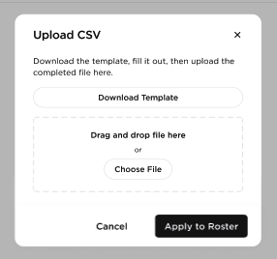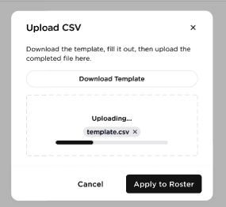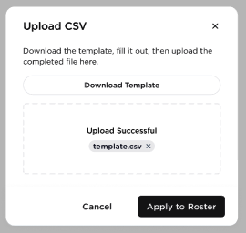  - Copy Roster  - Opens the Copy Roster modal  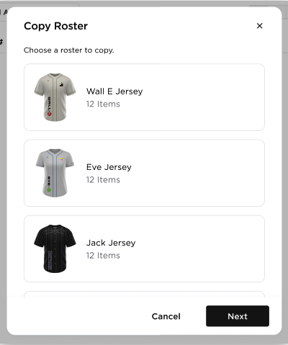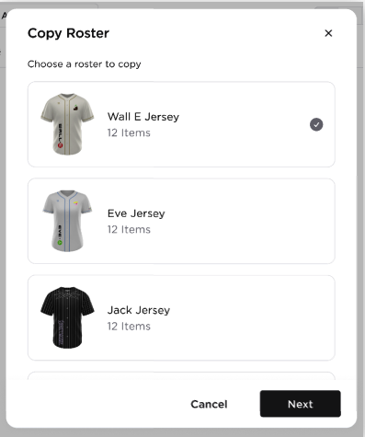
19 | SUMMARY TAB | The Summary tab will display the following if the user doesn’t have roster:  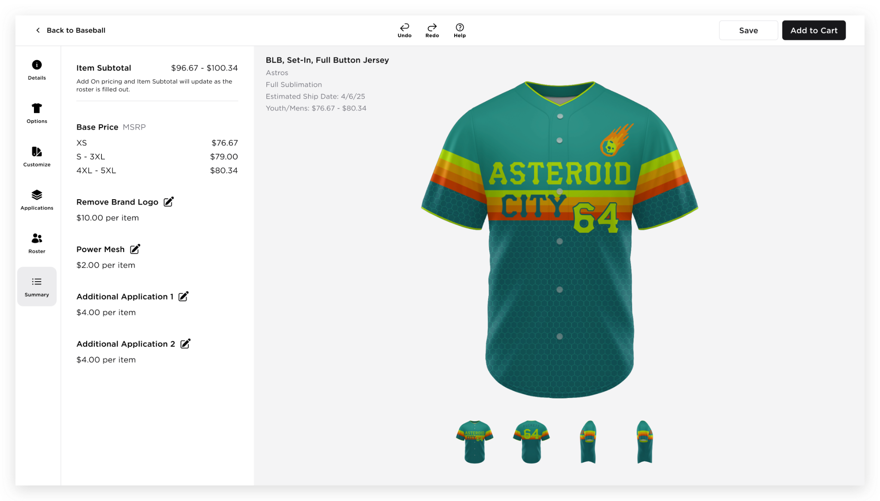  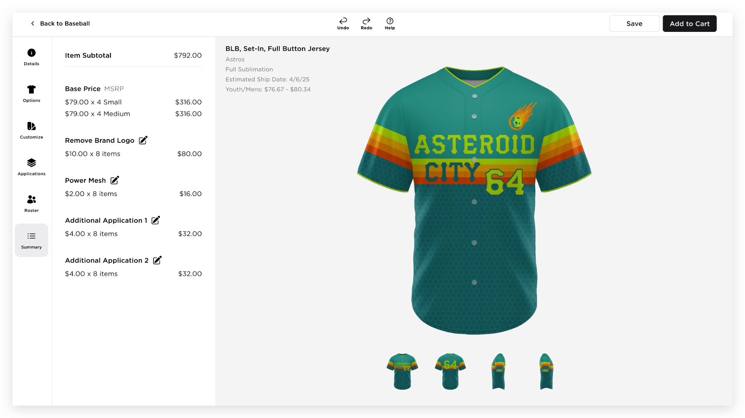  - Left Panel  - Item Subtotal - total of the items including the add-ons  - Base Price  - Should show either MSRP or Brand/Dealer Cost  - Format: {Price} x {QTY} {Size}  - List of add-ons  - Format: {Price} x {QTY} items  - Edit button - this will redirect the user to the section where they added/configured the add-on (e.g. Remove Brand Logo edit icon will redirect the user to the Colors Panel → brand Logo dropdown)  - Uniform Canvas  - Should show the final design of the uniform  - Part and applications are clickable and will redirect the user to the correct panel. (E.g. if the user clicks on the logo or player number, the user will be redirected to the application edit panel or edit logo
20 | MANUAL ORDER FUNCTIONALITY | BRD_Manual Orders/Custom Pro  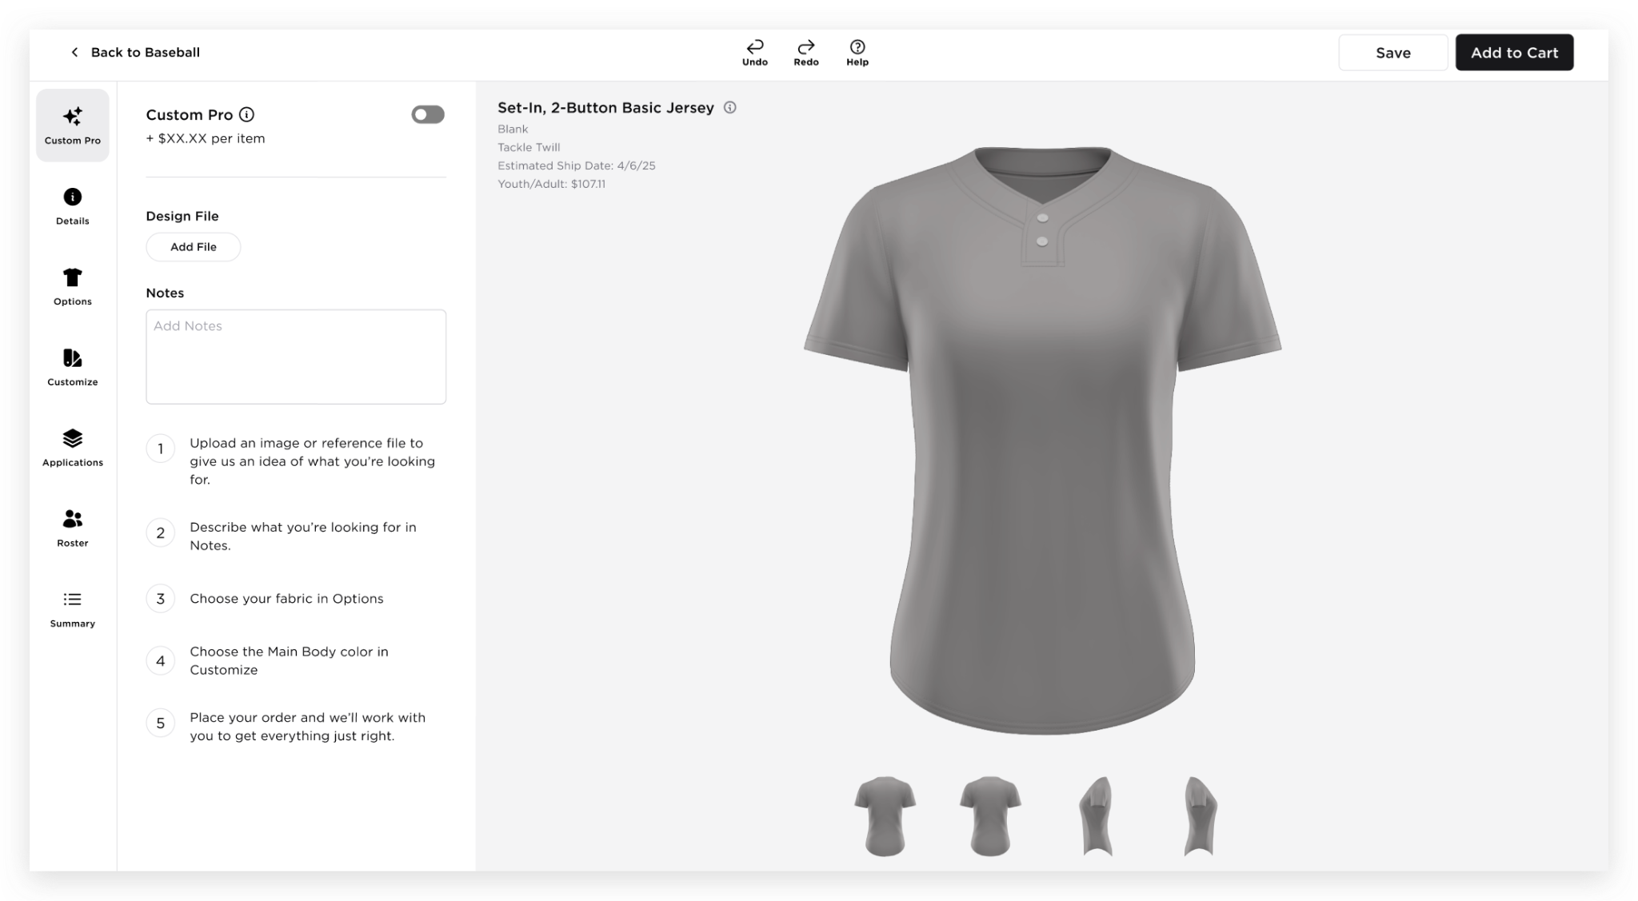  - Manual Order new tab  - Manual Order toggle switch  - Design File  - Notes  - Steps  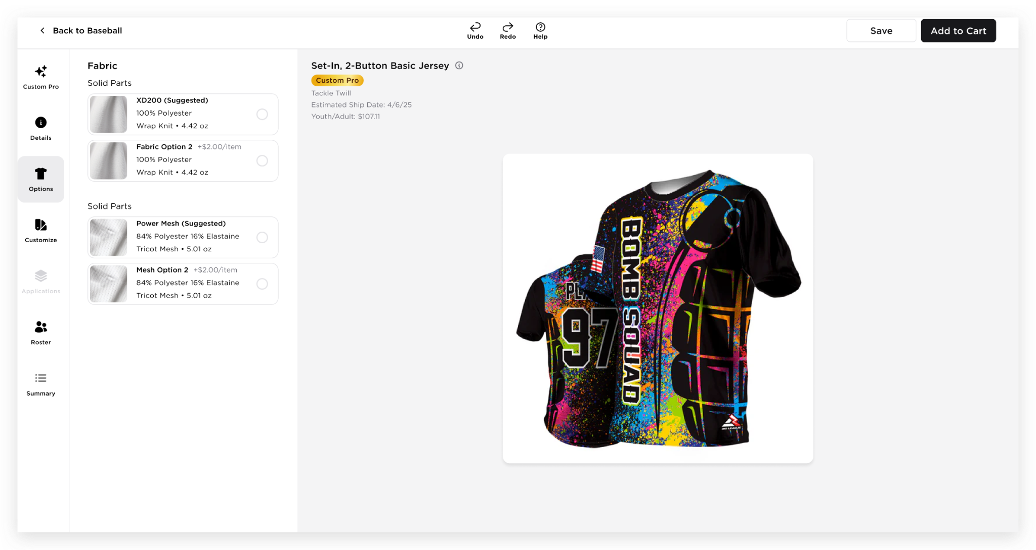  - Main Body color  - When Manual Order is enabled, the Main Body Color field will initially be empty.  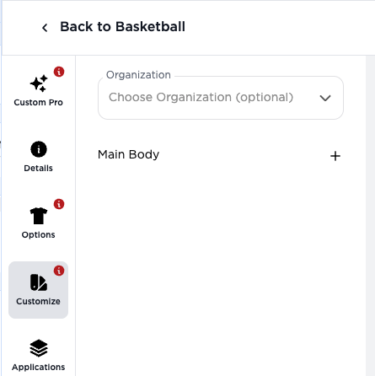  - A “+” icon will be displayed, allowing the user to open the Color Selection Modal and select a color.  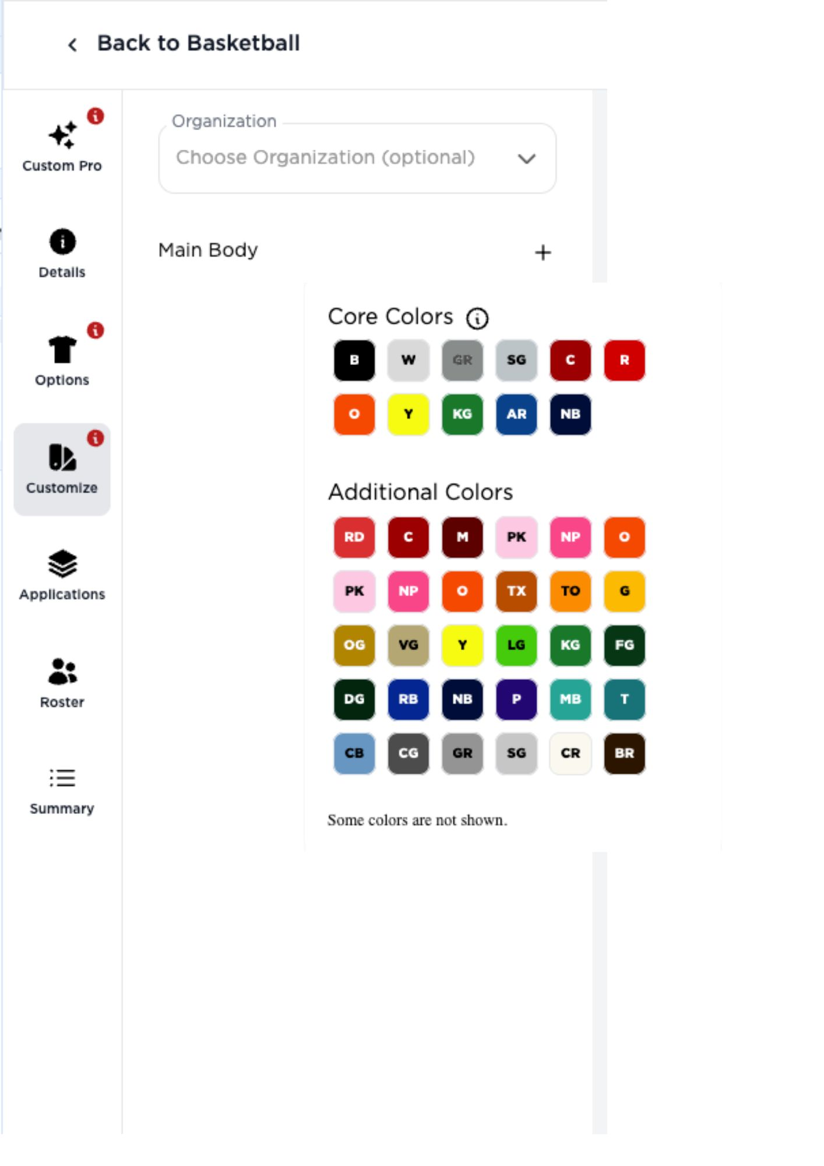  - Once a color has been selected, the “+” icon will be replaced by the selected color name and color tile.  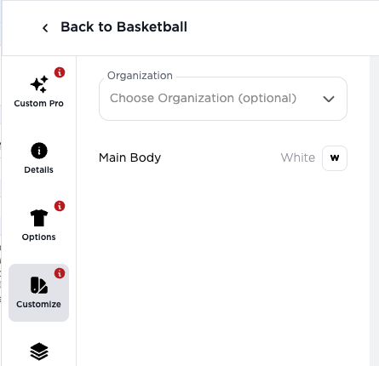  - When the user hovers over the selected color tile, the Color Selection Modal will be displayed, allowing the user to select a different color.  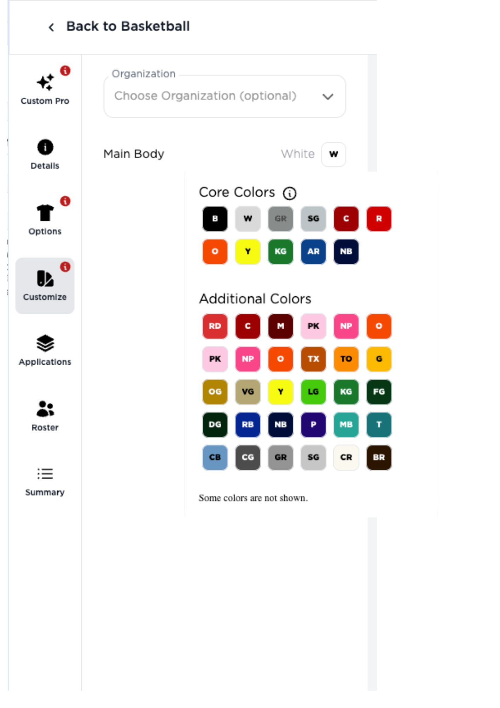  - Builder Validation  - When the user clicks “Add to Cart” and there are tabs with missing required selections, a modal will appear showing “MISSING ITEMS.”  - The message should be dynamic depending on what is missing (Design File, Fabric Selection, or Main Body Color)  - Example message:  “MISSING ITEMS: Please add a design file before adding this item to your cart.”  - Related ticket: Manual Orders: Shopping Cart | Ability to Add an Item to the Cart without a Fabric Selected  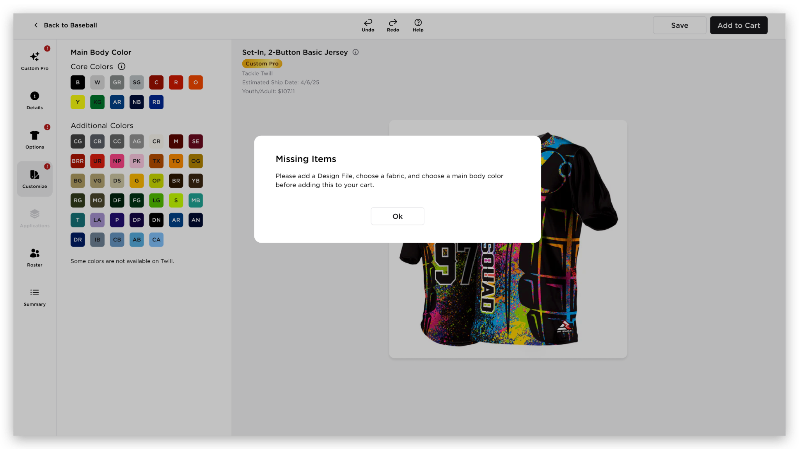  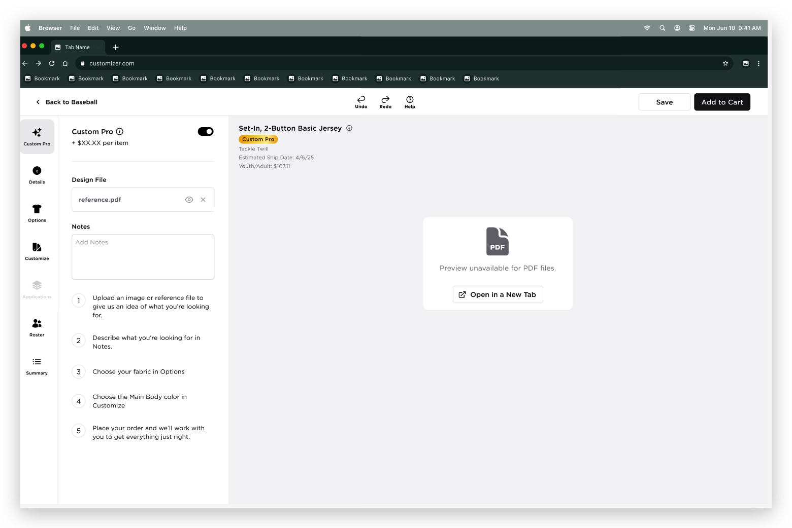  - ‘Open in New Tab’ will open the uploaded file in a new tab
21 | NOTIFICATION NOTES | 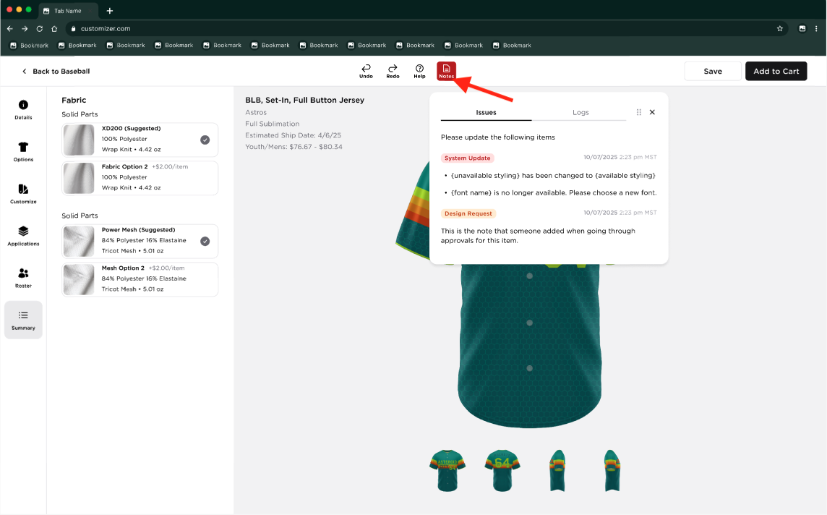  Notes Modal  - A new Notes button will be added alongside the Undo, Redo, and Help buttons.  - When clicked, a draggable modal will appear displaying the Issues and Logs tabs.  - Users can move the modal to different areas of the Customizer using the grip dots.  - Users can dismiss the modal by clicking the "X" button.  - When the Notes modal is reopened, it will appear in its default location.  Issues Tab  - This tab displays all System Updates and Design Requests that need to be resolved.  Logs Tab  - This tab displays a consolidated history of System Updates and Design Requests  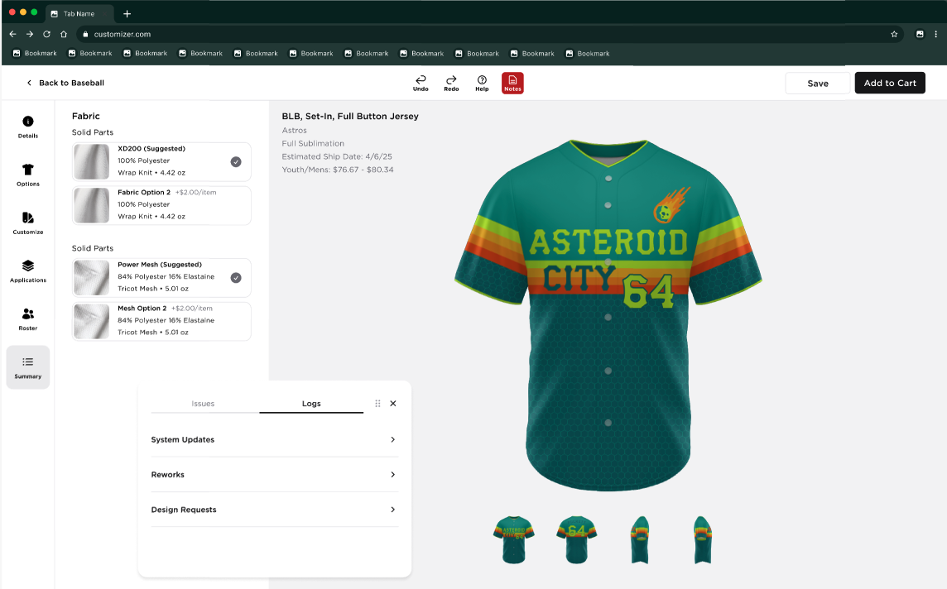
22 | NOTIFICATION NOTES - REWORK ITEMS | Rework Workflow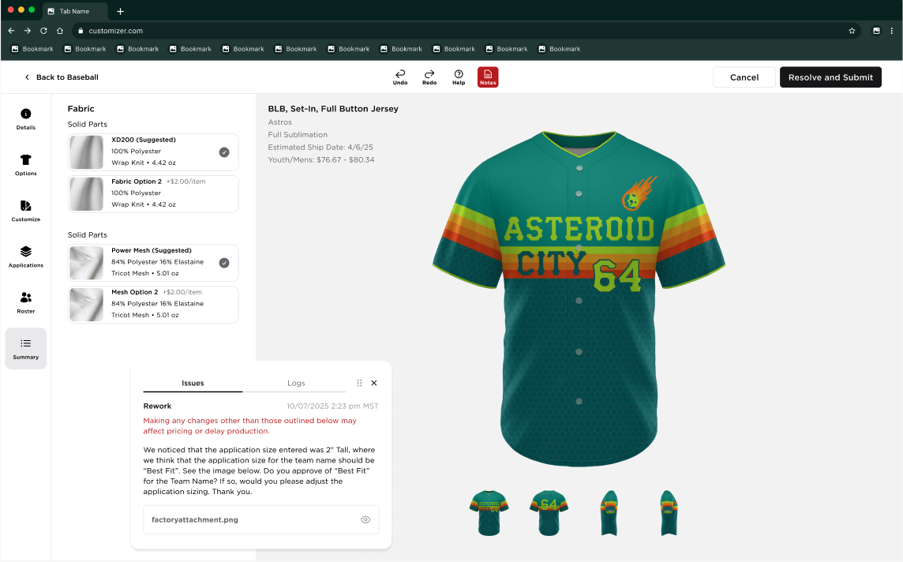  When an item is tagged as a Rework, the Save and Add to Cart buttons will be replaced with ‘Cancel’ and ‘Resolve and Submit’ when the user opens the Builder.  Cancel - Returns the user to the page from which they accessed the rework item.  Resolve and Submit - Opens a confirmation modal where the user must select one of the following options: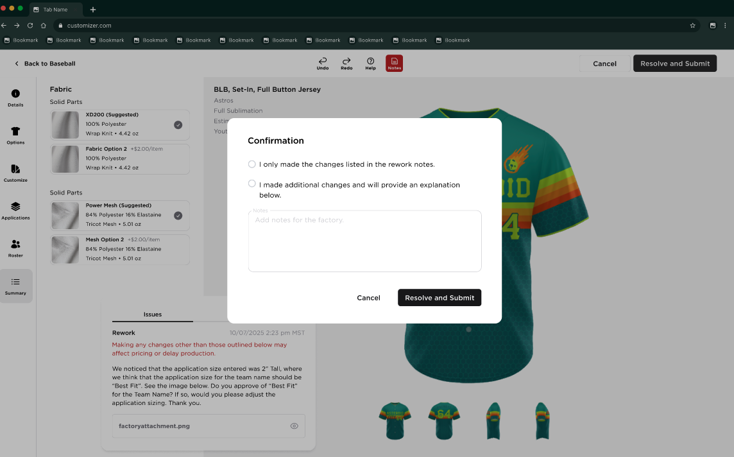  - “I only made the changes listed in the rework notes”  - “I made additional changes and will provide an explanation below”  - Notes Field  - The Notes field should remain disabled by default.  - The field will only be enabled when the user selects an option;  - Select “I only made the changes listed in the rework notes” - will enable the field but Notes field is optional  - Select “I made additional changes and will provide an explanation below” - will enable the field and Notes field is mandatory  - If no option is selected, the Notes field must remain disabled.  Confirmation Modal Actions  Cancel - Closes the confirmation modal without submitting any changes.  - Resolve and Submit - Submits the rework resolution and follows the existing Rework Process workflow.  Notes (Header Item) Behavior  - When the user opens the Builder for a Rework item, the Notes modal will automatically open.  - The Logs tab will be selected by default, and the Reworks section will be expanded.  - The user will be able to view the factory's rework notes, including any attachments associated with the rework.  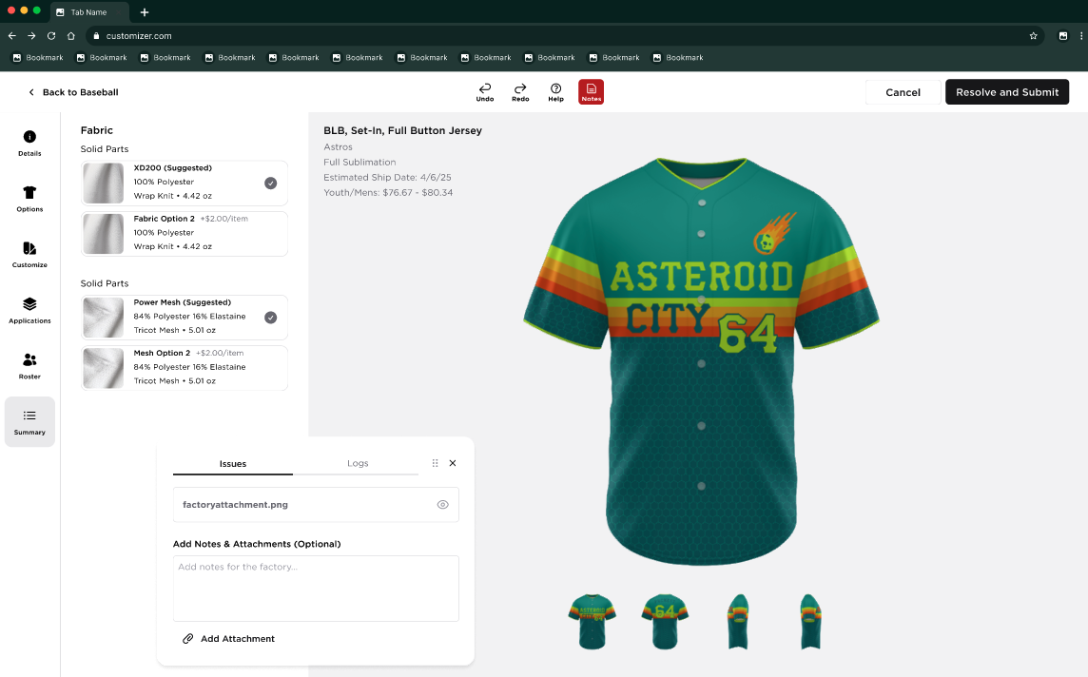  Viewing Attachments  - If an attachment is available, the user can view it by clicking the Eye icon.  - The attachment will open in a separate browser tab.  - Adding Notes and Attachments  - The user may optionally add notes and upload an attachment as part of the rework response.  - When an attachment is uploaded:  - The user can view the attachment by clicking the Eye icon, which will open the file in a separate browser tab.  - The user can remove the attachment by clicking the "X" button.  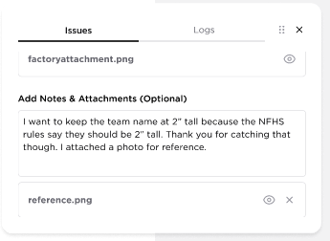  Rework History  - Once the user submits the rework, all notes and attachments will be logged under the Reworks section of the Logs tab.  - If the item is returned as a rework again in the future, the new rework notes and attachments will be appended to the existing rework history.  - Rework logs should be displayed in chronological order, providing a continuous record of all rework cycles for the item  - The Reworks section will automatically scroll to the latest rework entry when new rework history is added
23 | PRICING TOGGLE RELATED
  CUSTOMIZER BUILDER SECTION/TAB | PRICE RELATED CONSIDERATION
  CUSTOM PRO (MANUAL ORDER) | Custom Pro Add-on Fee
  DETAILS | Youth and Adult Price
  OPTIONS | Fabric Upgrade and Downgrade Fee
  CUSTOMIZE | Brand Logo (No Logo fee)
  APPLICATIONS | Soft Limit fee
  ROSTER | Roster Subtotal  MOQ by Item
  SUMMARY | All Prices
  CANVAS | Pricing Display
24 | ZOOM FUNCTIONALITY | A new Zoom button will be displayed in the header, allowing users to access the zoom functionality  - This button will behave same with the implementation of this ticket, Core Customizer: Zoom Feature on the Builder Canvas  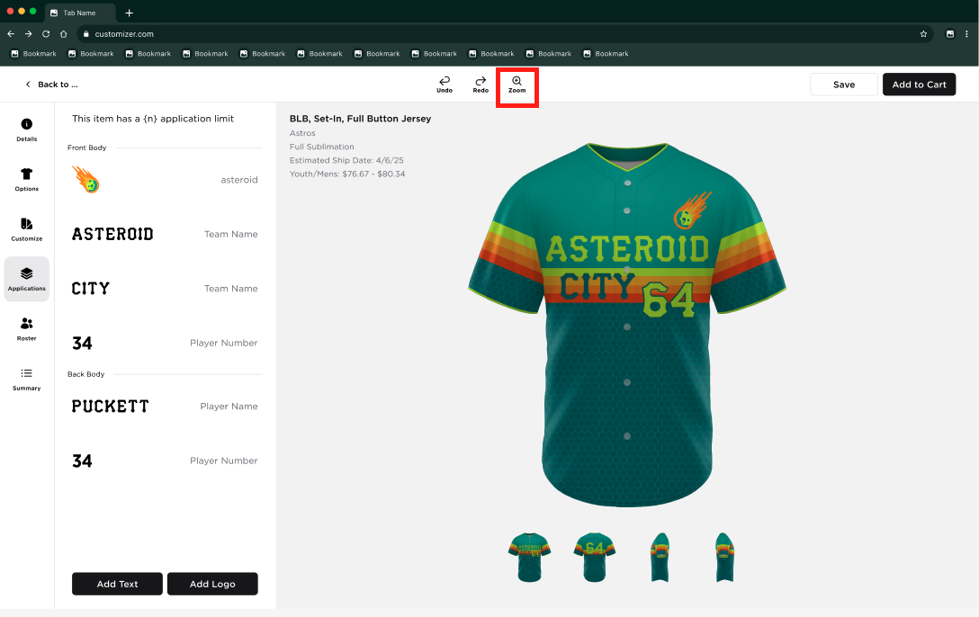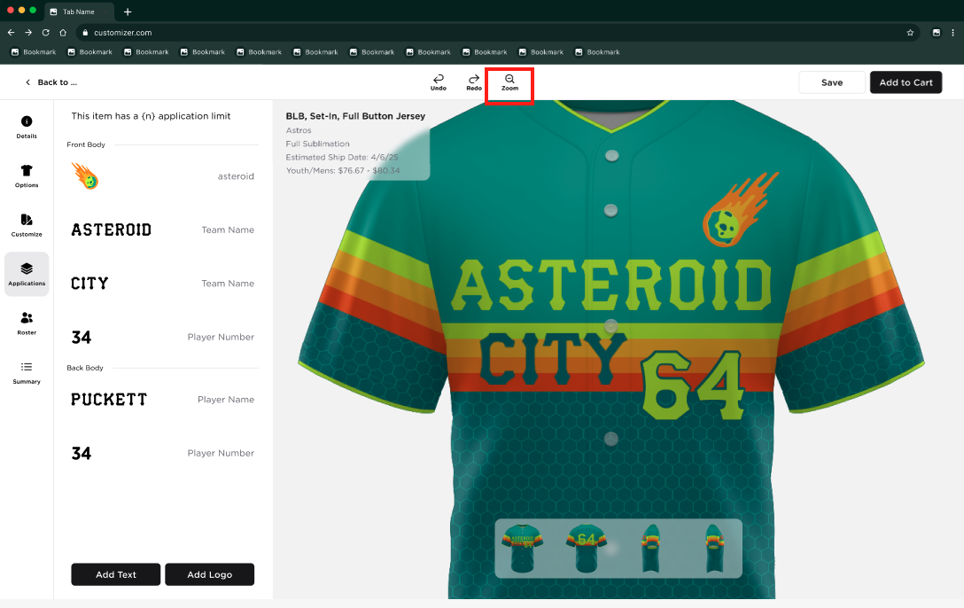  When the style contains Notes, the Zoom button will be positioned between the Redo and Notes buttons in the header.  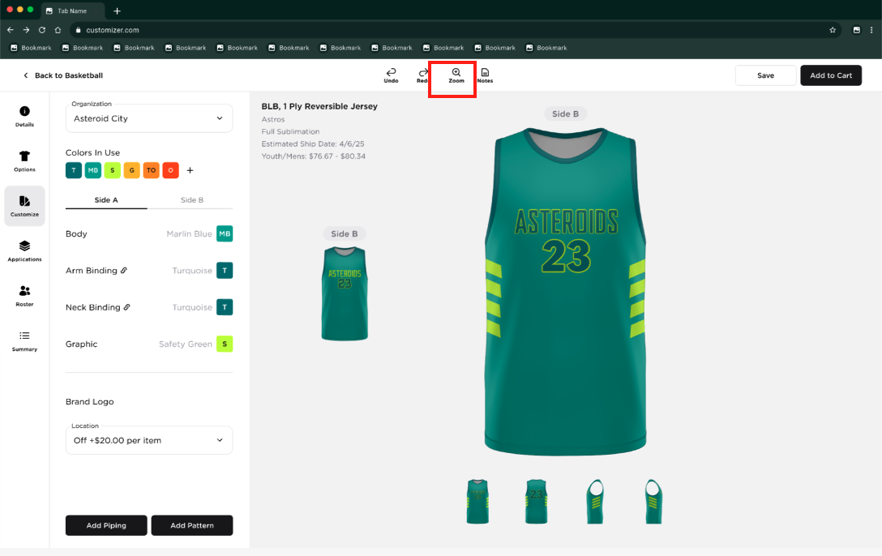
25 | COPY ROSTER ENHANCEMENT | The user should be able to copy all the roster details including the Additional Number and Custom Numbers
26 | MOQ BY ITEM | MOQ BY ITEM ADD-ON IS ADDED  When the user clicks the "Add to Cart" button and the minimum required quantity has not yet been met, a modal is displayed.  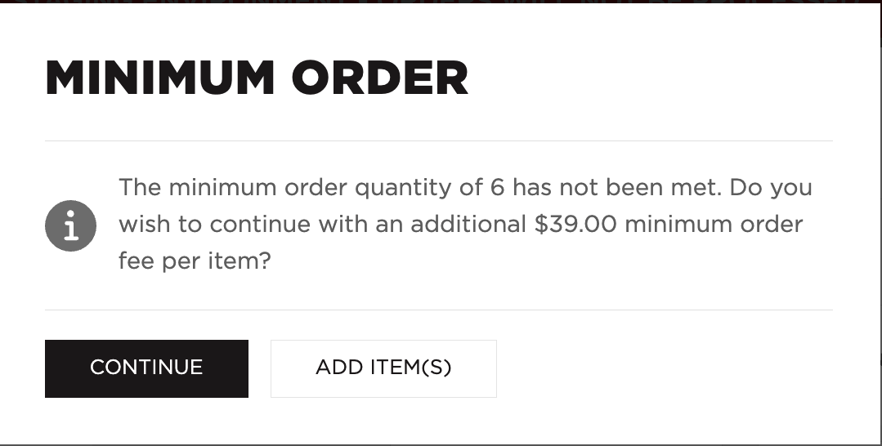  The system shall retain the existing validation flow. If no player names have been added, the player name validation message shall be displayed first. Upon clicking the Add to Cart button again, the Minimum Order modal shall be displayed if the minimum order quantity requirement has not been satisfied.
27 | STOCKS PRODUCT FUNCTIONALITY CHANGES | Stock Products should retain the same functionality as the current implementation, with the following enhancements and requirements:  Color Selection in Customize Tab  - ‘Color in Used’ color picker should not be displayed for Stock products  - The Body part shall have its own dedicated color picker modal.  - Upon hovering over the Body color tile, the color picker modal should be displayed and should show only the colors available for the selected Stock Product.  - Existing hardcoded behavior for applicable styles should remain unchanged and continue to function as currently implemented  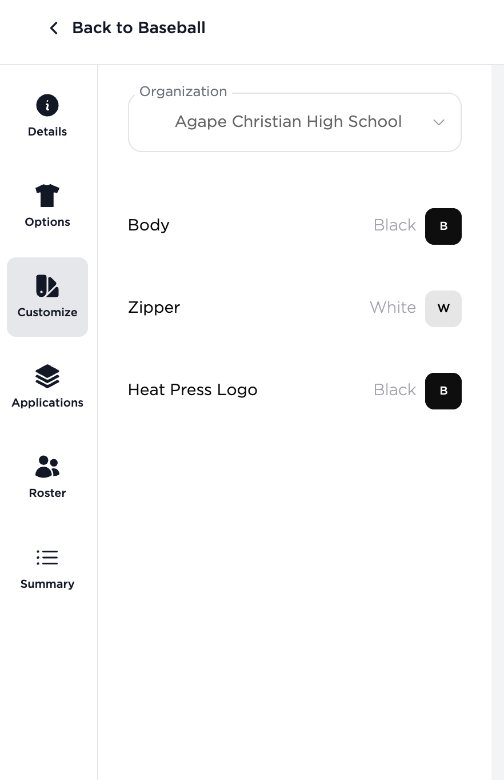  Color Selection in Application Tab  - Upon hovering over an Application color tile, the system will display the Colors in Use overlay with a "+" button  - Upon clicking the "+" button, the Additional Colors section will display only the color options available for the selected application  - Upon selecting a color tile from the Additional Colors section, the selected color will be automatically applied to the corresponding Brand Logo application and added to the Colors in Use section  - The user can remove a color from the Colors in Use section by clicking the "x" button (). When the color is removed, it will also affect the other application’s Color In Use  - If the user choose to remove a color that is currently applied in other applications, Remove Color modal will be displayed (same behavior stated in FR 6: CUSTOMIZE TAB - REGULAR UNIFORM: Removing a color via ‘x’button on color tiles )  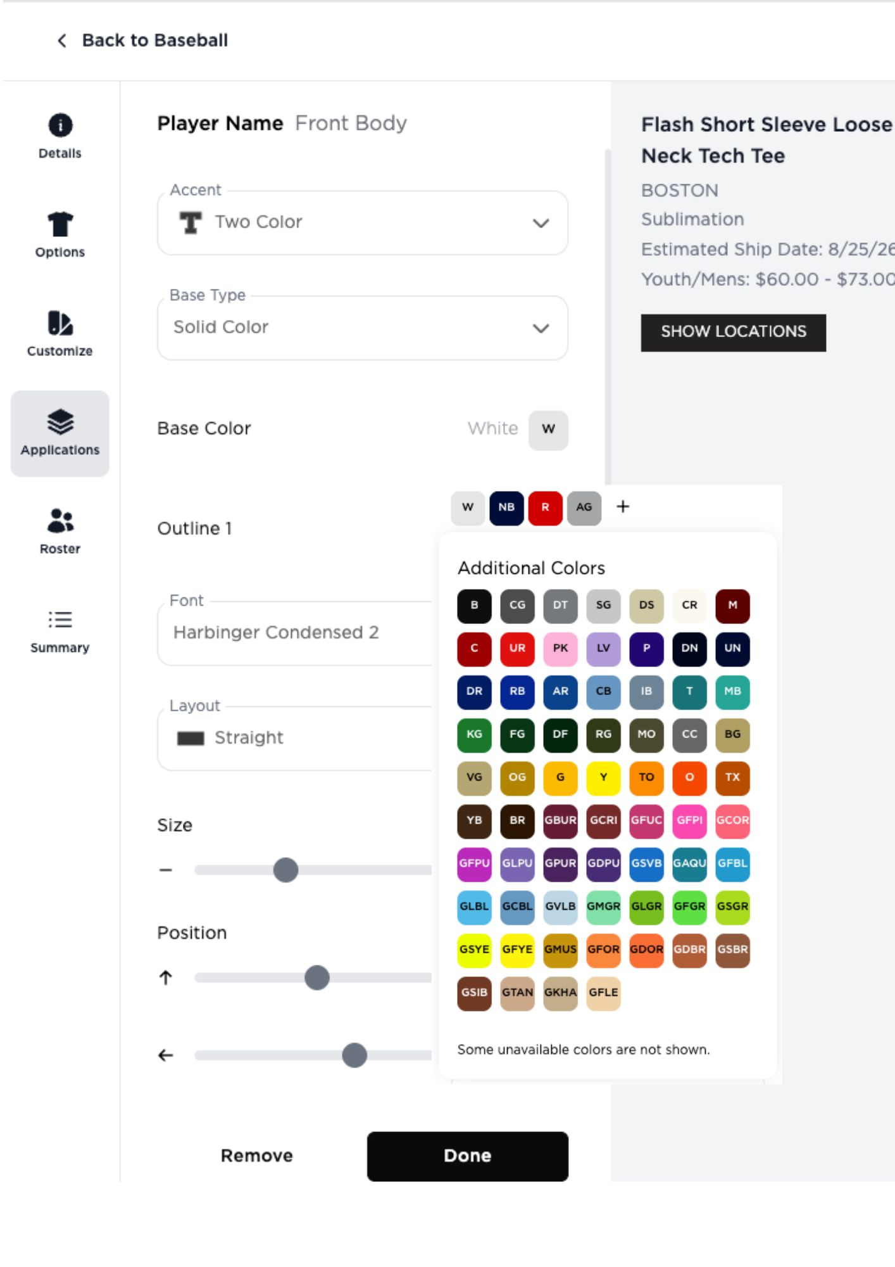
28 | SUBLIMATED, TWILL AND HYBRID PRODUCT  FUNCTIONALITY CHANGES | Color Selection in Application Tab  - Upon hovering over an Application color tile, the system will display the Colors in Use overlay with a "+" button  - Upon clicking the "+" button, the Additional Colors section will display only the color options available for the selected application  - Upon selecting a color tile from the Additional Colors section, the selected color will be automatically applied to the corresponding application and added to the Colors in Use section  - The user can remove a color from the Colors in Use section by clicking the "x" button (). When the color is removed, it will also affect the other application’s Color In Use  - If the user choose to remove a color that is currently applied in parts and applications, Remove Color modal will be displayed (same behavior stated in FR 6: CUSTOMIZE TAB - REGULAR UNIFORM: Removing a color via ‘x’button on color tiles )
29 | CARRYOVER OF TEAM NAME TO THE PICKER PAGE – STICKY FILTER | When the user adds a team from the Builder page, Organization dropdown, or Add to Cart flow, the added team should be carried over to the Picker page and displayed as the selected team
30 | HIDE ADD PATTERN, ADD PIPING, ADD TEXT AND ADD LOGO IF NOT APPLICABLE | - If adding a pattern or piping is not applicable, hide the corresponding button  - If adding a text and logo is not applicable , hide the Application Tab  - If only one button is applicable, center-align the button  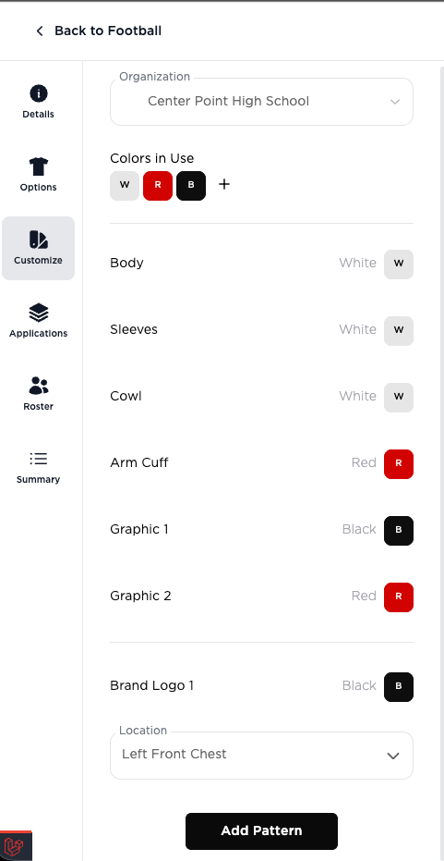
31 | DISCOUNT CODE | DISCOUNT CODE IMPLEMENTATION IN THE STYLE CANVAS  - If Discount Code is applied in the shopping cart,  - The original price is displayed with a strikethrough  - The discounted price is displayed below the original price  - A badge is shown below the pricing information to indicate the discount association  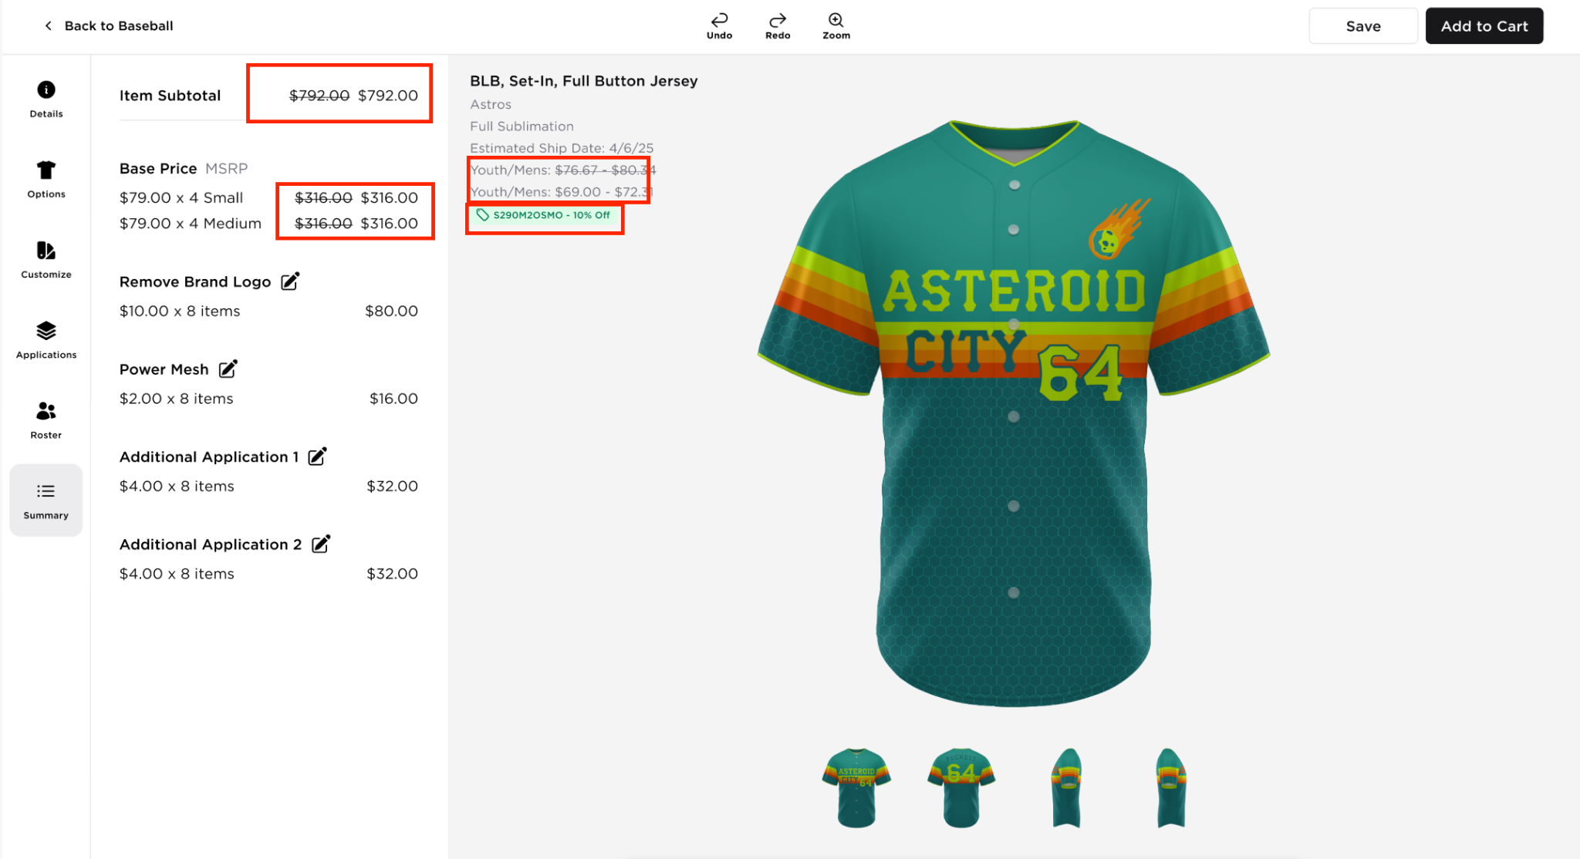  DISCOUNT CODE IMPLEMENTATION IN THE DETAILS TAB  - If Discount Code is applied in the shopping cart,  - The original price is displayed with a strikethrough  - The discounted price is displayed next to the original price  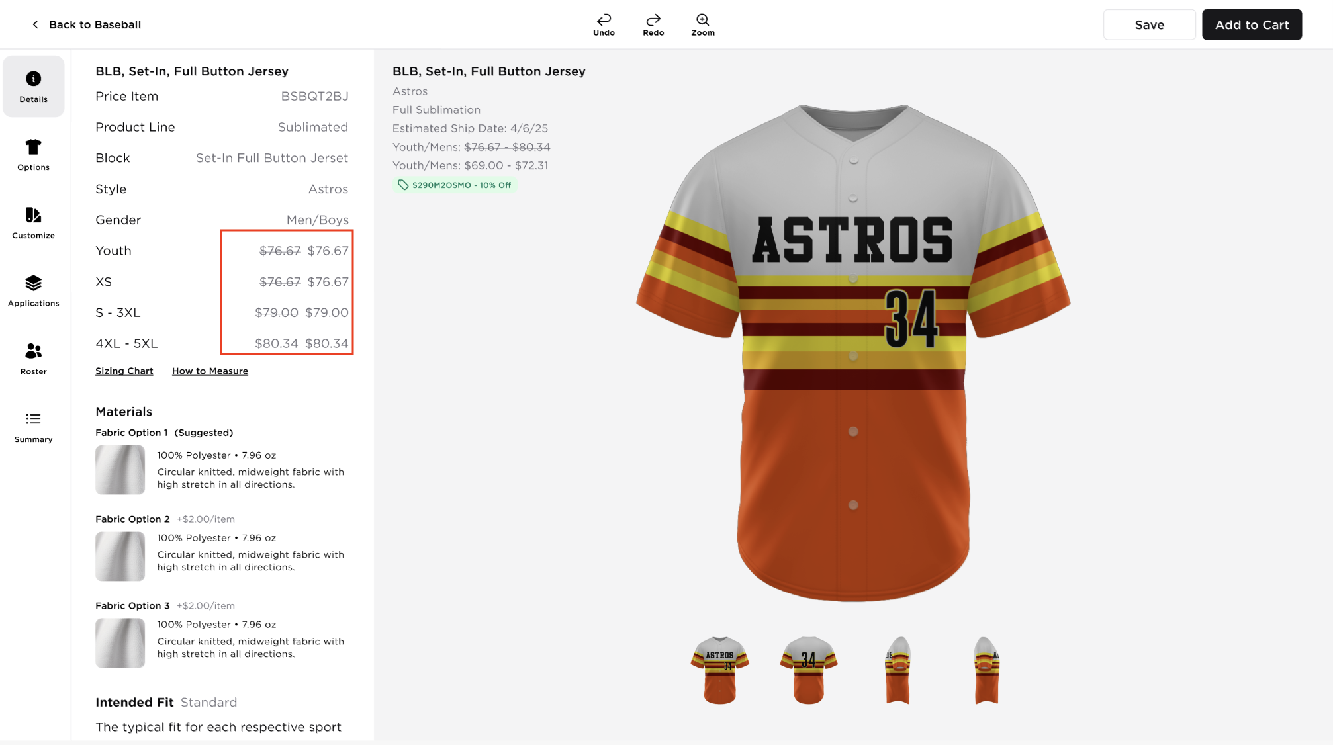  DISCOUNT CODE IMPLEMENTATION IN THE SUMMARY TAB  - If Discount Code is applied in the shopping cart,  - The original price is displayed with a strikethrough  - The discounted price is displayed below and next to the original price  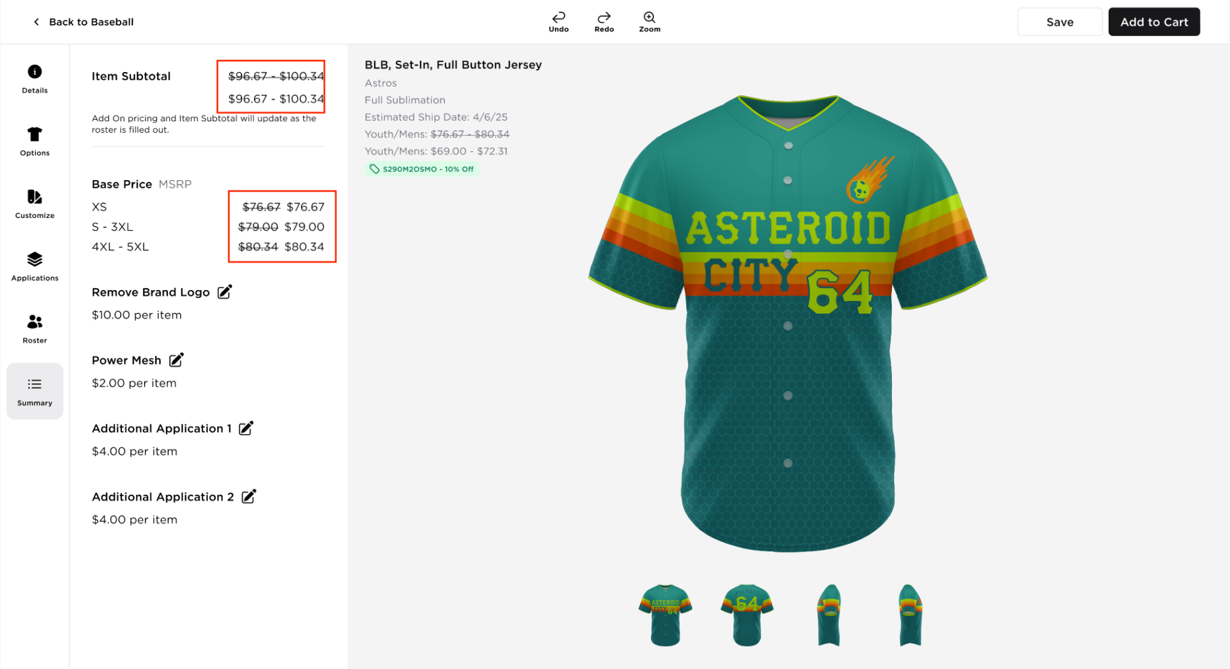

OUT OF SCOPE REQUIREMENTS
NO. | NAME | DESCRIPTION
1 | Multi Fabric For Twill and Hybrid  (Color wheel of the ‘Body’part) | This functionality will not be implemented in Customizer Reskin.  https://qstrike.atlassian.net/browse/CRE-301

PHASED IN REQUIREMENTS
NO. | NAME | DESCRIPTION |  | Status
1 | Customizer Reskin: Add Profile Icon to the Builder Header | 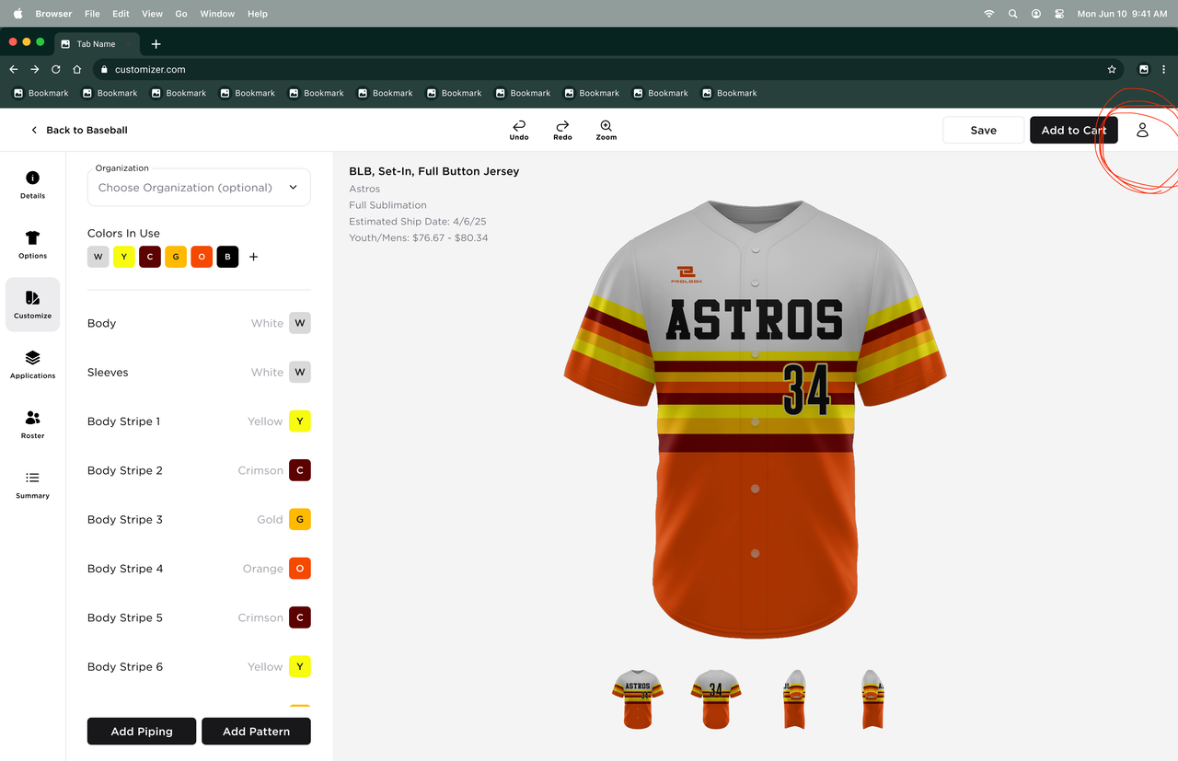  https://qstrike.atlassian.net/browse/CRE-9767 |  | Phased In
2 | Customizer Reskin: Remove Body Part Highlight on Next Click | https://qstrike.atlassian.net/browse/CRE-9773 |  | Included
3 | Customizer Reskin: Body Part Highlight Color | https://qstrike.atlassian.net/browse/CRE-9790 |  | Included
4 | Customizer Reskin: Update Navigation Bar with Grey Navigation Bar | https://qstrike.atlassian.net/browse/CRE-9785 |  | Included
5 | Customizer Reskin: Hide Empty Sections in Details Tab | https://qstrike.atlassian.net/browse/CRE-9788 |  | Included
6 | Customizer Reskin: Update Special Character Validation Message | https://qstrike.atlassian.net/browse/CRE-9789 |  | Included
7 | Customizer Reskin: Outline Colors Locked After Switching 3-Color Application to Pattern | https://qstrike.atlassian.net/browse/CRE-9798 |  | Included
8 | System Wide Hide Empty Sections/Selections |  |  | Phased In

REFERENCES
NAME | LOCATION
Final Design Figma Link | https://www.figma.com/design/mXMHzcKvW4Vs8r30pUET55/Builder-Page?node-id=4039-28715&t=kqnWUM6AvZUxg7OY-0
Monday ticket | https://prolook.monday.com/boards/4880298520/pulses/7459057252
Hand-off Video | https://drive.google.com/drive/u/0/folders/1Dd-QXBURh8n_fXsW1BeGhYUaM4l4SIwy
Technical Specs
JIRA Ticket | https://docs.google.com/spreadsheets/d/13tMkOvKn2hFUu9asc6OTSG4cCbXNm6uR7UuPpqHkDaw/edit?usp=sharing
QX7 New Configuration Related | RD_Core Colors Toggle in Colors By Brand Page  RD_Reversible Trim functionality, physical binding

